Success Story

April 01, 2025

Sustainable and fast from design to production

A mechanical movement is simply fascinating: at least 100, usually more high-precision parts are put together by skilled hands in the smallest of spaces – and with a glance at the watch on our wrist, we always know what time it is. With a precision of 99.9 percent and better. In this market which is dominated by a few major players of manufacturers of movements, Landeron Swiss Movements in Kaiseraugst is a sought-after address among insiders when it comes to technical reliability and the individual design of a caliber for a watch.

Word has also gotten around that the whole thing is affordable, too. With the Micro5 from the CHIRON Group, Landeron has invested in a machining center that is perfect for strengthening and further developing this image. The results after three months of practical use show that it’s a perfect match.

Swiss made – established brand and flagship of the watch industry
When people think of watches, they usually think of Switzerland and its well-known manufacturers – the image of proverbial Swiss precision is firmly established; the entire Swiss watch industry launched around 17 million watches worldwide in 2023. By comparison, Apple Watches sold 37 million units in the same period, but are only ahead in terms of unit sales, not turnover. And in our increasingly digitalized world, watches with mechanical movements have a special appeal. This has been the case since the 1990s following the so-called “quartz crisis" of the 1970s/80s, when battery-powered quartz watches flooded the market en masse and made life difficult for traditional watch manufacturers. A success story that has been virtually uninterrupted to this day, employing a good 60,000 people in Switzerland and generating sales of around 25 billion Swiss francs.

Making the movement, not the watch
Landeron Swiss Movements is also part of this industry, with owner and managing director Krisztina De Paola and her husband, Sergio De Paola, who is a qualified watchmaker and works as a technical manager. She trained as a porcelain painter and everything that has to do with design and decoration is her world, her passion. She came to Switzerland as a jewelry designer at the end of the 1990s and was one of the few designers who could already operate computer-aided programs such as 3D Studio Max – something that would later become important with the Micro5. She came to the watches through her husband Sergio, whom she met in early 2000.

Krisztina De Paola founded her company in 2007 with the idea of launching self-designed products – jewelry, watches and other luxury goods – on the market. Over time, the focus increasingly shifted to the production of watch movements. In 2015, the brand Landeron Swiss Movements was registered and the De Paolas began to market their movements under this name. „Building a complete watch is extremely complex and that was not our goal,” says Sergio De Paola, a qualified watchmaker and production specialist who is very well connected in the industry and has 40 years of experience and expertise. „We wanted to concentrate on the movement and with Landeron we found exactly the right basis on which to build. This means to produce reliable and affordable mechanical movements and at the same time be able to realize a wide variety of individual customer solutions.“

Design is the alpha and the omega
Kaiseraugst, located directly on the Rhine, is home to Landeron's headquarters with design, engineering, administration and – new with the Micro5 of the CHIRON Group – prototype production. Production and tool manufacturing are located in La Chaux-de-Fonds. Landeron has distinguished itself with a number of groundbraking innovations in its company history. For example, the rotating bezel, which replaced the correction buttons for setting the calendar functions. Or the first Swiss electric watch movement with a battery-operated watch balance instead of a pull spring. The De Paolas and their employees have been behind the Landeron brand for a good ten years now and are committed to the guiding principle of affordable and reliable movements.

There are four types of movement in the product range: manual movements, automatic movements, chronographs and tourbillons, and within these types there are four to five different calibers. Krisztina De Paola is the contact person when it comes to determining the right caliber and implementing the customer's ideas, i.e. transforming the design with the form and function of the movement accordingly. „Whether our customers come from Italy or from Australia, America or Asia – they are all looking for the right movement for their idea of a watch. And everyone has their own ideas, which we try to fulfill,”
she says, giving examples from her experience: „Automatic movement or the most accurate movement of all, the tourbillon? Blue or red jewels, a rectangular or round watch shape, an additional complication, i.e. perpetual calendar function, moon phase display – our initial consultation is extremely important for the customer to ensure that the watch and movement are a perfect match. There are many factors to consider that are decisive for the technical implementation, series production and ultimately the costs.”

Produce more sustainably and get faster to »number zero«
It was with the De Paolas that Simon Heim, who has been in sales working for the CHIRON Group in Switzerland since 2019, held the first discussions about the purchase of the Micro5. He wanted to understand exactly what Landeron intended to do with the machine, which was specially designed for micromachining. „The De Paolas' enthusiasm for the machine concept itself helped,” says Simon Heim, explaining: „With an energy consumption of just 0.5 kW/h and a footprint of just one square meter, the Micro5 is what can justifiably be described as a 'sustainable product'. That's exactly what Landeron was looking for.” And Sergio De Paola adds: „With the existing CNC machines, the energy requirement for what they machine here in the micro range is simply far too high. It was important for us to think ahead and significantly reduce these costs. As everywhere in Switzerland, so here too, the small space requirement in production is always a good argument.”

The driving force behind everything was above all Krisztina De Paola herself. She had clearly defined her goals: To do the process of hand-drawing the design, writing the CAD/CAM program, setting up and operating the machine – to do all of this in-house in order to get more quickly from finished design to prototype and, of course, to try out ideas and new designs. „At the moment,” says Krisztina De Paola, „manual movements, for example, are very much in vogue at and demand is also increasing for tourbillons. We all have our hands full here. With the Micro5, I can get straight down to work and implement the basis for each prototype, the front and back watch plates. We can get much faster to number zero of the new creations, faster into series production and our customers can sell their watches faster, too.” A statement that makes Simon Heim visibly satisfied. „I find it impressive how Krisztina De Paola has got to grips with the Micro5 and has now mastered the entire process from A to Z.”

Improve something every day
Smartwatches and quartz watches often cannot be repaired; if they break, you have to dispose of them and buy a new one. All parts of a watch with a mechanical movement, on the other hand, can be repaired, making such a timepiece one of the most sustainable products of all. Well cared for and regularly serviced, it will last a lifetime and more. For Krisztina and Sergio De Paola, sustainability is also a very good symbol of their plans for the future. „We are small, maintain a responsible, open and social personnel policy, everyone enjoys their work – all of which makes us very flexible. And with the new possibilities in production with the Micro5 of the CHIRON Group, we have taken the right step towards more environmentally and cost-conscious production and thus keep the individual diversity of our range affordable.”

About the company
Landeron Swiss Movements is based in Kaiseraugst and develops individual movements. The program offers manual movements, automatic movements, chronographs and tourbillons, Swiss made. Landeron masters the entire production process, from consulting, design, planning and conception to prototyping and series production. The production and toolmaking facilities are located in La Chaux-de Fonds. Among the few pure movement manufacturers, Landeron offers a high degree of customization for reliable and affordable calibers.

Further information: https://landeron-swiss-movements.com/

About the CHIRON Group

The CHIRON Group, headquartered in Tuttlingen, is a global company specializing in CNC vertical milling and mill-turn machining centers, as well as turnkey manufacturing solutions. The Group has a global presence, with production and development sites, sales and service subsidiaries, and sales agencies worldwide. Around two thirds of machines and solutions that are sold are exported. Key customer sectors are the automotive, mechanical engineering, medicine and precision engineering, aerospace industries and tool production.

Contact person for editors:

CHIRON Group SE
Melanie Buschle
Kreuzstraße 75, 78532 Tuttlingen, Germany

Phone: +49 (0)7461 940-3255
Mail: melanie.buschle@chiron-group.com
www.chiron-group.com

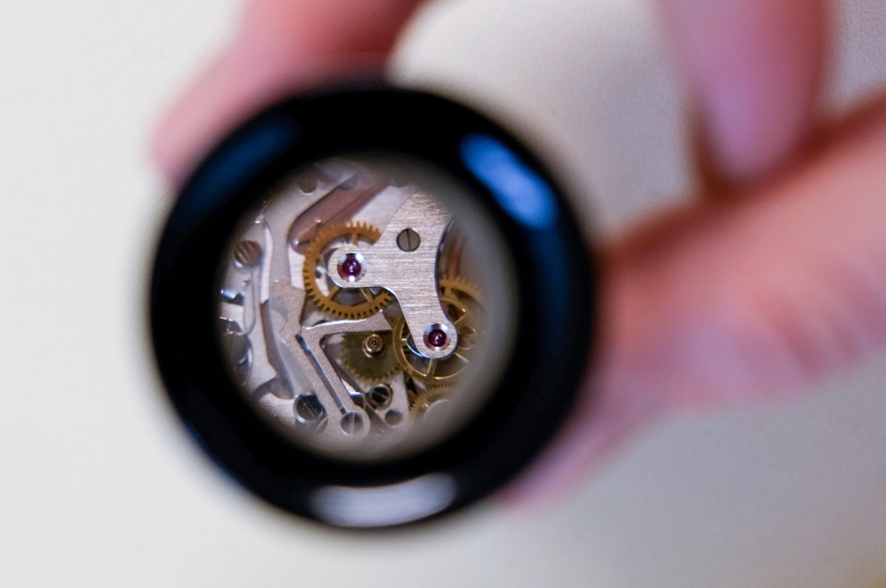

Image title Start-up
A small insight into a great tradition – the movement caliber 248 from Landeron Swiss Movements. Founded by the brothers Auguste and Charles Hahn on January 1, 1883, Landeron Swiss Movements is today one of the top addresses for reliable and affordable watch movements in a wide variety of designs.

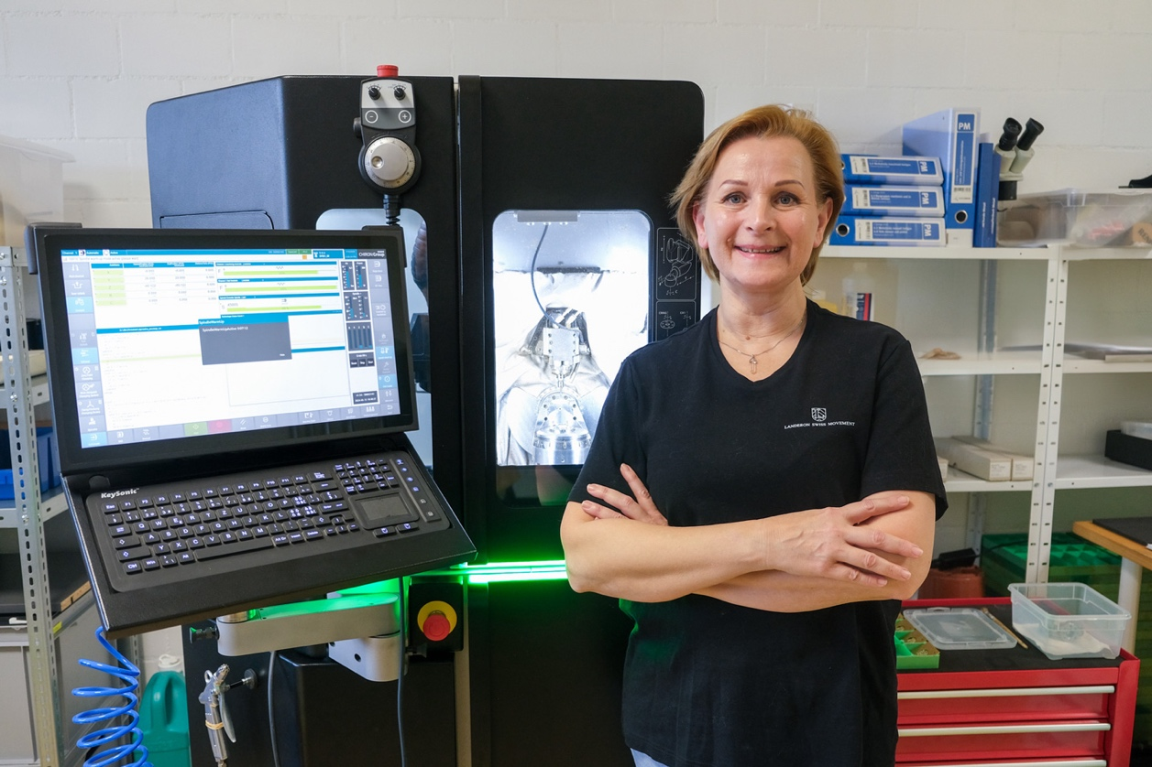

Picture 1
Sought and found – Krisztina De Paola has become friends with the Micro5 over
the last few months and says: „It's one of the best investments we've made so far. We can quickly produce prototypes and reliably produce small series with the required high precision.”

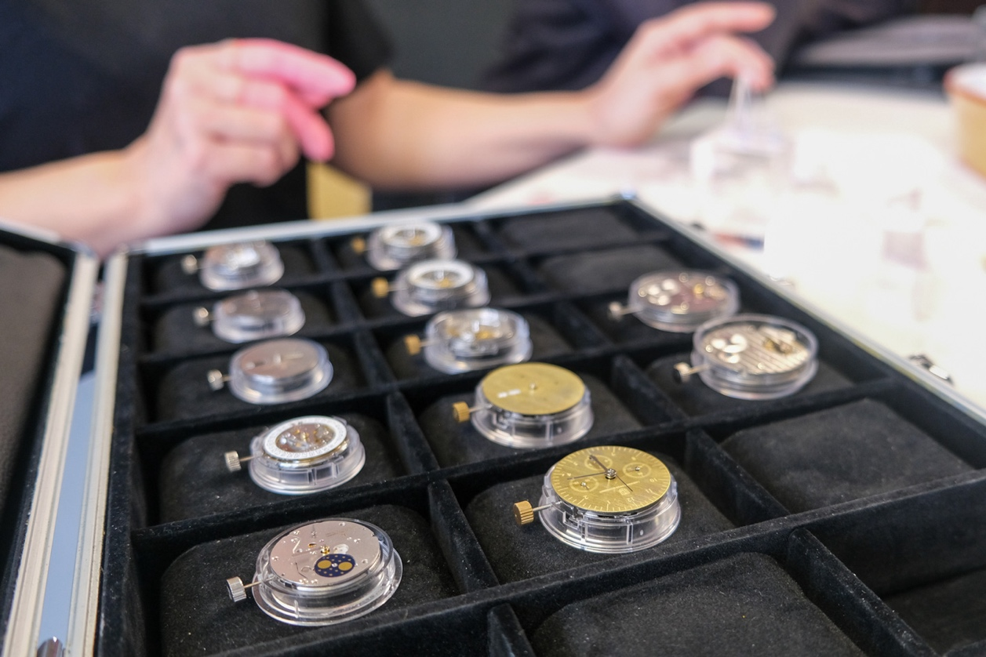

Picture 2
The sample watch movements from Landeron – the basis is always the watch plate. The watch movement is built on it. The pull spring, clockwork, crown, watch bridge and anchor espacement, anchor wheel and watch balance are added later on. Whether with manual winding or automatic – it is very helpful to discuss every little detail when talking to customers.

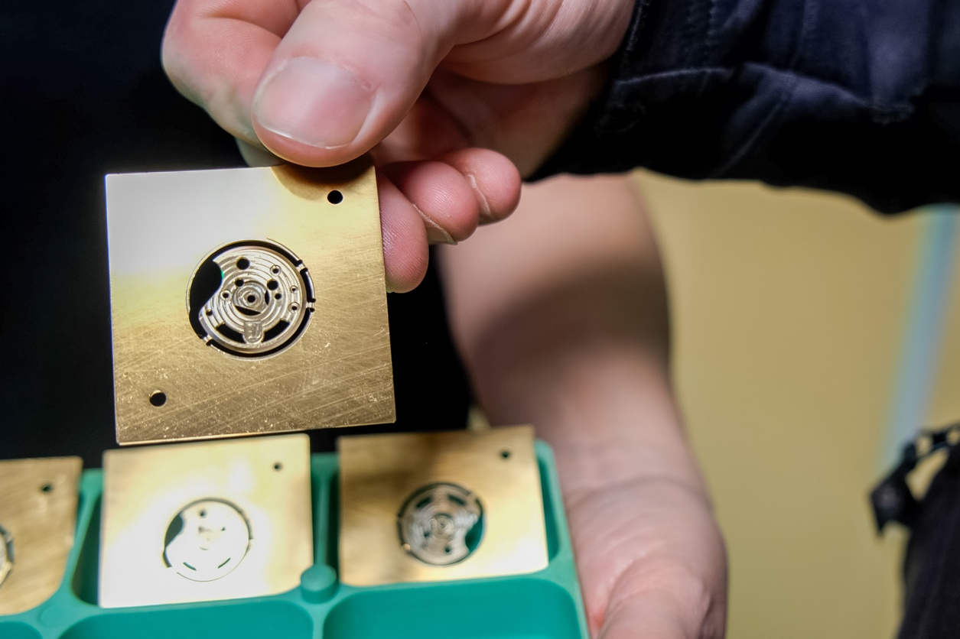

Picture 3
The automatic bridge of a L77 caliber chronograph movement is currently running on the Micro5 of the CHIRON Group. The processing time is approx. 43 to 46 minutes.
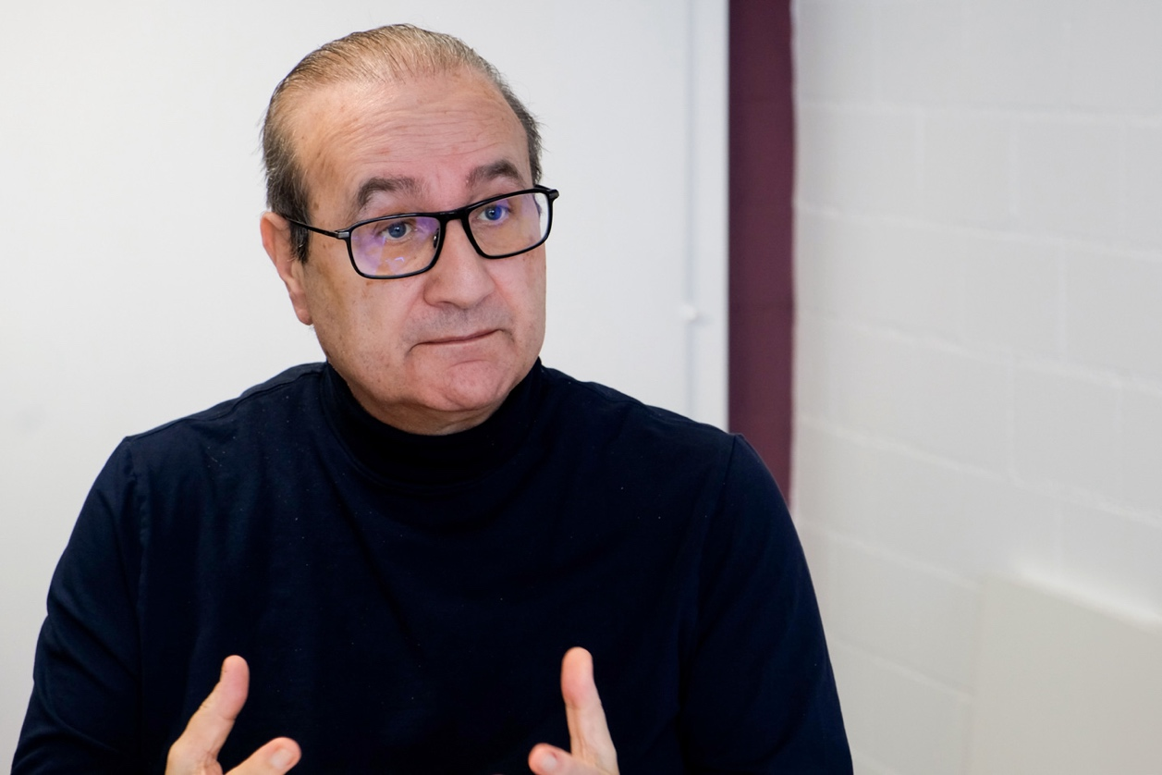

Picture 4
Sergio De Paola knows that Landeron is well positioned to assert itself in this lucrative but also highly competitive market. „We are small, maintain a responsible, open and social personnel policy and everyone enjoys their work – all of which makes us very flexible. And with the new possibilities in production with the Micro5, we have taken the right step towards a more environmentally and cost-conscious production and thus keep the individual diversity of our range affordable.”

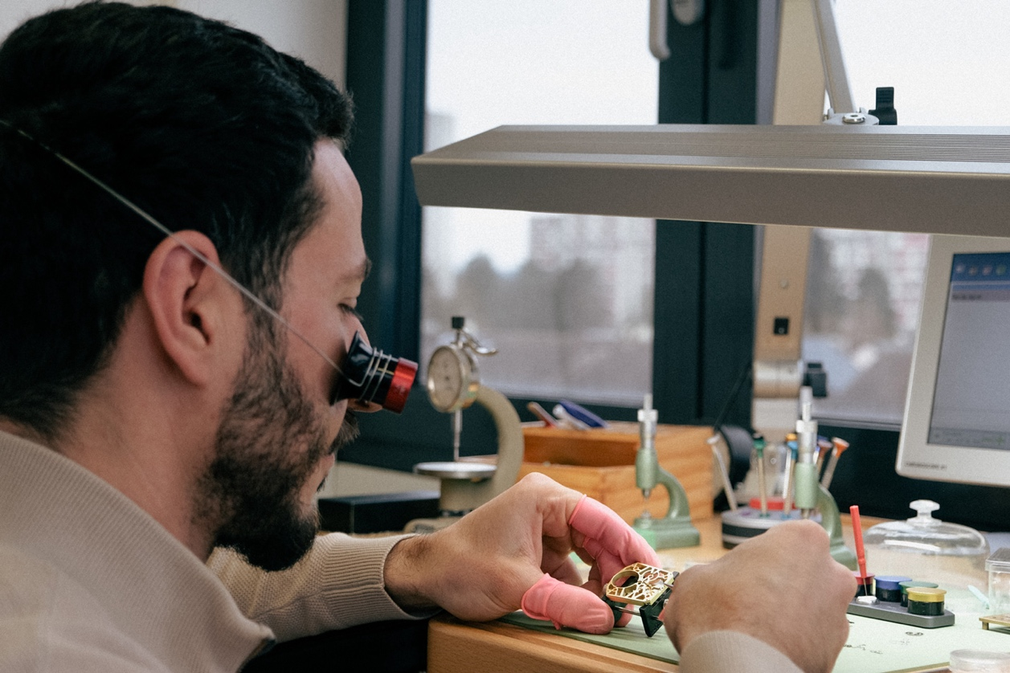

Picture 5
Watchmaker Driss Belmaaziz with a freshly made watch plate. In this case, there are another 45 to 50 parts that he will assemble so that the tourbillon movement will last a lifetime – and longer.

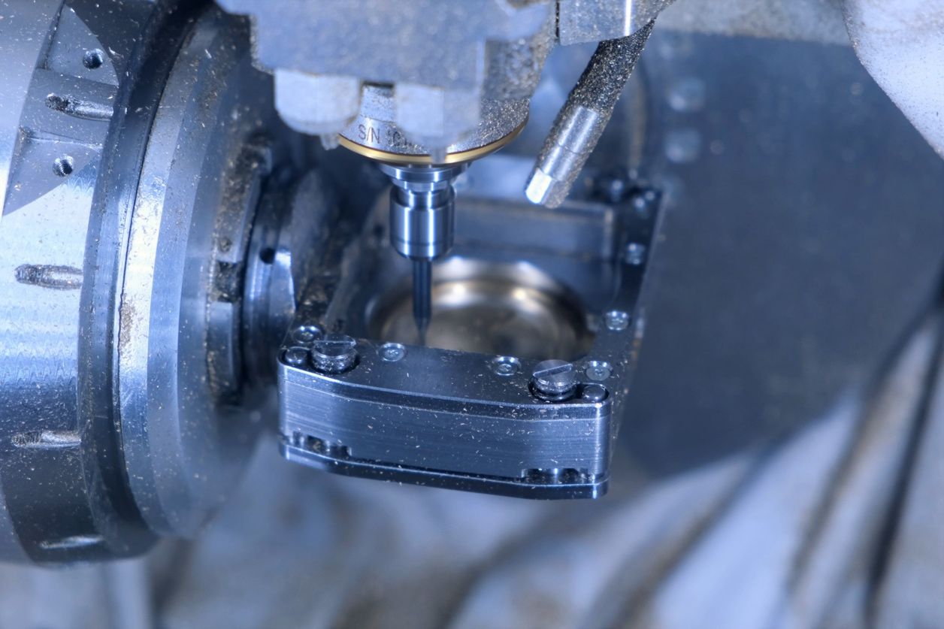

Picture 6
The Micro5 in action when drilling the holes on a watch plate. The diameters are between 0.4 and 0.8 mm.
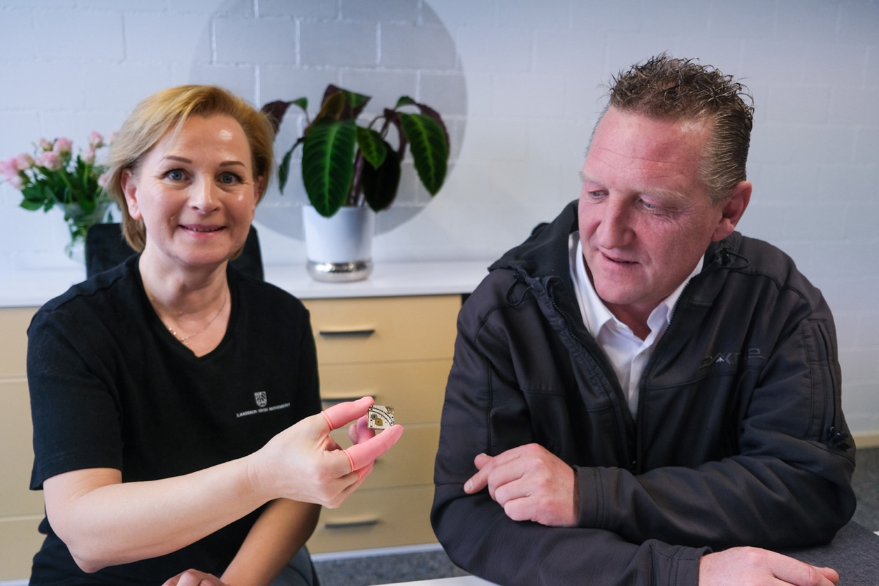

Picture 7
Simon Heim, Technical Consulting Sales for the CHIRON Group in Switzerland, is impressed by „... how Krisztina De Paola has got to grips with the Micro5 and now masters the entire process from A to Z.”

