23 September 2026

AMB 2026: CHIRON Group reports positive results

Five intensive days at the exhibition, around 65,000 trade visitors from 76 countries. And right at the heart of Hall 10: the CHIRON Group. The focus was on integrated manufacturing concepts combining machining technology, automation and digital solutions. The range of applications extended from delicate precision parts for medical technology and precision engineering to large, heavy components for the aerospace industry.
A packed booth and the full attention of visitors: Shortly after AMB 2026 officially opened on 15 September, the CHIRON Group booth was already buzzing. The exhibits were cutting metal and generating keen interest in future-ready manufacturing solutions. Visitors took a close look, asked the experts questions and discussed technical details. Among them was Kati Wilhelm, special guest of Messe Stuttgart. The former world-class biathlete spoke with CEO Roman Gaida about the parallels between elite sport and precise, high-performance manufacturing.
For him, his first AMB as CEO of the CHIRON Group was also special on a personal level: “For me, it feels like a homecoming. After a few years away from machining, it is a pleasure to see familiar faces again and to sense the improving mood in the industry.”
Where Automation Meets Machining Excellence
“Whether it was the fully automated Micro5 XL, the MT 715 two+, the new MILL 2000 five axis, or the FZ 16 S five axis and FZ 19 S five axis, each with new pallet automation: We truly used every square meter here to demonstrate what we stand for. We put tools to metal and produce chips. And that is exactly what an exhibition like AMB is all about for me,” said Roman Gaida.
“Uncompromising quality. From very small to very large.” This statement on one of the booth walls made the CHIRON Group’s capabilities tangible. Representing “very small” was the Micro5 XL: highly precise, automated 5-axis machining for complex precision parts in medical technology and precision engineering, mechanical engineering, electronics, and tool and mold making. Together with the selected automation solution, the compact machining center forms an integrated unit: with Variocell PICK&PLACE for part handling, Variocell PALLET for automated pallet changing, or Variocell UNO, featuring a 4 kg payload and a 6-axis robot for workpiece handling and additional process steps.

Maximum process integration for the precise and cost-effective complete machining of complex workpieces, for example in mechanical engineering, generated considerable interest in the MT 715 two⁺. Milling and turning can be combined in any sequence with additional processes such as gear-cutting technologies and polygon turning. This reduces reclamping and throughput times while ensuring reproducible quality for complex workpieces.

The new MILL 2000 five axis was another crowd-puller. It features rotary and swivel axes with torque technology for simultaneous 5-axis machining, as well as a machine concept that can be adapted flexibly to different requirements. Consistent standardization also reduces investment costs by up to 25 percent. With bed lengths of up to 12,000 millimeters, the MILL Series covers applications ranging from demanding milling tasks in mechanical engineering for small and medium-sized batches to large structural components for aerospace.

Visitors seeking to combine high-performance 5-axis machining of high-strength materials with flexible automation found the right solution in the FZ 16 S five axis with Variocell PALLET. The combination is designed for high variant diversity, for example in automotive applications or contract manufacturing, as well as productive operation beyond the end of a shift. Twenty-six pallets provide flexibility for changing workpieces and small batch sizes, while workpieces weighing up to 300 kilograms can be fed automatically.

How can more value be created in heavy-duty applications? Through automated manufacturing for long periods of autonomous operation, beyond the end of a shift, overnight or throughout the weekend. With the FZ 19 S five axis featuring a turning function and the new Variocell PALLET, the CHIRON Group demonstrated how this works for “very large”. The pallet transfer system is designed for weights of up to 1,200 kg and large workpiece dimensions, for example in aerospace; the freely accessible setup pallet makes it easier to prepare new orders.

Integrated into all manufacturing solutions, from small to large, is the new standardized order management system for autonomous and flexible production, even for small batch sizes. It provides transparency regarding orders, workpieces and machining progress, and supports planning, prioritization and structured processing.

The CHIRON Group’s comprehensive range of solutions also includes services, automation, refurbishment and spindle repair. At dedicated themed areas, experts presented the portfolio and were available to discuss specific questions and provide individual advice.

Inspiring the next generation to pursue technology
AMB also provided a stage for the next generation. At the special education showcase organized by the Mechanical Engineering Youth Foundation in the atrium, CHIRON Group technical apprentices gave school students hands-on insights into modern milling technology and encouraged them to consider apprenticeships and careers in mechanical engineering.

Ten, nine, eight … one – and go!
At exactly 3 p.m. on the final day of the exhibition, things got loud once again at the booth. The exhibition team counted down together from ten; at “Go!”, the traditional “knocking off” of the machining centers began, marking the shared finale after five intensive days. Matthias Rapp, Vice President Global Marketing at the CHIRON Group, gave an initial assessment: “AMB 2026 demonstrated the importance of combining machining technology, automation, service and digital solutions for industrial manufacturing. At our booth, the breadth of our offering, from micromachining and productive high-mix manufacturing across all industries to the production of large workpieces, attracted particular interest. The strong international profile of the visitors, the quality of the technical discussions and numerous new contacts confirm AMB’s role as an important meeting place for the industry.”

The aftermovie featuring the best moments and highlights is available here:
CHIRON Group at AMB 2026

Characters including spaces: 6,445

About the CHIRON Group

Headquartered in Tuttlingen, the CHIRON Group specializes in CNC-controlled vertical milling and mill-turn machining centers, as well as turnkey and automation solutions. Comprehensive services and digital solutions complete the portfolio. The Group has a global presence through production and development sites, sales and service subsidiaries, and commercial agencies. Around two thirds of the machines and solutions sold are exported. Key user industries include automotive, mechanical engineering, medical technology and precision engineering, aerospace, and tool manufacturing.

Editorial contact:

CHIRON Group SE
Matthias Rapp
Kreuzstraße 75
78532 Tuttlingen

Phone: +49 7461 940-3181
Email: matthias.rapp@chiron-group.com
www.chiron-group.com

Image captions

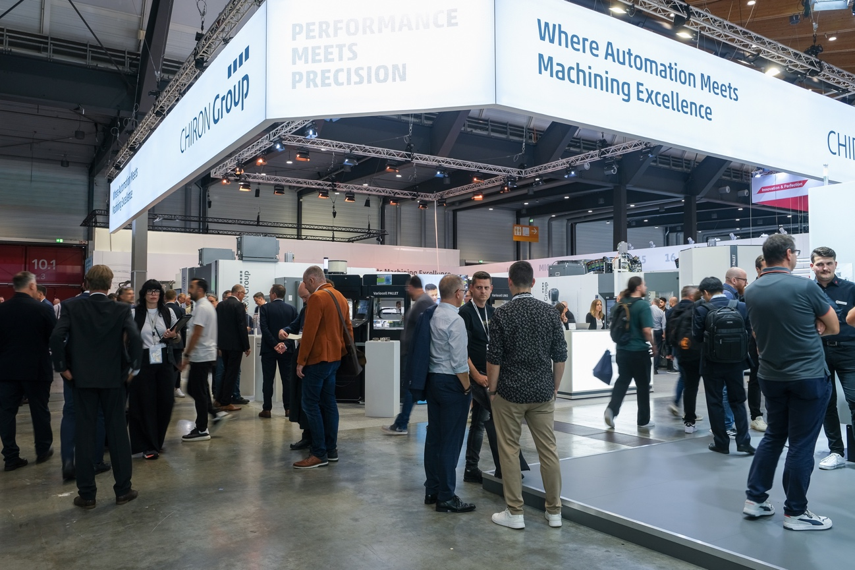
Image 1: “Where Automation Meets Machining Excellence”: At the CHIRON Group booth, trade visitors experienced future-ready manufacturing solutions in every dimension in action.
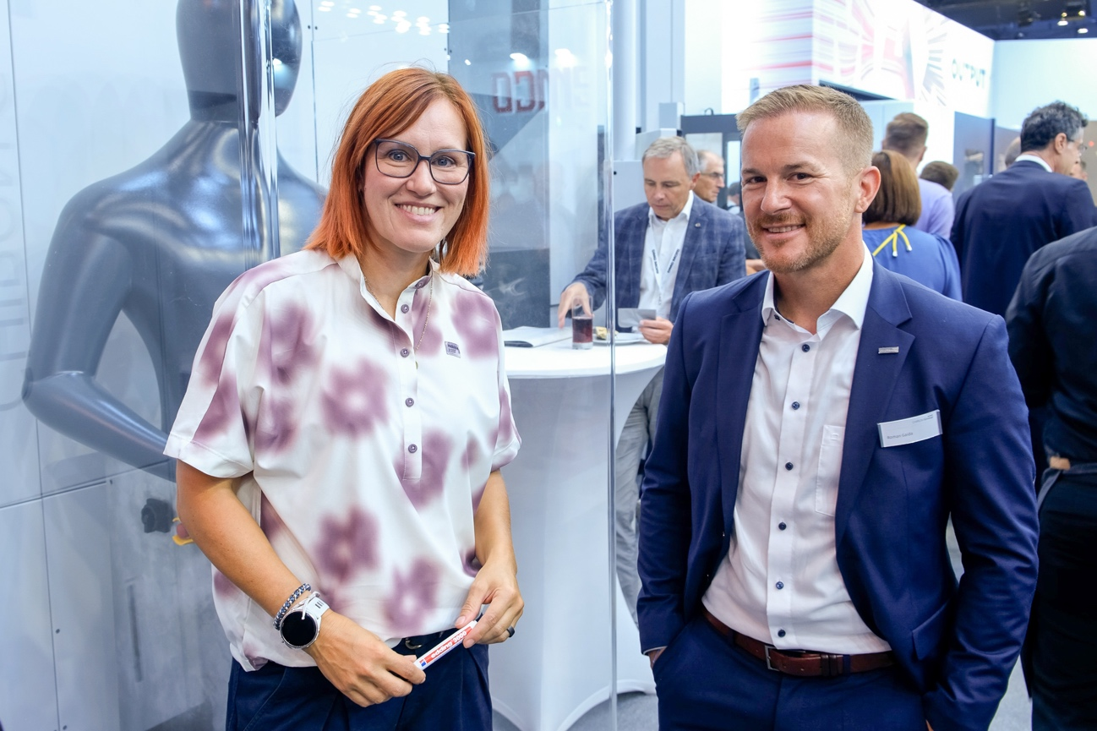
Image 2: An expert in precision and high performance: former top biathlete Kati Wilhelm, special guest of Messe Stuttgart, in conversation with CEO Roman Gaida.

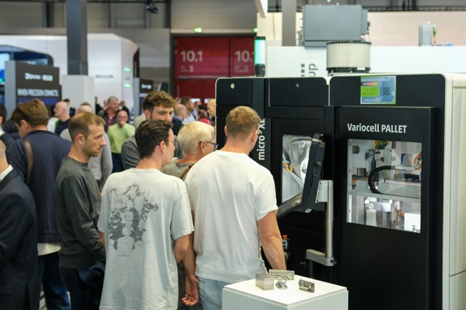

Image 3: A key focus of attention: automated production of small precision parts with the integrated combination of the Micro5 XL and Variocell PALLET.
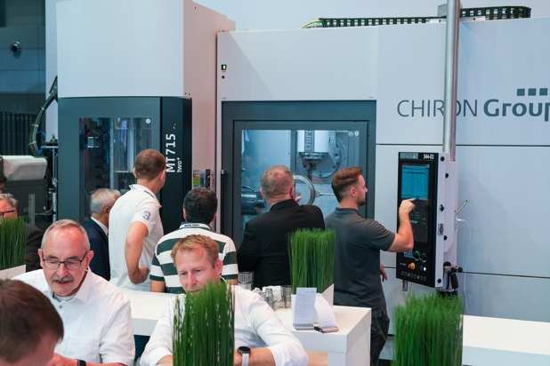
Image 4: Precise and cost-effective complete machining for small and medium-sized batches: At the MT 715 two⁺, trade visitors learned about maximum process integration for complex workpieces.

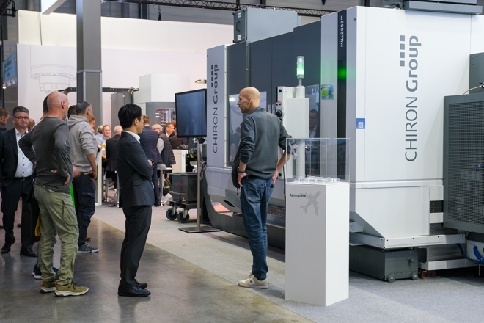
Image 5: The MILL 2000 five axis for demanding simultaneous 5-axis machining celebrated its premiere at AMB 2026. The flexibly configurable machine concept of the Series can be scaled with bed lengths of up to 12,000 millimeters.

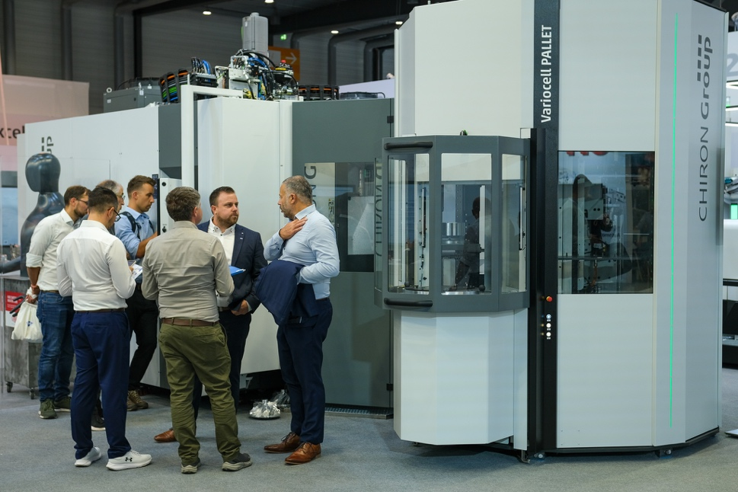
Image 6: Productive with high variant diversity: The FZ 16 S five axis with Variocell PALLET offers 26 pallet positions for automated manufacturing and long periods of autonomous operation.

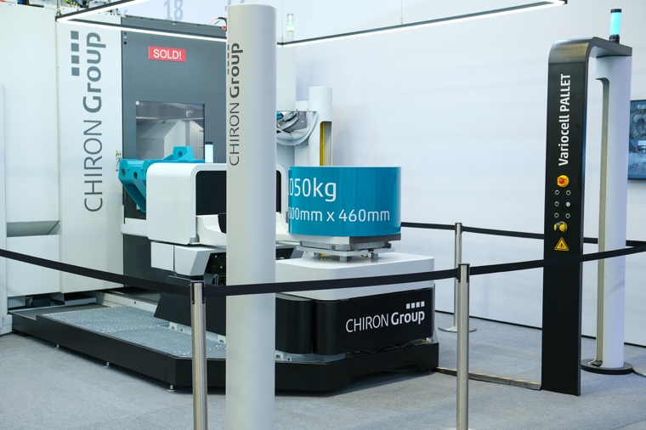

Image 7: Automation and autonomy for “very large”: With the FZ 19 S five axis and the new Variocell PALLET, the CHIRON Group presented a retrofit solution for large and heavy components in aerospace, mechanical engineering and contract manufacturing.

