23rd December 2022

SUSTAINABILITY by Performance and Precision: The CHIRON Group publishes its first sustainability report

Grow profitably, acquire market shares, boost global business: The CHIRON Group will be pursuing ambitious objectives over the next few years. To help achieve them, the company is setting itself apart from the competition with its product range. The company's commitment to sustainability, an important topic for the future, gives customers and potential customers even more reasons to choose the CHIRON Group. The company has already achieved its first major success in this area: From the end of the year, production at the German sites will be carbon-neutral. The CHIRON Group documents the measures it has taken and success it has enjoyed so far in its first sustainability report „SUSTAINABILITY by Performance and Precision“.

„Our objective is to achieve environmentally conscious and carbon-neutral production — the sooner the better,“ states CEO Carsten Liske. To this end, in recent months, the CHIRON Group has been focusing on developing a global sustainability program. And, by investing in heat recovery and photovoltaic systems, as well as purchasing the required energy from renewable sources, the first milestone has already been reached: Production operations at the CHIRON Group sites in Germany are now carbon-neutral. CHIRON China will soon follow suit in 2023 with a photovoltaic system for the Taicang Innovation Factory, while plans are already underway at CHIRON Croatia.

Benjamin Kurth, Global Program Manager Sustainability, explains that, as a machine tool manufacturer, the CHIRON Group faces a double challenge: „Firstly, we are striving for carbon-neutral production at our company and, secondly, we want to ensure that our customers conserve resources and operate machining centers and manufacturing solutions ever more efficiently.“ As a founding member of the VDMA Blue Competence Initiative, the CHIRON Group actively advocates for sustainability concerns and systematically implements the defined criteria in its products. Alongside improved energy and raw material efficiency, this also includes income-boosting automation of machining centers, resource-conserving implementation of the processes with intelligent turnkey solutions, and the digitalization of customer and development projects.

In the Sustainability Report 2021, the company presented its strategy and detailed its activities in all sustainability-related areas: Continuous development of the product range, responsibility for staff and society, quality, supply chain and resource management, energy use and CO₂ footprint. In his foreword, CEO Carsten Liske states: „With our report, which has been drawn up in accordance with the core guidelines of the Global Reporting Initiative (GRI), we are providing verifiable proof that, not only is sustainable behavior of huge importance when it comes to maintaining our economic performance, it is also part of our DNA.“

All of the activities are based on the „Sustainability@CHIRON Group” strategic program. The objective is to achieve fully carbon-neutral production throughout the world by the end of 2025. Benjamin Kurth explains that the CHIRON Group has officially pledged its commitment to this ambitious project: „Since December 2022, we have been the first company in our industry to collaborate with the Science Based Target initiative (SBTi). This shows just how seriously we take sustainability.” The SBTi is a joint initiative undertaken by CDP, United Nations Global Compact, World Resources Institute and World Wide Fund for Nature (WWF). Its approach is to define emission reduction targets for the participating companies and to independently assess whether these have been met, with the ultimate aim of achieving the Paris Climate Agreement targets, namely to limit global warming to 1.5 °C.

For Benjamin Kurth, this commitment, alongside the first sustainability report, represents another significant milestone: „Now what matters is specifying our reduction targets in greater detail, achieving them in the projected time frame, and having their impact validated by the SBTi.” Carsten Liske adds: „With 'Sustainability@CHIRON Group', we have laid a solid foundation for making sustainability a strategic factor in our business model, for us and our customers. We are building on this and continuing with this approach – to make the CHIRON Group carbon-neutral and, just as importantly, successful in the long term.“
The online version of the Sustainability Report 2021 is available on the CHIRON Group Website under „Environment and Quality”.

About the CHIRON Group

The CHIRON Group, headquartered in Tuttlingen, Germany is a global company specializing in CNC vertical milling and mill-turn machining centers, as well as turnkey and automation solutions. Comprehensive services, digital solutions and products for additive manufacturing complete the portfolio. The Group has a global presence, with production and development sites, sales and service subsidiaries, and sales agencies worldwide. Around two thirds of machines and solutions that are sold are exported. Key customer sectors are the automotive, mechanical engineering, medicine and precision engineering, aerospace industries, as well as tool manufacturing.

The CHIRON Group is proprietor of the CHIRON, STAMA and FACTORY5 brands for new machines, as well as the automation brand GREIDENWEIS, CMS for refurbishment and HSTEC for motor spindles and fixtures. CHIRON machining centers are renowned for their highly dynamic design and their precision. The focus of STAMA is on stability and complete machining, while FACTORY5 expert area is high-speed machining of micro-technical components. GREIDENWEIS is a system partner for custom, end-to-end automation solutions, and CMS provides completely refurbished machines from the Group. HSTEC specializes in the development, manufacture and repair of high-speed motor spindles and fixtures. The final core area of expertise in the CHIRON Group is in additive manufacturing products and solutions.

Contact person for editors:

CHIRON Group SE
Christina Messmer
Kreuzstraße 75, 78532 Tuttlingen, Germany
Phone: +49 (0)7461 940-3712

Mail: christina.messmer@chiron-group.com
www.chiron-group.com

Image captions

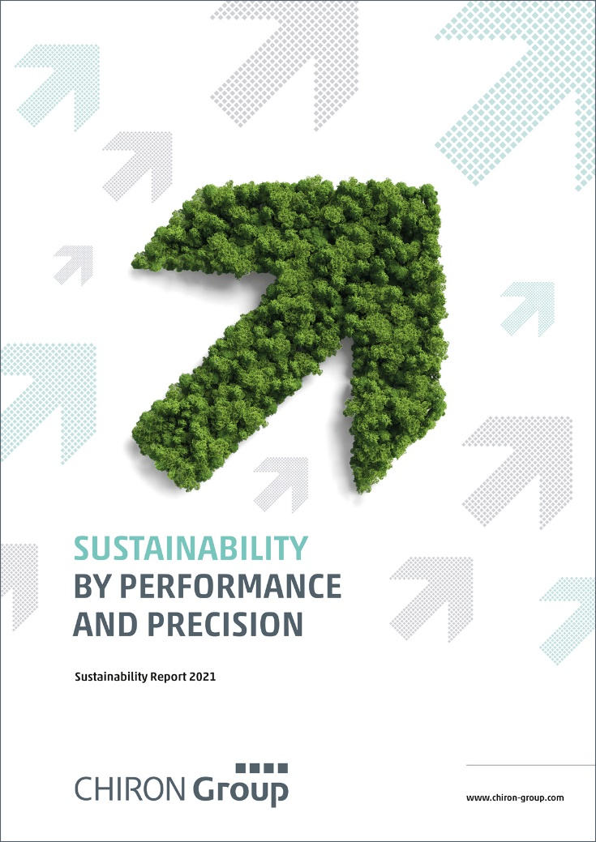

Image 1: The sustainability report published by the CHIRON Group demonstrates from the upwards arrows over the title alone just how ambitious the company's goals are.

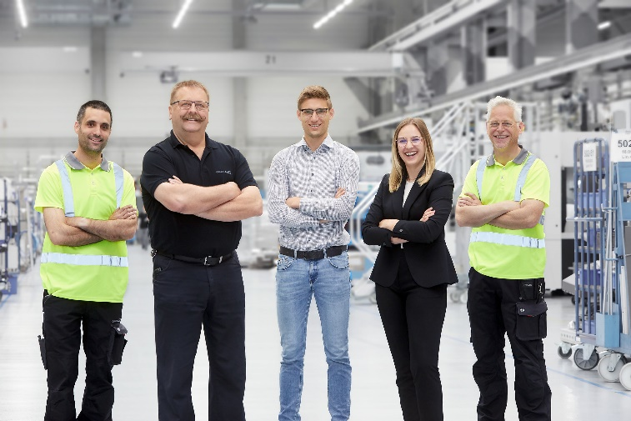
Image 2: Committed and qualified employees around the world are the basis of the
leading market position and growth achieved by the CHIRON Group.

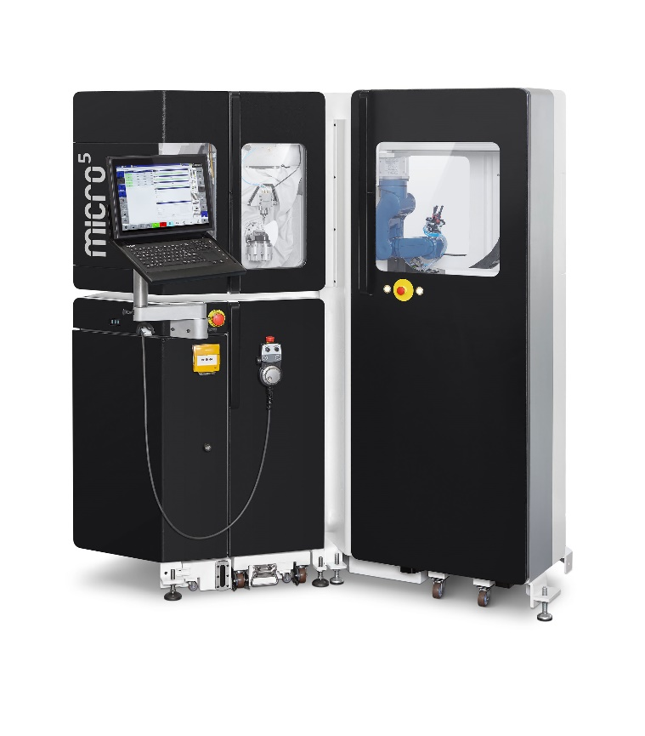
Image 3: Sustainability is reflected in all products – for example in the extremely compact Micro5 for ultra-precise machining of small parts the smart way.

.

