March 16, 2023

The CHIRON Group invites to the OPEN HOUSE 2023

Advanced manufacturing – now: This is the motto of the OPEN HOUSE, which will once again take place from May 10 to 12. The three days of the exhibition in Tuttlingen, Germany, are dedicated to pioneering manufacturing processes that perfectly match the specifications, products and industries of the users.
What could a process like this look like and what benefits could it offer? Experts will demonstrate this using exemplary machining solutions for Automotive, Medical Technology, Aerospace, Precision Technology, Tool Manufacturing and Mechanical Engineering.
The guiding principle is the special combination of four attributes that characterizes the future-oriented actions of the CHIRON Group and influence how the company develops and offers tailored solutions to meet individual requirements: competent, smart, innovative, sustainable. These attributes are represented on the one hand by the six brands CHIRON, STAMA, CMS, FACTORY5, GREIDENWEIS and HSTEC, which are showing their specific or combined expertise at the OPEN HOUSE.
On the other hand, by the machine highlights: Mill-turn expertise taken a step further in the DZ 22 S mill turn system 8 for double-spindle machining of large volumes. Or complete machining of six sides with high autonomy with the MT 715 two⁺. Visitors can experience the full range of manufacturing solutions – from micro-machining with the Micro5 with a reduced environmental footprint to maximum productivity per unit area when machining high-volume components for Automotive and Aerospace with the 22, 25 and 28 Series.

Presentations by the expertise areas Additive Manufacturing, Automation, Services, Digital Solutions and Refurbishment also provides inspiration for manufacturing practice today and tomorrow. Just like the lecture program with the two themed days »competent & smart« and »innovative & sustainable«. And, not to forget, the exhibition with 26 quality partners along the entire metalworking value chain.
„In addition to showcasing exemplary pioneering machining processes for all user industries, our main focus is on the lively dialog with our guests,“ emphasizes Matthias Rapp, Head of Marketing Global. Each visitor is personally attended and is given an „exclusive tour“ of the exhibition with targeted advice. And of course the event not only offers an excellent platform for experiencing this year’s motto „advanced manufacturing – now“, it is also an opportunity for inspiring exchanges, for example at the Get together with catering and live music at the end of the second day of the exhibition.
Register and make an appointment via:
https://chiron-group.com/open-house

About the CHIRON Group

The CHIRON Group, headquartered in Tuttlingen, Germany is a global company specializing in CNC vertical milling and mill-turn machining centers, as well as turnkey and automation solutions. Comprehensive services, digital solutions and products for additive manufacturing complete the portfolio. The Group has a global presence, with production and development sites, sales and service subsidiaries, and sales agencies worldwide. Around two thirds of machines and solutions that are sold are exported. Key customer sectors are the automotive, mechanical engineering, medicine and precision engineering, aerospace industries, as well as tool manufacturing.

The CHIRON Group is proprietor of the CHIRON, STAMA and FACTORY5 brands for new machines, as well as the automation brand GREIDENWEIS, CMS for refurbishment and HSTEC for motor spindles and fixtures. CHIRON machining centers are renowned for their highly dynamic design and their precision. The focus of STAMA is on stability and complete machining, while FACTORY5 expert area is high-speed machining of micro-technical components. GREIDENWEIS is a system partner for custom, end-to-end automation solutions, and CMS provides completely refurbished machines from the Group. HSTEC specializes in the development, manufacture and repair of high-speed motor spindles and fixtures. The final core area of expertise in the CHIRON Group is in additive manufacturing products and solutions.

Contact person for editors:

CHIRON Group SE
Christina Messmer
Kreuzstraße 75, 78532 Tuttlingen, Germany
Phone: +49 (0)7461 940-3712

Mail: christina.messmer@chiron-group.com
www.chiron-group.com

Captions

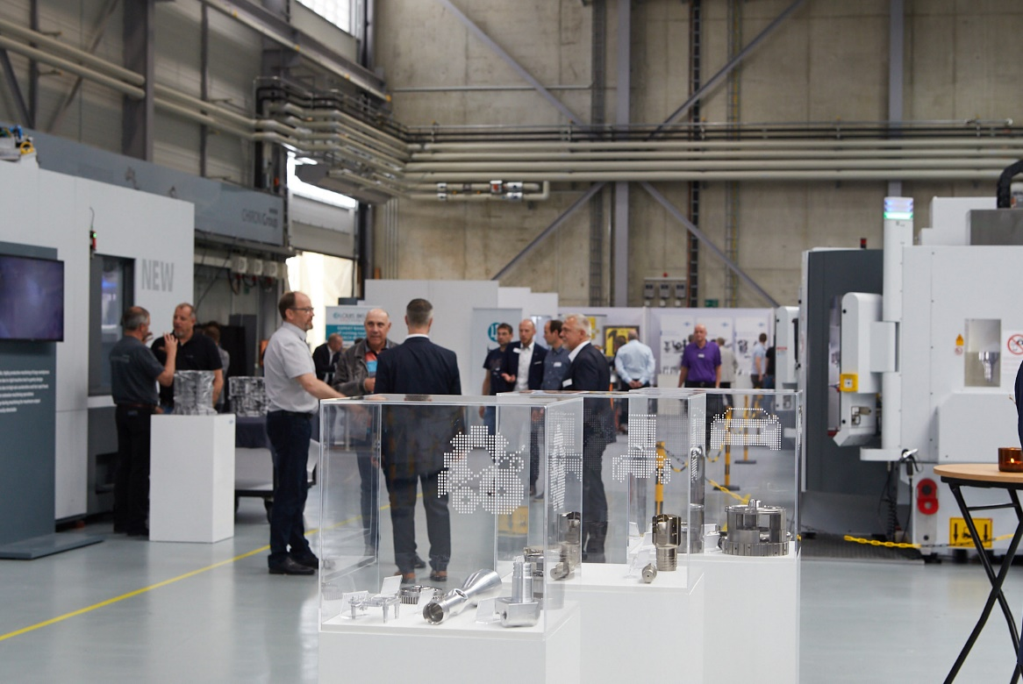

Picture 1: Review CHIRON Group OPEN HOUSE 2022: The well-established industry event was finally took place again live in Tuttlingen, Germany last year.

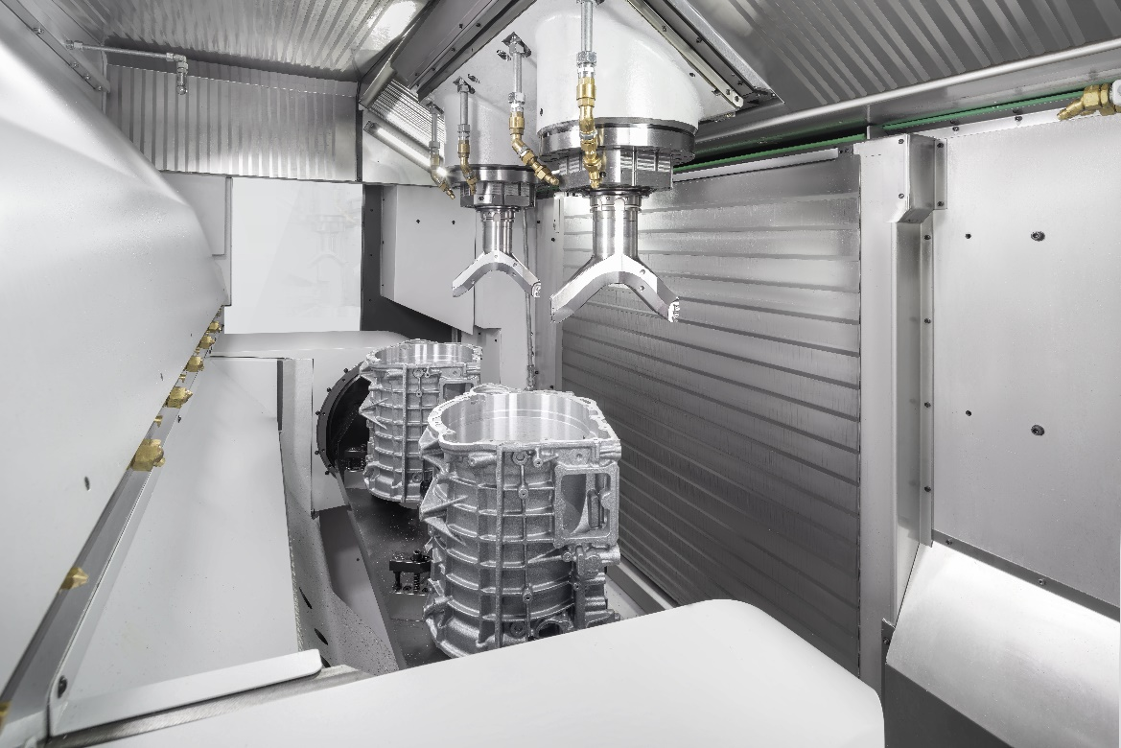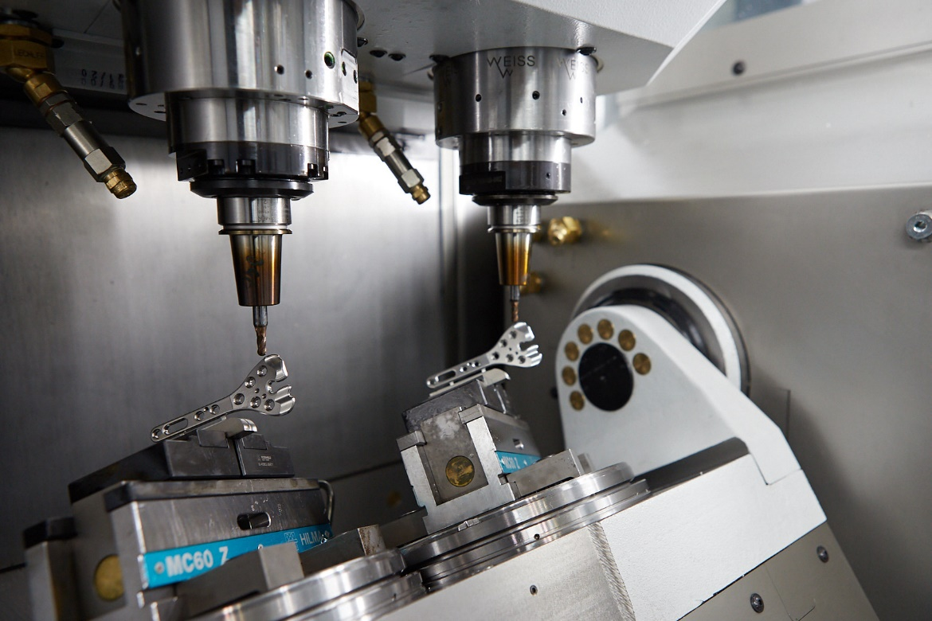
Picture 2+3: Over the three days of the exhibition, the visitors will be able to experience exemplary machining processes for all user industries as well as numerous machine highlights live.
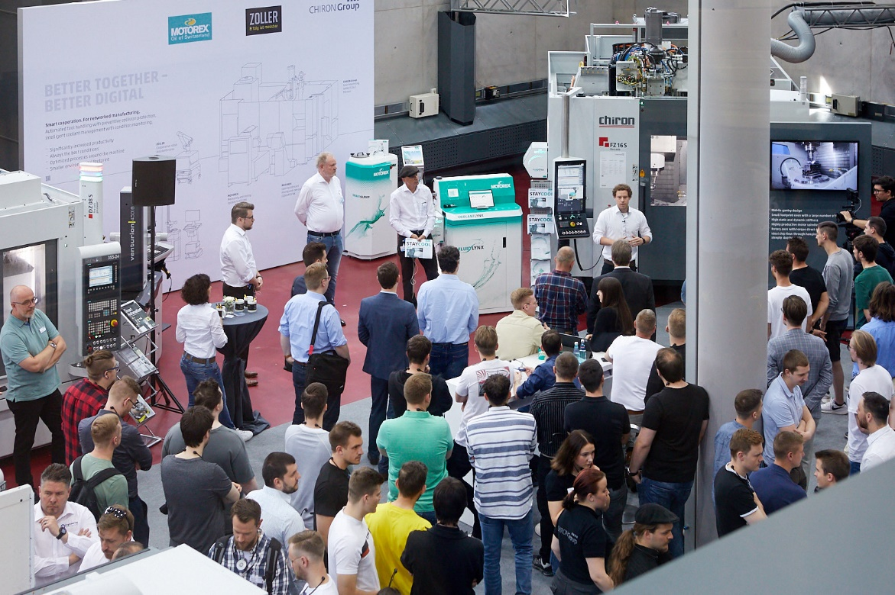
Picture 4: 26 expert partners and the exciting program of lectures also provide new inspiration for manufacturing practice.

