May 10, 2023

Gaining a competitive edge – in all industries
Machine highlights at the CHIRON Group OPEN HOUSE 2023

Machine e-motor housings with the new DZ 22 S mill turn system 8. Five-axis complete machining with the 715 Series with integrated workpiece automation. Intelligent, smart manufacturing of large quantities with a combination of Micro5 and the Feed5 handling system: The machine highlights that can be seen at the OPEN HOUSE from May 10 to 12 in Tuttlingen could not be more different. And yet they all support the same aspiration: Enabling customers of the CHIRON Group to gain a competitive edge.

Mill-turn expertise taken to the next level: DZ 22 mill turn system 8
Whether a stator, rotor, or e-motor housing for diverse hybrid variants or for an all-electric car: Since 2020, the CHIRON Group has offered the perfect manufacturing technology for components with a diameter up to 600 mm with the 22 Series. For highly productive machining of large series, the DZ 22 double-spindle milling centers in combination with special tools are ideally used. But what if even more flexibility is required? Then the new DZ 22 mill turn system 8 is the first choice.

Equipped with a rigid machine bed with a mobile gantry construction, the new machine type is all about high precision and stability. Mill-turn operations for large series can be performed easily with an optimum cost-per-unit ratio thanks to the double spindle. In other words, it's the perfect solution for machining workpieces such as e-motor housings.

But why does the CHIRON Group refer to the 22 Series as a benchmark? Because the advantages of vertical machining are particularly relevant here, as CTO Dr. Claus Eppler explains: „In comparison with horizontal solutions, vertical machining centers make better use of the forces of physics. This makes it possible to have consistently excellent surface quality and the highest geometric precision. This enables consistently best surface quality and highest geometric accuracy. Even when heavy and long tools are used, as in the machining of electric motor housings.“ Another advantage for best surface quality as well as a smooth process: The chips fall downwards, away from the workpiece and are discharged in a controlled manner.

715 Series for multifunctional complete machining
Knee prostheses and cable ducts, or seat rails, valve housings, and milling tools: Designed for workpieces measuring up to 300 mm in diameter and 1,000 mm in length, the machining centers of the 715 Series are suitable for many different products in the Medical, Aerospace, Tool Manufacturing and Mechanical Engineering industries. Whether it's the MT type for mill-turn operations or the MP model for machining bar stock: The integrated workpiece automation makes a higher degree of utilization possible by means of unmanned production in three-shift operation or at weekends.

The four MT machine types – at the highest configuration level MT 715 two⁺ with a swivel head, rotary and counter spindle plus extra machining unit – offer many advantages compared with production spread across multiple machines: Higher precision, shorter throughput times, more flexibility for changing functions, minimized set-up times for small batch sizes, reduced logistics costs. The MP 715 machine variant, where MP stands for Multi Profile, is designed for machining bar stock with any profile. All milling operations, such as machining hollow aluminum profiles for electric vehicles, run very efficiently in one set-up.

A feature common to both machine types is the large magazine for 128 tools in total as well as integrated workpiece handling including a workpiece store for an even higher degree of utilization through unmanned production. The automation handles the discharge of finished parts, or if machining chuck parts, the feed and discharge of the workpieces. Bar stock is also inserted into the machining center by automated means, via the bar loader.

More productivity in highly dynamic micro-machining: With Feed5 for up to two Micro5
„The combination of Micro5 and Feed5 for loading and unloading is exactly what the market needs.“ This statement by CSO Bernd Hilgarth is not an advertisement on his own behalf, but is reflected in the project inquiries: Around half of the extremely compact machining centers are ordered directly with the new Feed5 automation and are configured accordingly. The inquiries not only come from the medical and precision engineering or the jewelry and watchmaking sector, there are also inquiries from other fields where delicate parts require autonomous machining with excellent surface quality.

The six-axis handling robot feeds workpieces and tools into the micro-machining center fully automatically, allowing more productivity, particularly for large series, when machining delicate workpieces highly dynamically. One handling system equips up to two Micro5 units with blanks measuring up to 50 x 50 x 50 mm; up to 60 tools in total are changed in less than 5 seconds. Further advantages of this smart combination: Such an autonomous production island requires very little energy and, another scarce resource in production, also very little space.

About the CHIRON Group

The CHIRON Group, headquartered in Tuttlingen, Germany is a global company specializing in CNC vertical milling and mill-turn machining centers, as well as turnkey and automation solutions. Comprehensive services, digital solutions and products for additive manufacturing complete the portfolio. The Group has a global presence, with production and development sites, sales and service subsidiaries, and sales agencies worldwide. Around two thirds of machines and solutions that are sold are exported. Key customer sectors are the automotive, mechanical engineering, medicine and precision engineering, aerospace industries, as well as tool manufacturing.

The CHIRON Group is proprietor of the CHIRON, STAMA and FACTORY5 brands for new machines, as well as the automation brand GREIDENWEIS, CMS for refurbishment and HSTEC for motor spindles and fixtures. CHIRON machining centers are renowned for their highly dynamic design and their precision. The focus of STAMA is on stability and complete machining, while FACTORY5 expert area is high-speed machining of micro-technical components. GREIDENWEIS is a system partner for custom, end-to-end automation solutions, and CMS provides completely refurbished machines from the Group. HSTEC specializes in the development, manufacture and repair of high-speed motor spindles and fixtures. The final core area of expertise in the CHIRON Group is in additive manufacturing products and solutions.

Contact person for editors:

CHIRON Group SE
Christina Messmer
Kreuzstraße 75, 78532 Tuttlingen, Germany
Phone: +49 (0)7461 940-3712

Mail: christina.messmer@chiron-group.com
www.chiron-group.com

Captions

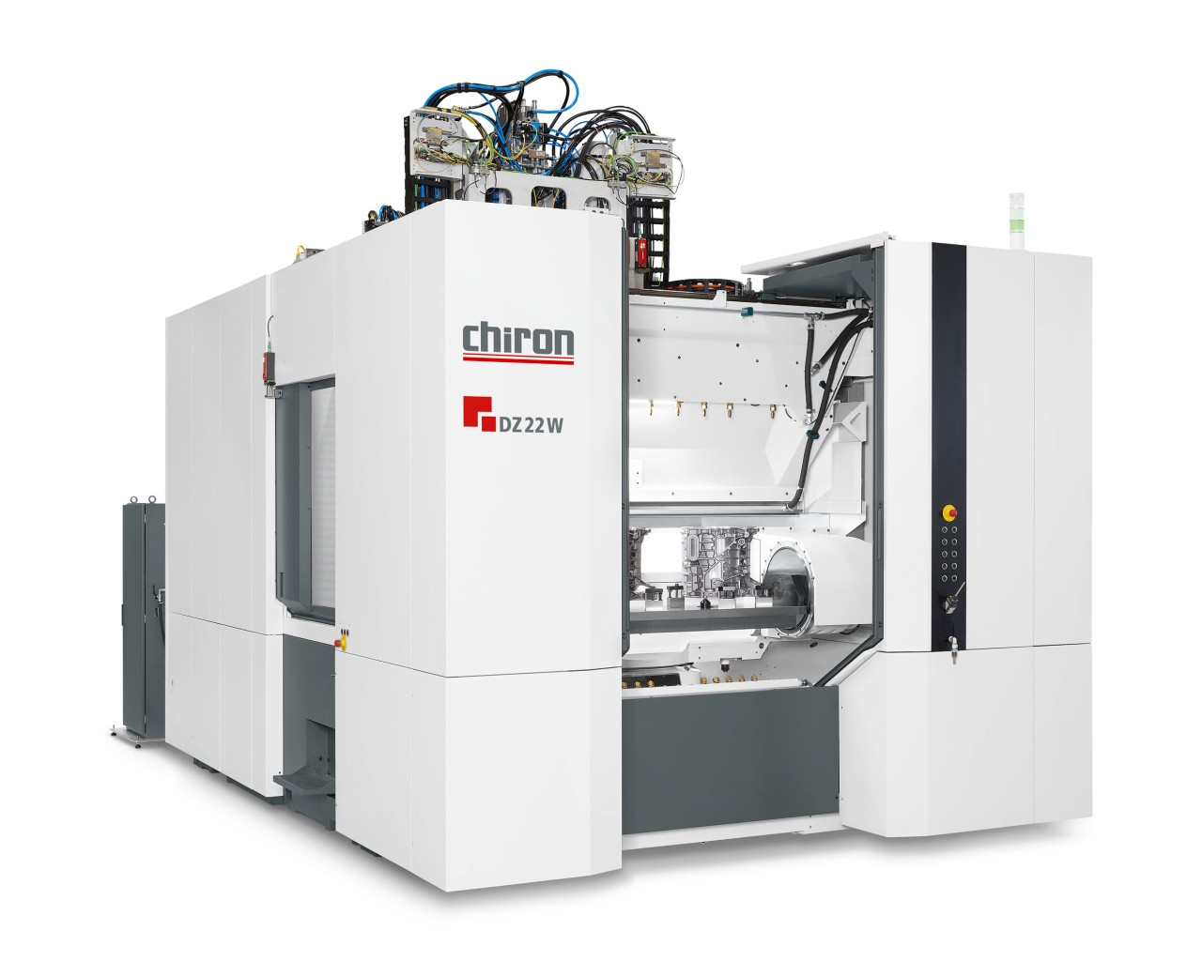
1: The machine variants of the 22 series are predestined for large quantities – here the DZ 22 W with spindle distance of 600 mm with clamped e-motor housing.

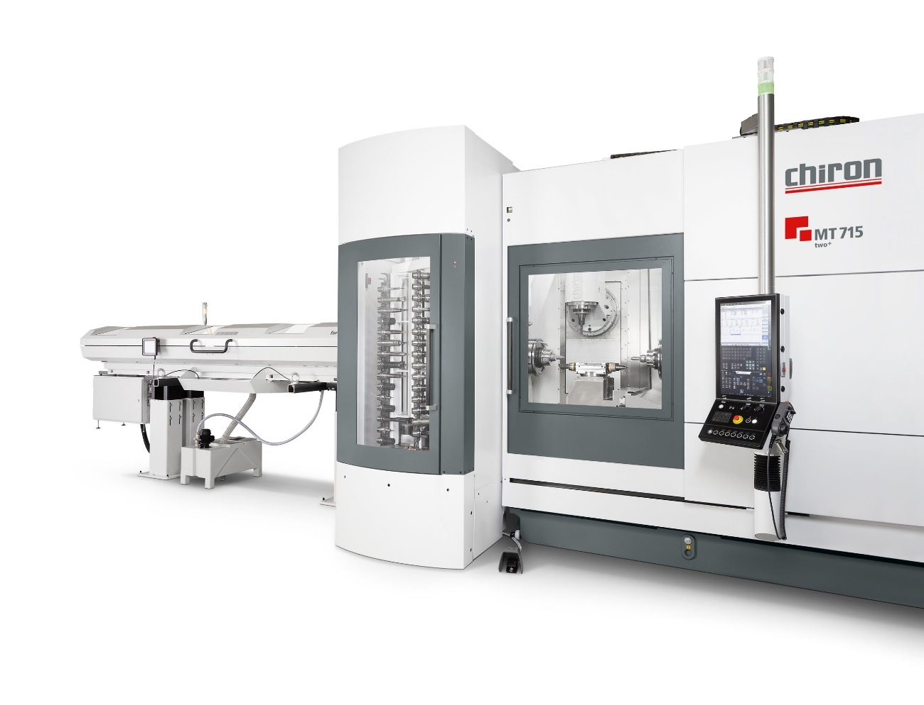

: Complete machining of six sides with a high degree of autonomy using the MT 715 two⁺ with integrated workpiece automation

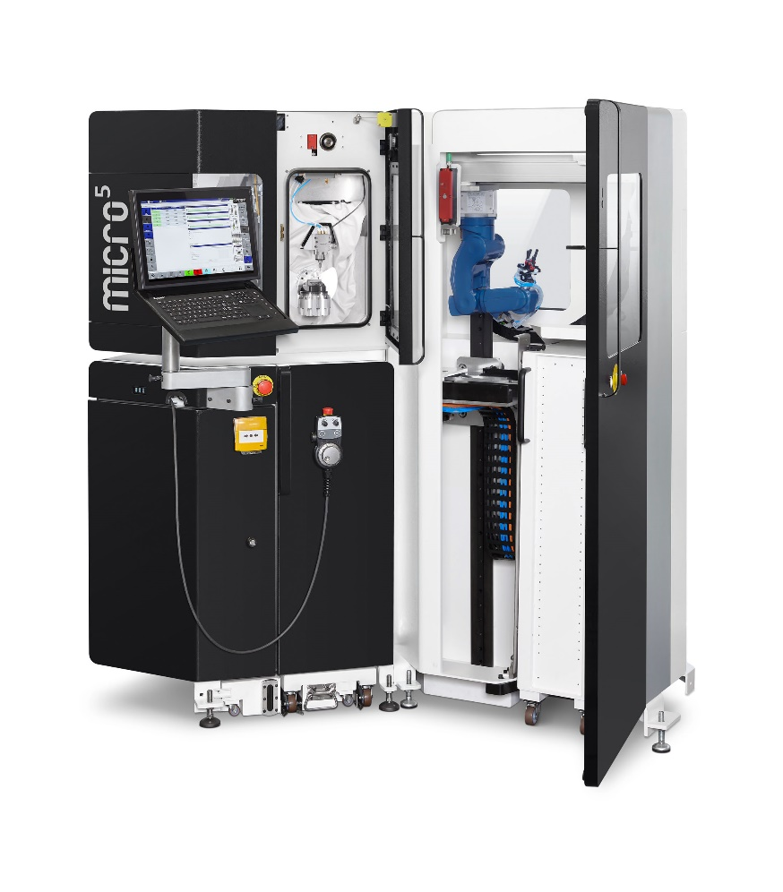
Picture 3: Smart combination of a Micro5 high-speed machining center and Feed5 automation

