May 13, 2025

**Focus on micromachining at OPEN HOUSE 2025**

**CHIRON Group presents innovative manufacturing solutions**

**“Innovations for future demands – explore our machining world premiere” – this is the motto behind the latest manufacturing solutions from the CHIRON Group. At the heart of OPEN HOUSE 2025 is the world premiere of the Micro5 XL, introducing a new dimension in micromachining with maximum precision, dynamics and resource efficiency. Other highlights: the dynamic DZ 22 W speed+ for shortest cycle times in series production, and the FZ 19 S five axis. The entire line-up can be experienced live in Tuttlingen from May 13 to 15, 2025.**

**Micro5 XL – premiere for micromachining in a new dimension**

What began with the Micro5 as a highly dynamic machining center for the finest precision parts is now being continued in a pioneering way: With the Micro5 XL, the CHIRON Group is scaling up the successful concept for further demanding applications in medical and precision technology, electronics and mold and die manufacturing.

Whether bone plates or knee inlays, bracelets or connectors, whether titanium, stainless steel or precious metals: the new micromachine processes complex, sophisticated geometries and different materials with maximum dynamics, precision and minimum cycle times.

The name Micro5 XL is, explains Senior Product Manager Michael Wurster, "not a contradiction, but a deliberate choice. As with the Micro5, the 5 stands for the ideal ratio of milling center to workpiece – in this case 600 mm to 120 mm cubic capacity. And XL, because the machining center stands for a new dimension in micromachining in several respects: for more travel distance, significantly higher cutting performance and maximum flexibility."

A common feature with the Micro5 is its minimal footprint, which is just 1.7 m2 for the Micro5 XL including magazine for up to 100 tools and peripherals. The tools are inserted via a 4-fold gripper with short chip-to-chip times and are used over their entire length thanks to machining strategies with high axial and low radial infeeds.

The Micro5 XL is operated entirely from the front and with a clear view of the process, even in the version with an integrated handling system. In this version, several machines can be arranged close together. This not only saves the cost-intensive resource of production space but also enables very ergonomic operation. The operating logic is consistent: Anyone who can program the micromachining center can also control the automation intuitively.

**Process advantages of the new Micro5 XL**

Cubature workpiece 120 x 120 x 120 mm

Travel X - Y - Z 170 - 140 - 120 mm

Rapid feed X - Y – Z 30 - 30 - 30 m/min

Axis acceleration X - Y - Z 15 - 15 - 20 m/s2

Milling spindle speed max. 50,000 min-1

Spindle interface HSK-E 25

Number of tools max. 100

B-axis swivel angle - 90°/ + 120°

Installation area incl. peripherals 1.7 m2

Weight 1,900 kg

**Top speed and top performance in series: the DZ 22 W speed+**

With the DZ 22 W speed+, the CHIRON Group is expanding its portfolio with a particularly dynamic version of the double-spindle 5-axis machining center. The new version with 600 mm spindle distance is designed for the economical complete machining of large components in series. With even greater productivity, optimized machine structure and significantly reduced non-productive times.

The performance data: 20 percent higher acceleration and a 40 percent improvement in jerk behavior for significantly faster achievement of maximum speed when changing direction – important for thread cutting, for example. In addition, the core component, the motor spindle developed in-house, has a ramp-up time of 0.5 seconds and a chip-to-chip time of 2.0 seconds. All these factors ensure a significantly faster machining process.

The increased productivity is made possible by targeted design measures. This has made it possible to achieve significantly higher dynamics with the same electrical drive power – without compromising on precision or process stability. “The demands on series production are constantly increasing,” says Senior Product Manager Markus Vollmer. “The DZ 22 W speed+ delivers the decisive plus in process efficiency, noticeably reduces non-productive times and ensures that every second of machining time is optimally utilized.”

**Power, precision, productivity: The FZ 19 S five axis**

Trade visitors can see these qualities for themselves at OPEN HOUSE 2025. In live operation, the FZ 19 S five axis produces struts for an aerospace landing gear assembly using precision tools from the cooperation partner MAPAL. For the machining of demanding materials – here titanium grade 5 – the machining center is available with an HSK-A100 interface and a maximum spindle torque of 408 Nm.

Armrests, brackets, engine mounts or airfoils are further examples from the aerospace application field where the machine variant of the Series 19 shows its strengths when machining “from the solid”. The largest magazine for up to 196 tools is recommended for complex components or part variants.

The FZ 19 S five axis impresses with its large traverse paths – 850 mm in X, 960 mm in Y and 700 mm in Z. This makes it ideal for components up to a diameter of 820 mm. In combination with perfectly matched CHIRON Group spindles, this optimum ratio of work area to workpiece dimension enables high-precision and particularly dynamic machining.

*Characters without spaces: 4.511*

**About the CHIRON Group**

The CHIRON Group, headquartered in Tuttlingen, is a global company specializing in CNC vertical milling and mill-turn machining centers, as well as turnkey manufacturing solutions. The Group has a global presence, with production and development sites, sales and service subsidiaries, and sales agencies worldwide. Around two thirds of machines and solutions that are sold are exported. Key customer sectors are the automotive, mechanical engineering, medicine and precision engineering, aerospace industries and tool production.

**Contact person for editors:**

CHIRON Group SE

Melanie Buschle

Kreuzstraße 75, 78532 Tuttlingen, Germany

Phone: +49 (0)7461 940-3255

Mail: melanie.buschle@chiron-group.com  
www.chiron-group.com

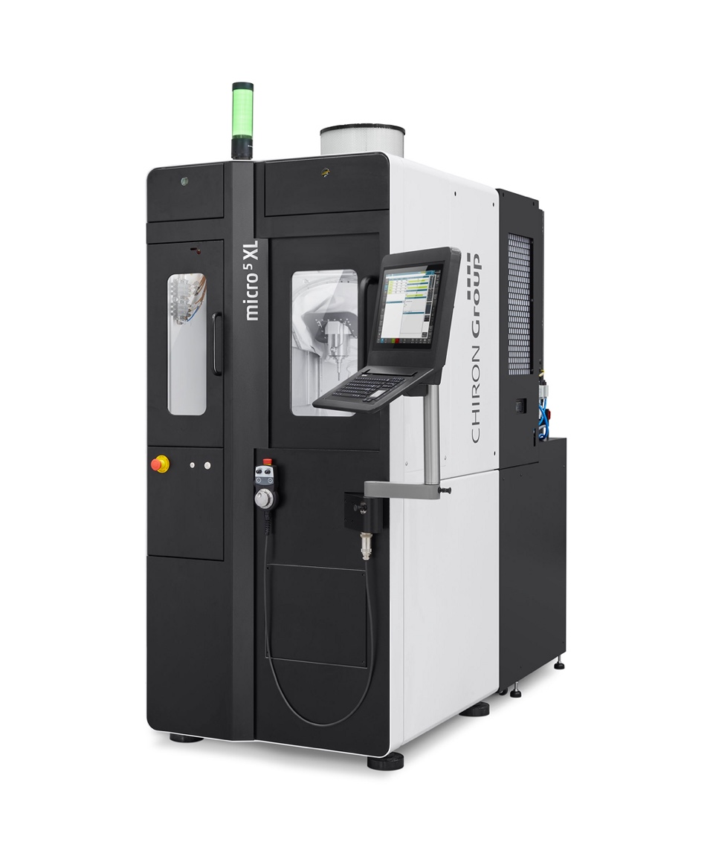

*Image 1:* Welcome to the world premiere of the Micro5 XL, the new “must have” for demanding micromachining.

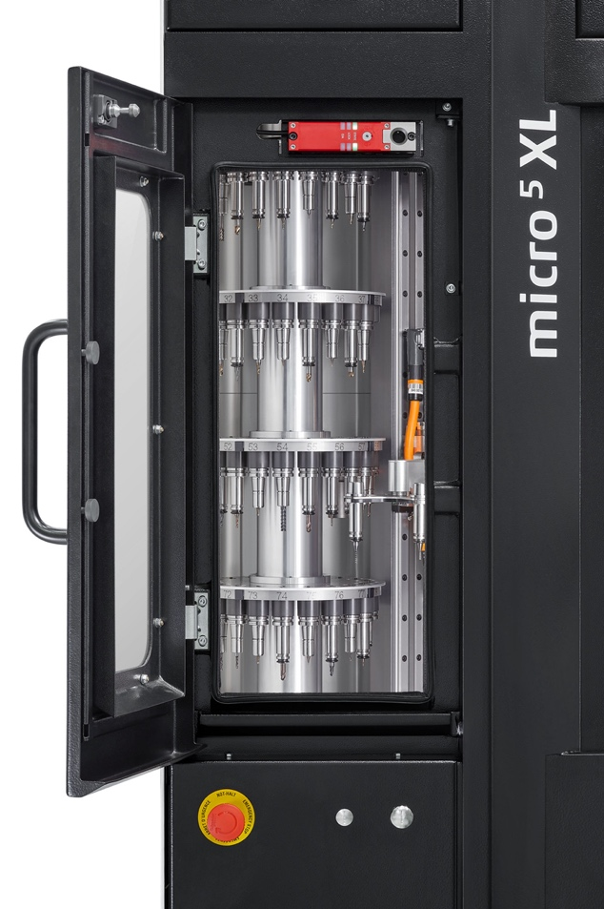

*Image 2:* Integrated into the footprint of just 1.7 m2: the optimally accessible magazine for up to 100 tools in total.

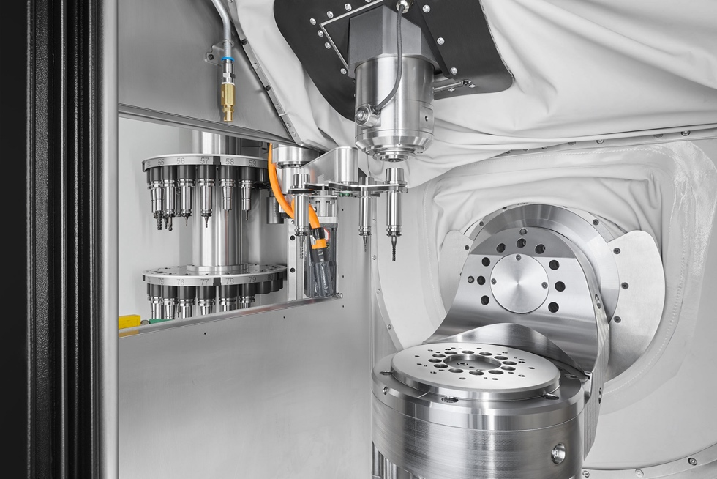

*Image 3:* Tools are changed from the tower storage via a 4-fold gripper – for short chip-to-chip times and sufficient buffer for fast follow-up operations.

Ein Bild, das Maschine, Im Haus, Stahl, Pfeife Flöte Rohr enthält.

*Image 4:* Precision machining of a titanium bone plate – example of the extended range of applications in medical technology with the Micro5 XL.

Ein Bild, das Maschine, Im Haus enthält.

*Image 5:*

The new DZ 22 W speed+ for constant top performance and top speed in the complete machining of large components in series.

Ein Bild, das Text, Design enthält.
*Image 6:* The FZ 19 S five axis stands for quality and productivity – in series production on a single-spindle machining center.

Ein Bild, das Werkzeug enthält.

*Image 7:* How stable and dynamic mills the FZ 19 S five axis? The CHIRON Group demonstrates this by machining a titanium strut for a nose landing gear.