June 02, 2025

CHIRON Group management team strengthened

Christian Kurtenbach took over the position of Chief Operations Officer (COO) of the CHIRON Group on June 1, 2025, thus strengthening the executive management of the globally operating company headquartered in Tuttlingen.

"The demands on modern industrial companies are constantly increasing: efficiency, speed and customer focus are key success factors today. With Christian Kurtenbach as COO, we are gaining a personality in operational management who not only understands processes, but also actively thinks them through – always with our strategic goals in mind," says Dr. Armin Schmiedeberg, Chairman of the Board of Directors.

Christian Kurtenbach studied mechanical and production engineering at Ulm University of Applied Sciences and is a master craftsman in precision mechanics. He joins the management team of the CHIRON Group, which in future will consist of Markus Unterstein CFO & Spokesman Group Executive Committee a.i., Dr.-Ing. Claus Eppler CTO and Christian Kurtenbach COO.

"In an industrial environment that is becoming increasingly complex and dynamic, it is crucial to constantly put our operational processes to the test. My aim is to work with the teams to develop solutions that have a lasting effect - through clear structures, measurable results and the courage to break new ground", says Christian Kurtenbach, COO of the CHIRON Group.

With his many years of experience as an independent entrepreneur, production manager and managing director, Christian Kurtenbach has the best qualifications for his new task at the CHIRON Group: he started his own business in 1993. In 2014, he moved to Gebrüder Heller Maschinenfabrik GmbH as Head of Project Management for the Management Board and developed into Production Manager and CEO of the Heller subsidiary Paatz Viernau GmbH in 2018. In 2023, he took over the position of Managing Director at Starrag AG & Starrag GmbH before taking up the new position at the CHIRON Group in June.

Markus Unterstein, CFO and Spokesman of the Group Executive Committee a.i.: "In an industrial environment like ours, operational management is not a background task – it is at the heart of our success. Together with Christian Kurtenbach as COO and Dr.-Ing. Claus Eppler as CTO, I am convinced that we have a strong team that will lead our company safely and decisively through future challenges."
About the CHIRON Group

The CHIRON Group, headquartered in Tuttlingen, Germany, is a specialist in CNC-controlled vertical milling and mill-turn machining centers as well as turnkey and automation solutions. Comprehensive services and digital solutions complete the portfolio. The Group has a global presence with production and development sites, sales and service branches and commercial agencies. Around two thirds of the machines and solutions sold are exported. The main user industries are the automotive industry, mechanical engineering, medical and precision technology, aerospace and tool manufacturing.

Contact person for the editorial team:

CHIRON Group SE
Matthias Rapp
Kreuzstrasse 75
78532 Tuttlingen

Phone: 07461 940-3181
E-mail: matthias.rapp@chiron-group.com
www.chiron-group.com

Captions

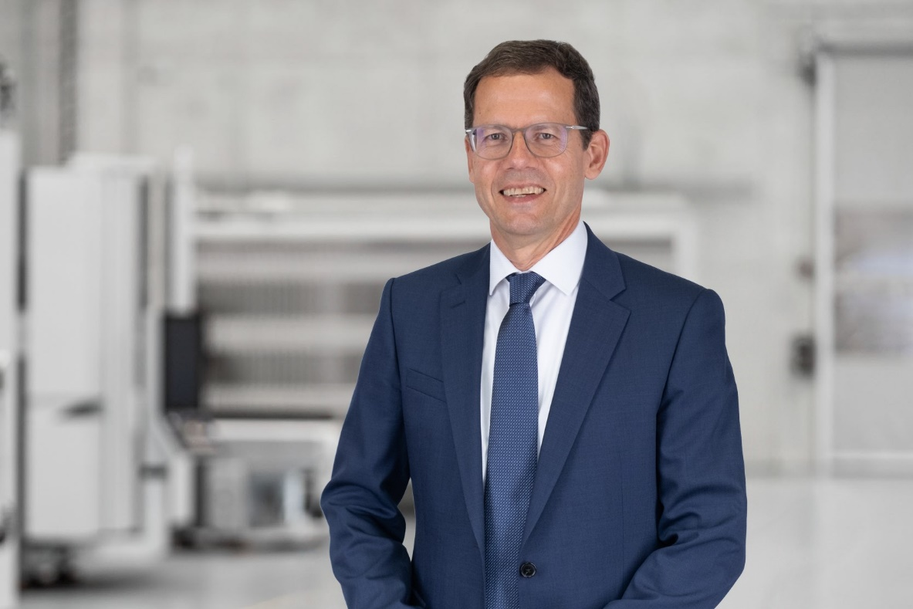

Image 1: Christian Kurtenbach has been the new COO of the CHIRON Group since June 1, 2025.

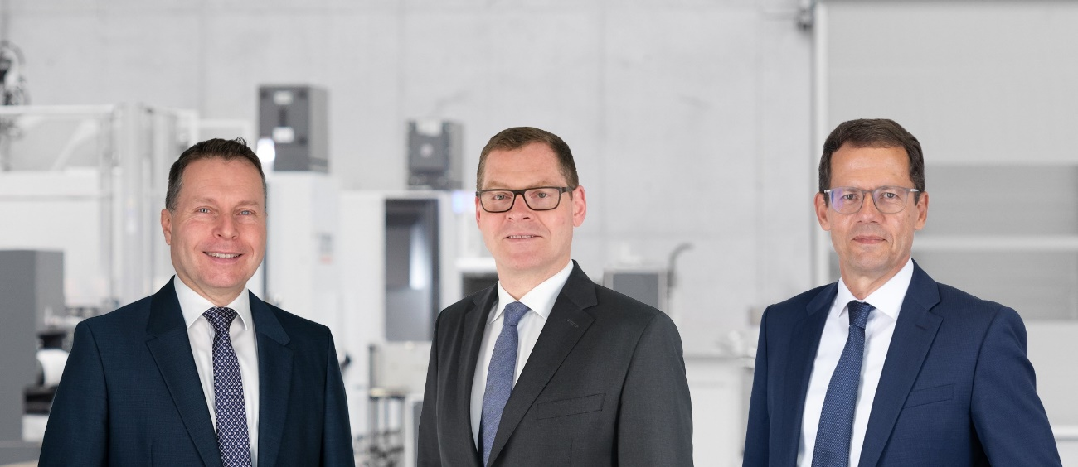

Image 2: The management team of the CHIRON Group (from left to right): Dr. Claus Eppler CTO, Markus Unterstein CFO & Spokesman GEC a.i and Christian Kurtenbach COO.

