July 1, 2025

Sustainability report 2024 of the CHIRON Group

The new sustainability report of the CHIRON Group deliberately bears the same title as last year's report – "WE ARE ONE". This title emphasizes the continued commitment of the CHIRON Group and its teams at the international sites to consistently move forward together the path toward a more sustainable future. The report shows how ecological and economic goals can be successfully combined even in challenging times – in a concrete, transparent and comprehensible way.

The 2024 report focuses on progress in CO₂ reduction in Scope 1, 2 and 3, new initiatives such as the photovoltaic systems at the global sites and the complete green electricity supply in Germany. These developments highlight that sustainability is not just a goal, but an integral part of the corporate strategy of the CHIRON Group.

"Together all around the world" – for the environment, for success
Under this guiding principle, the CHIRON Group is a global network that is becoming ever more closely interlinked. The Group consistently pursues its global growth strategy and at the same time strengthens its responsibility as a company that contributes to ecological change through sustainable manufacturing technologies and innovative solutions.

The Sustainability report 2024 illustrates the specific measures the CHIRON Group is implementing at its global sites to reduce its carbon footprint and promote resource-efficient manufacturing. In addition to centrally managed measures, there are a large number of local initiatives that make a significant contribution to the global sustainability goals.

In Neuhausen, for example, an additional reprocessing system for cooling lubricants was installed, which significantly reduces the use of lubricating oil, chemicals and water. CHIRON Czech covers a large part of its energy needs from renewable sources, and the site in Taicang, China, has been officially recognized for its achievements in energy savings, resource efficiency and environmental protection. With its repair service for motor spindles, Zadar in Croatia ensures extended product use of the central component in the machining centers of the CHIRON Group and thus also contributes to greater sustainability for customers.

Innovation for resource-optimized manufacturing
The Micro5 XL is a convincing example of the innovative strength of the CHIRON Group in sustainable manufacturing. This new micromachining center stands for resource-optimized production in every respect. With low energy consumption, maximum precision and high productivity in a very compact footprint: the Micro5 XL actively contributes to reducing the ecological footprint. "The Micro5 XL stands for the continuous development of our portfolio with products that meet current and future demands. This enables our customers to make their manufacturing processes sustainable while remaining competitive," explains CTO Dr. Claus Eppler.

Measurable success and continued ambitious goals
In 2023, the CHIRON Group has set ambitious emission reduction targets as part of the Science Based Targets Initiative (SBTi). These include a 50 percent reduction in CO₂ emissions in Scope 1 and 2 by 2028, starting from the base year 2018. At the same time, the aim is to reduce CO₂ emissions in Scope 3 by 25 percent within the same time frame. "The SBTi-certified targets give us a clear direction and a concrete roadmap for how we can further reduce our carbon footprint," says Dr. Claus Eppler.

The CHIRON Group will continue to invest in sustainable technologies and processes in the coming years and pursue its ambitions intensively.
"The willingness to face global challenges and take responsibility together is one of our strengths. Only with the commitment and cooperation of everyone can we successfully shape the transformation towards a more sustainable future," emphasizes Markus Unterstein, CFO of the CHIRON Group.

The Sustainability Report 2024 is now available online.

Sustainability Report 2024

Characters with spaces: 3,993
About the CHIRON Group

The CHIRON Group, headquartered in Tuttlingen, Germany, is a specialist in CNC-controlled vertical milling and mill-turn machining centers as well as turnkey and automation solutions. Comprehensive services and digital solutions complete the portfolio. The Group has a global presence with production and development sites, sales and service branches and commercial agencies. Around two thirds of the machines and solutions sold are exported. The main user industries are the automotive industry, mechanical engineering, medical and precision technology, aerospace and tool manufacturing.

Contact for the editorial team:

CHIRON Group SE
Melanie Buschle
Kreuzstrasse 75
78532 Tuttlingen

Phone: 07461 940-3255
E-mail: melanie.buschle@chiron-group.com
www.chiron-group.com

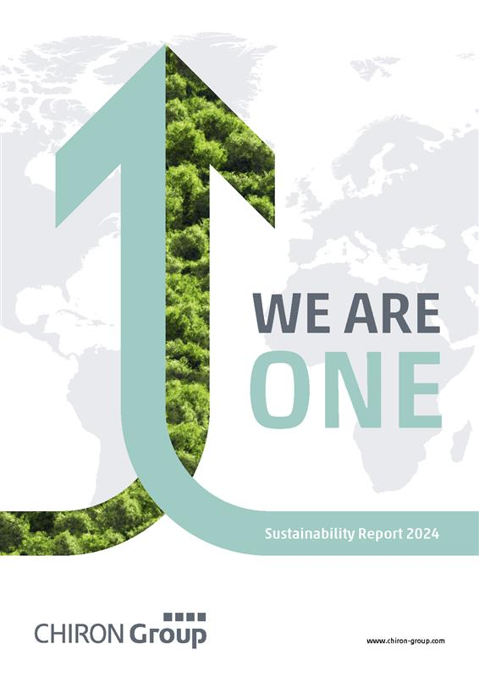
Image 1: "WE ARE ONE": The title of the 2024 report underlines that the CHIRON Group is a strong unit in terms of its commitment to sustainability.

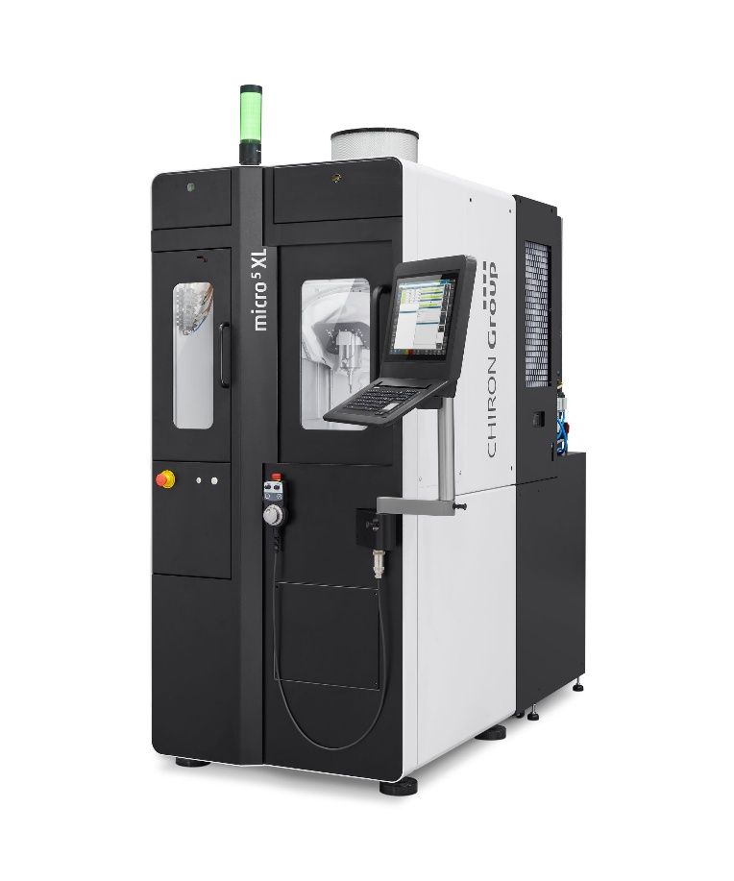
Image 2: The new micromachining center Micro5 XL stands for resource-optimized production in every respect.

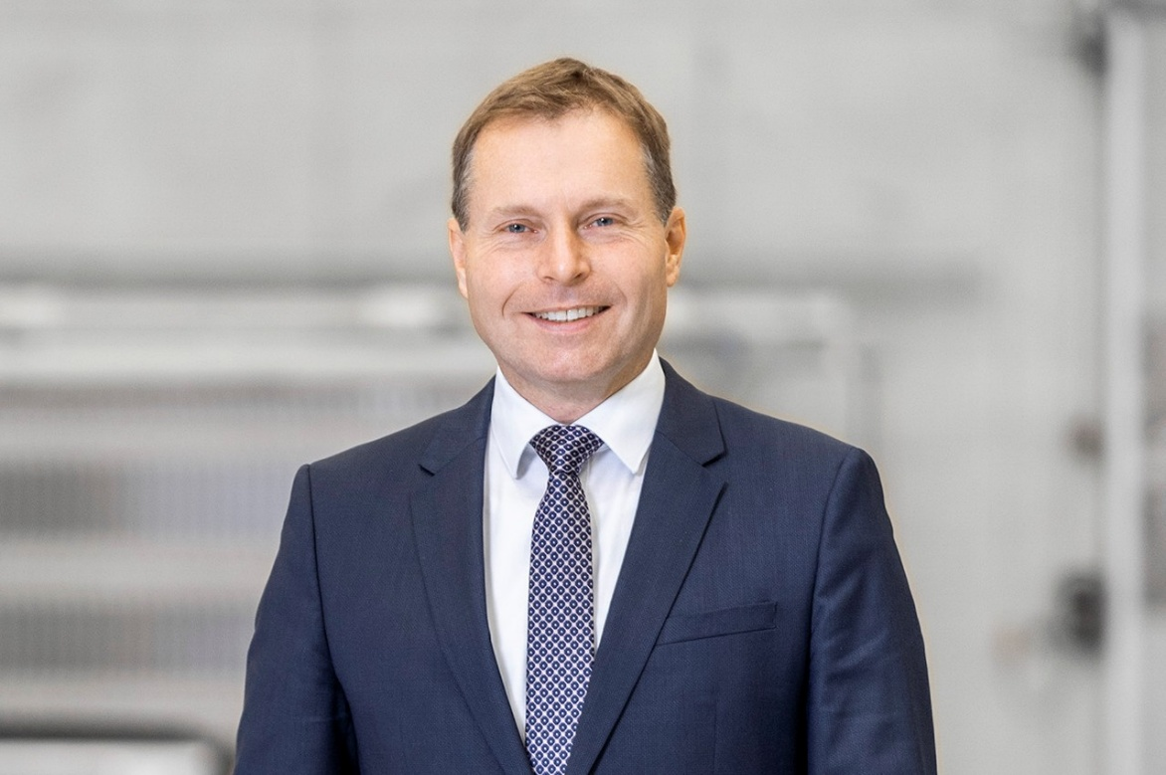
Image 3: Dr.-Ing. Claus Eppler, CTO of the CHIRON Group

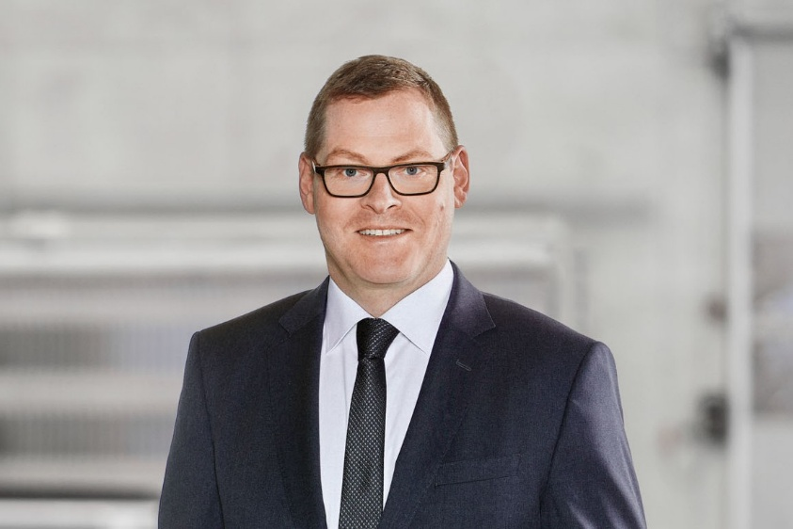

Image 4: Markus Unterstein, CFO of the CHIRON Group and Spokesman of the Group Executive Committee a.i.

