July 1, 2025

**CHIRON Group at EMO Hannover 2025:**

**Partner for tomorrow's manufacturing**

**From September 22 to 26, 2025, Hannover will once again become the global hub for production technology. The world’s leading trade fair for metalworking is celebrating its 50th anniversary, and the CHIRON Group will of course be there to showcase its expertise in both technology and consulting. Under the motto “Your Partner for Next-Generation Manufacturing”, the company will present its latest advancements for precision, cost-effective, and future-ready manufacturing processes.**

Volatile markets, rising quality and traceability requirements, skills shortages, and increasing investment pressure shape the economic environment of many manufacturing companies. As a result, investments require more than ever partners who provide comprehensive solutions for individual manufacturing tasks. The CHIRON Group sees itself as exactly that partner: with experience, expertise, innovation, and the goal of making its customers' manufacturing processes sustainably successful and economically efficient.

A key feature of trade fair presence is live experience: While many exhibitors only present their exhibits virtually, the CHIRON Group showcases machining centers live in action. This makes precision, dynamics, and process security directly tangible – especially in demanding applications and materials.

**Micro5 XL – micro machining in a new dimension**

One of the highlights at the booth: the new Micro5 XL, which will make its first major appearance to an international audience after its successful premiere at the OPEN HOUSE. The machining center consistently builds on the proven Micro5 concept, pushing its capabilities further to offer expanded options for high-dynamic micro machining in medical and precision engineering, electronics, and other challenging applications. The micro machine achieves jerk values of up to 900 m/s³, enabling excellent path and machining speeds with the highest precision.

At EMO 2025, the CHIRON Group will present the machining center in live operation with tailor-made automation for the first time. The combination enables more autonomy for both variant and series manufacturers while maintaining a small footprint. Especially relevant for daily practice: The consistent, intuitive control of the machining center and automation.

Another Highlight: The FZ 19 S five axis shows how power, precision and productivity can be perfectly combined in 5-axis machining of high-strength materials. In live operation, the single-spindle machining center will process a key component for aerospace. For machining demanding materials, the FZ 19 S five axis is equipped with an HSK-A100 interface and delivers a maximum spindle torque of 408 Nm. CHIRON Group motor spindles, various rotary table packages and magazines for up to 196 tools are further plus points to maximize customer benefit through application-oriented configuration.

**Discover series and technologies digitally – in the “Interactive Showroom”**

In addition to the live presentations, the “Interactive Showroom” offers a complete overview of the technology portfolio of the CHIRON Group. Here, the new DZ 22 W speed+ celebrates its digital premiere, a particularly dynamic version of the double-spindle 5-axis machining center for the economical complete machining of the large components in series. The online presentation is complemented by the machine pool, which includes overhauled used and new stock machining centers from the CHIRON Group – the ideal solution for a quick, cost-effective upgrade of manufacturing with proven cutting-edge technology.

**Comprehensive expertise from a single source**

At Booth C 50 in Hall 12 the CHIRON Group will also provide information about its entire range of solutions – at various competence areas and through personal discussions with experts on-site. Whether it's automation from flexible to customized, in-house spindle technology for optimum performance, services for maximum machine availability, or the smart financing option PerformanceFinance: the CHIRON Group offers everything from a single source.

“At EMO 2025, we aim to demonstrate how we fulfill our commitment to being ‘Your Partner for Next-Generation Manufacturing’ in every way: with future-proof manufacturing technologies, personalized consultation, and solutions that precisely match our customers' requirements – both now and in the future,” says Matthias Rapp, Vice President of Global Marketing at CHIRON Group.

Register and schedule a meeting at:

<https://chiron-group.com/news/exhibitions-and-events/emo-2025>

More information about the new Micro5 XL you will find here:

<https://chiron-group.com/products/micro5xl>

*Characters with spaces: 4.678*

**About the CHIRON Group**

The CHIRON Group, headquartered in Tuttlingen, is a global company specializing in CNC vertical milling and mill-turn machining centers, as well as turnkey manufacturing solutions. The Group has a global presence, with production and development sites, sales and service subsidiaries, and sales agencies worldwide. Around two thirds of machines and solutions that are sold are exported. Key customer sectors are the automotive, mechanical engineering, medicine and precision engineering, aerospace industries and tool production.

**Contact person for editors:**

CHIRON Group SE

Melanie Buschle

Kreuzstraße 75, 78532 Tuttlingen, Germany

Phone: +49 (0)7461 940-3255

Mail: melanie.buschle@chiron-group.com  
www.chiron-group.com

Ein Bild, das Mann, Kleidung, Schuhwerk, Person enthält.

*Image 1:* “Your Partner for Next-Generation Manufacturing”: Under this motto, the CHIRON Group invites visitors to engage in conversation and learn more about solutions for future manufacturing requirements.

Ein Bild, das Kleidung, Mann, Person, Anzug enthält.

*Bild 2:* A highlight at the OPEN HOUSE and at the EMO-Booth C 50 in Hall 12: the new Micro5 XL, with which the CHIRON Group has scaled its successful micro machining concept for even more demanding tasks.

Ein Bild, das Maschine, Im Haus, Stahl, Pfeife Flöte Rohr enthält.

*Image 3:* Precision machining of a titanium bone plate – an example of the expanded application range of the Micro5 XL in medical technology.

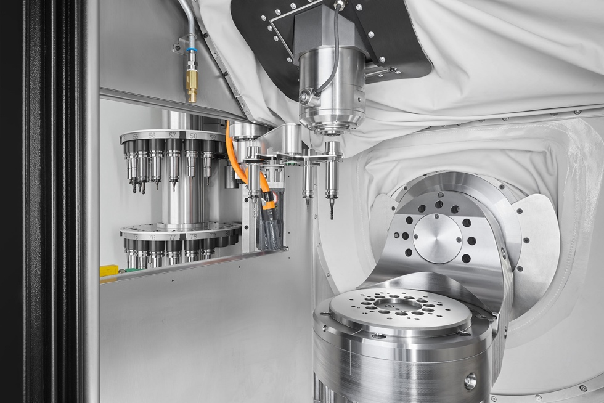

*Image 4:* Tool changes from the tower storage are performed via a 4-fold gripper – ensuring short chip-to-chip times and providing sufficient buffer for fast subsequent operations.

Ein Bild, das Text, Design enthält.

*Image 5:* The FZ 19 S five axis stands for quality and productivity in large batch production. Seen in live operation machining a key component for aerospace.

Ein Bild, das Maschine, Im Haus enthält.

*Image 6:* Premiering in the “Interactive Showroom”: the new DZ 22 W speed+ for consistent top performance and top speed complete machining of large components in series.