July 23, 2025

Gold and silver for CHIRON Group apprentices
Double victory at the German Championship 2025 in CNC milling

The CHIRON Group is not only one of the most innovative and technologically leading manufacturers of vertical machining centers. The company also has the best-trained young talent: At the WorldSkills Germany vocational competitions in CNC milling, two of the company's young talents stood on the winner's podium with gold and silver.

From July 7 to 18, 2025, the CHIRON Group hosted the grand finale of the German CNC Milling Championship at the company's headquarters in Tuttlingen. Twelve young talents from Germany had previously qualified in two demanding preliminary rounds. In the end, two CHIRON Group trainees stood at the top of the podium: Nico Bosch, an industrial mechanic in his third year of training, won gold and secured the German championship title. Niklas Steinhauser, also in his third year of apprenticeship and a prospective cutting machine operator at the CHIRON Group, won silver. Two bronze medals went to Lukas Poggel from Mematek GmbH and Fabio Kessler from Paul Horn GmbH.

Intensive preparation – top performances in the final
Preparation for the competition began in the spring with targeted training in CAD/CAM and on the machines. New this year: For the first time, the competition has been opened to other CAD/CAM systems. In addition to Mastercam, which is used in international competitions, the participants were also able to use other systems such as SolidCAM. Two intensive qualifying rounds Tuttlingen followed in May and June – the twelve best qualified for the final in July.

The final task was a tough one: A complex assembly consisting of a base plate, half-moon mount and three claws not only had to be programmed and milled, but also assembled to fit precisely. Special tools and an auxiliary device – the use of which was not known in advance – were also put to the test by the participants. "These are high-precision parts that you first have to be able to manufacture with this precision – and under considerable time pressure. This shows the high level of WorldSkills," emphasized Steffen Sigrist, skills expert and trainer at the CHIRON Group.

Proud of strong training and young talent
Great joy at the official award ceremony on July 18 – especially for training manager Herbert Mattes and CTO Dr. Claus Eppler: "All participants did an extraordinary job. My respect goes to everyone who took on this challenging competition. And especially our two winners, who represented the CHIRON Group excellently. The result underlines the high quality of our training and shows that we are ideally positioned for the future with such committed specialists."

The two winners also drew a positive conclusion: "The competition showed me how crucial clean and precise work is – both in programming and milling," explains 19-year-old Nico Bosch, German champion in CNC milling. "Dealing with stress was also a real challenge. I've learned to trust myself and be confident in what I'm doing – that's the only way to stay focused and work crash-free in the end."
Niklas Steinhauser (20), who won silver, adds: "What I have definitely learned: to stay calm and focused under time pressure - and yet to work quickly and precisely. It was an intense, but incredibly instructive time. I learned that you can achieve a lot with the right support and personal ambition."

International exchange at the highest level
The best of the competition will now move on to the next round: they will be accepted into the national CNC milling team. After further joint training for the upcoming international vocational competitions, a decision will be made as to who will represent Germany at WorldSkills 2026 in Shanghai and EuroSkills 2027 in Düsseldorf.

Parallel to the final, a cross-border comparison competition took place in Tuttlingen – in preparation for EuroSkills 2025 in Herning, Denmark. Participants from Germany, Liechtenstein and the Czech Republic also faced the final tasks as well as a special "challenge" in which a workpiece had to be programmed and manufactured in just 4.5 hours without specification.

Sustainable commitment to the future
As a founding member of WorldSkills Germany e.V. and a long-time host of the CNC milling competition, the CHIRON Group is consistently committed to promoting young talent. In addition to modern infrastructure and technical know-how, this also includes personal commitment: Steffen Sigrist will accompany the German participation at the international level together with Herbert Mattes as a technical expert. An investment in the future – for the CHIRON Group, for the next generation of the industry and for Germany as an industrial location.

An insight into the competition can be found here: https://youtu.be/HTWrTBVb9KI

About the CHIRON Group

The CHIRON Group, headquartered in Tuttlingen, Germany, is a specialist in CNC-controlled vertical milling and mill-turn machining centers as well as turnkey and automation solutions. Comprehensive services and digital solutions complete the portfolio. The Group has a global presence with production and development sites, sales and service branches and commercial agencies. Around two thirds of the machines and solutions sold are exported. The main user industries are the automotive industry, mechanical engineering, medical and precision technology, aerospace and tool manufacturing.

Contact for the editorial team:

CHIRON Group SE
Melanie Buschle
Kreuzstrasse 75
78532 Tuttlingen

Phone: 07461 940-3255
E-mail: melanie.buschle@chiron-group.com
www.chiron-group.com

Captions

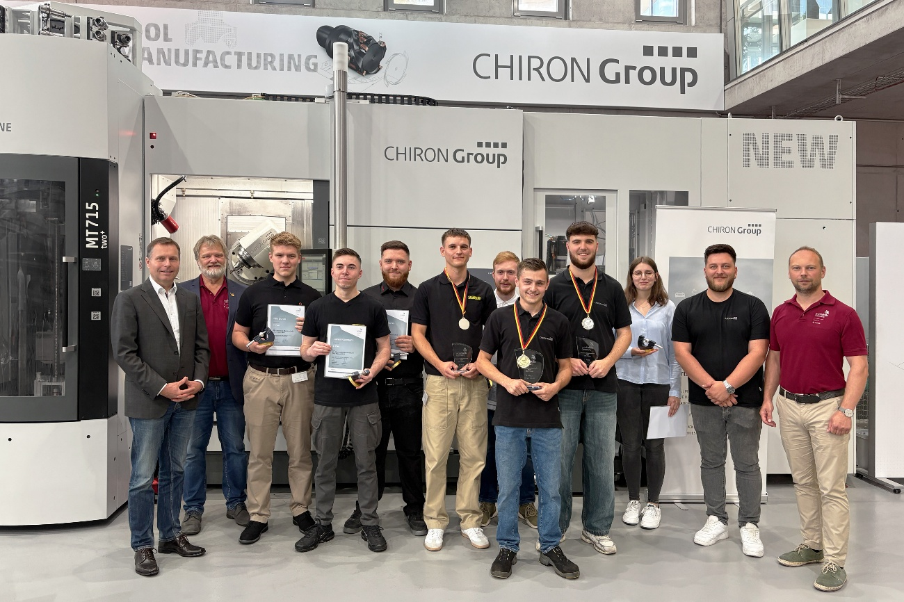

Image 1: The finalists of the German Championship 2025 in CNC milling with CTO Dr. Claus Eppler (left), training manager Herbert Mattes (2nd from left), trainer and skills expert Steffen Sigrist (2nd from right) and Stephan Paschke, board member of WorldSkills Germany (right).

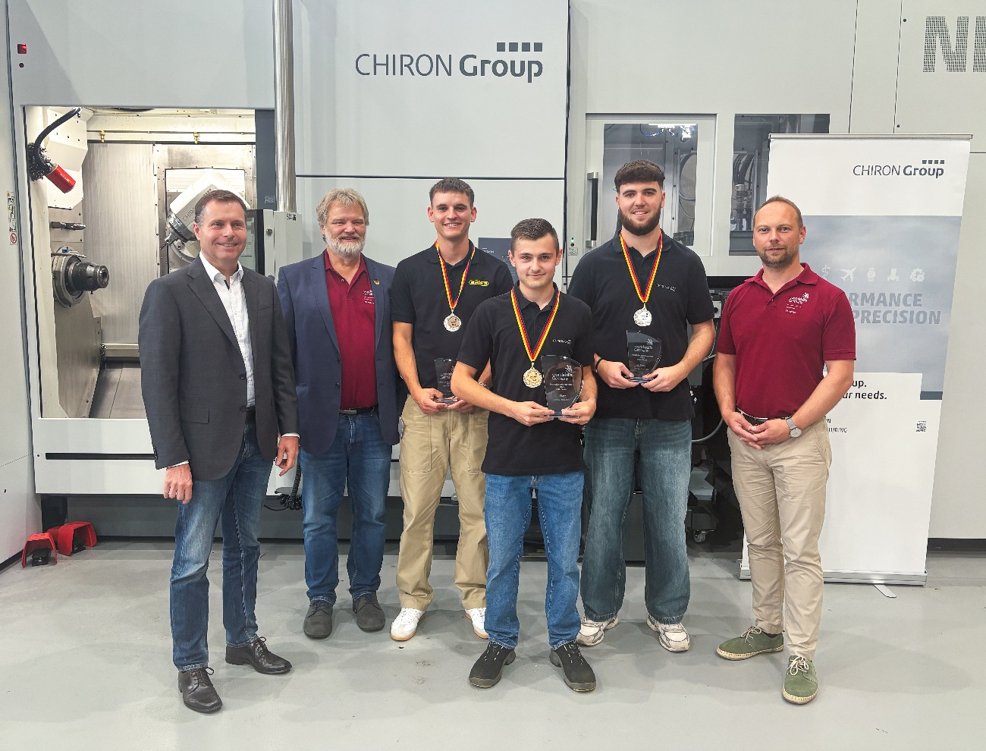

Image 2: Spotlight on the winners: Nico Bosch (front), German champion in CNC milling, Niklas Steinhauser (2nd from right), runner-up – both from CHIRON Group SE – and Fabio Kessler (3rd from left), bronze winner from Paul Horn GmbH.

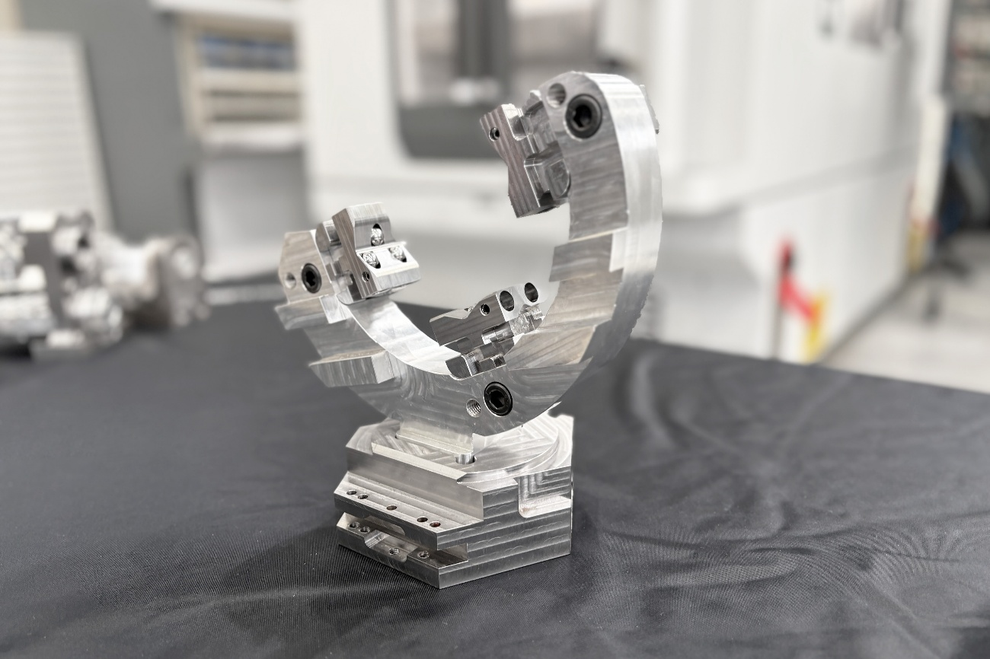
Iamge 3: The final task: A complex assembly consisting of a base plate, half-moon holder and three claws had to be manufactured precisely and assembled precisely.

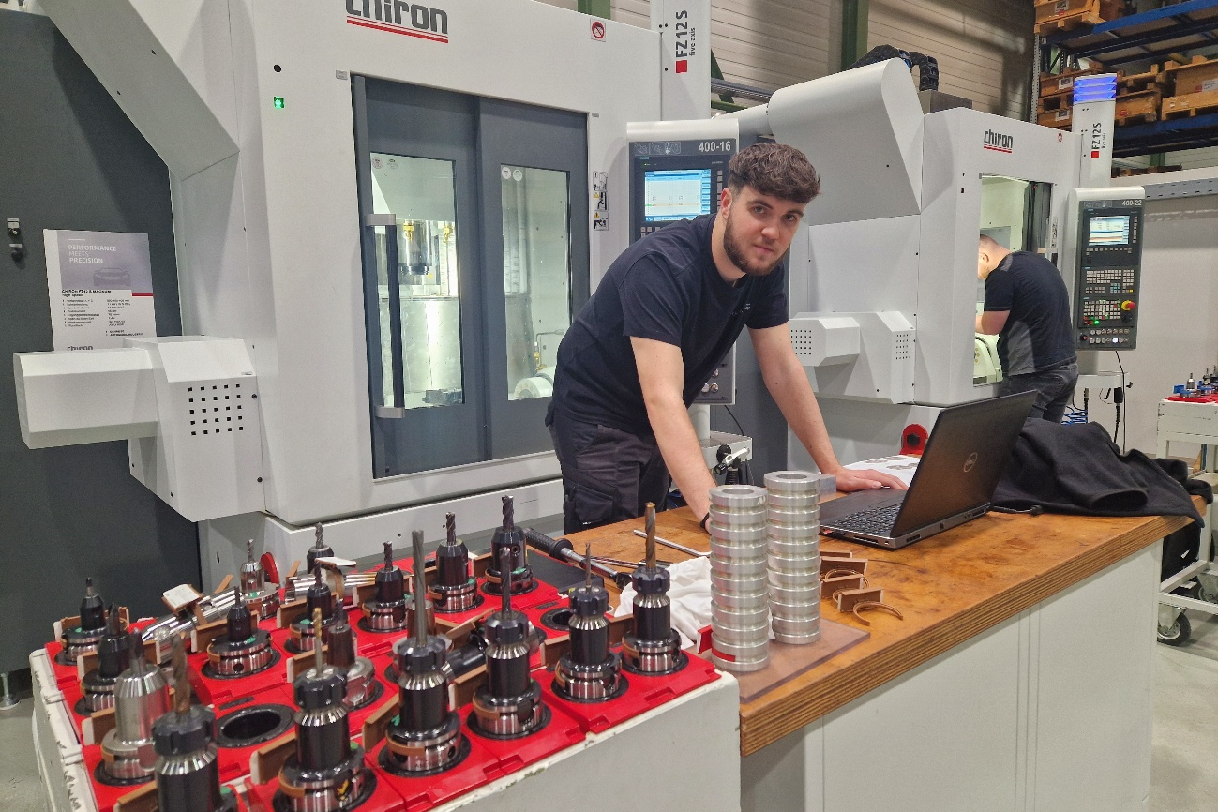
Image 4: Full concentration required: programming, set-up, set-up, milling and quality control – all precise and under high time pressure.

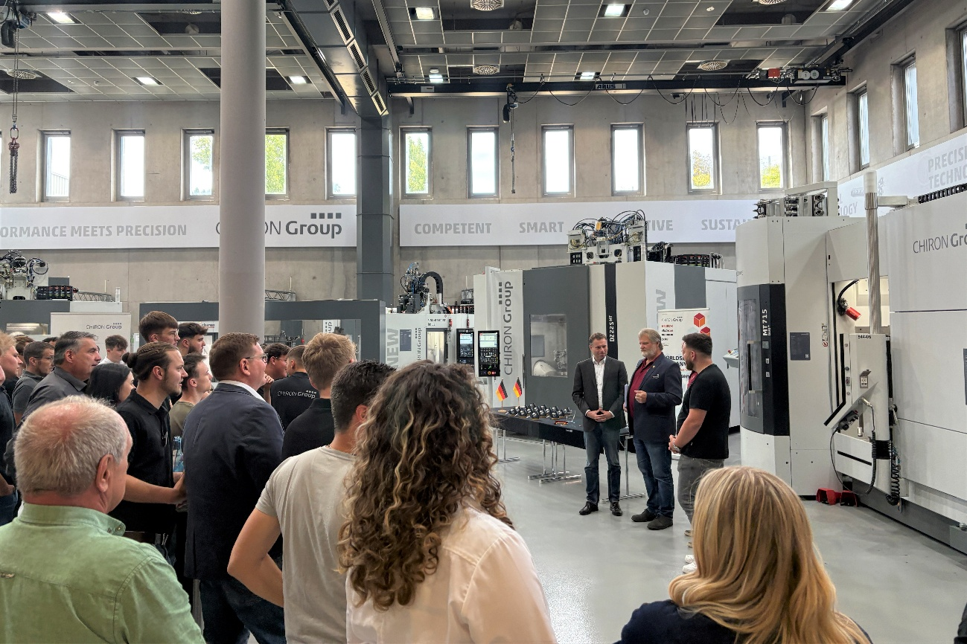
Image 5: Excitement at the WorldSkills Germany award ceremony: Who will be Germany's best young talent in the CNC milling competition discipline?

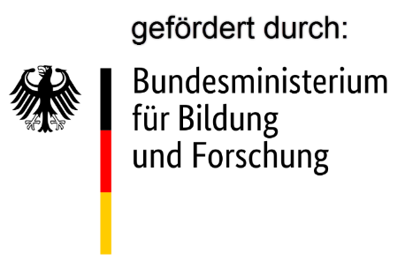
Image 6: Funded by: Federal Ministry of Education and Research

