October 02, 2025

Successful appearance of the CHIRON Group at EMO 2025
„Your Partner for Next-Generation Manufacturing“

Around 80,000 trade visitors from all over the world took the opportunity at EMO 2025 to discuss the latest developments and gain inspiration for their future production needs. For the CHIRON Group, the trade fair appearance was a complete success: The company showcased four machining centers live under cutting conditions on a compact 450 m² space, along with tailored automation solutions – and received highly positive feedback from international decision-makers.

The CHIRON Group impressively demonstrated what partnership-based cooperation with a view to the production of the future looks like: with a presentation that covered the entire spectrum of modern, efficient production. From micromachining for medical technology, watches and jewelry or the electrical industry to the complete machining of complex turbine components for aerospace and highly productive automotive and mechanical engineering applications, precision, dynamics and process reliability could be experienced in real processes. A truly unique selling point at the trade fair, as only a few exhibitors demonstrated real milling and mill-turn processes – with chips, live and in a hands-on setting.

World premiere in micromachining: the Micro5 XL with automation
The Micro5 XL, which celebrated its official premiere in front of an international audience at EMO 2025, was a crowd-puller. The "XL" stands for a new dimension in micromachining: more travel distance, increased cutting performance and maximum flexibility. The Micro5 XL machines workpiece cubatures of up to 120 mm on a footprint of just 1.7 m² – with highly dynamic BC 5-axis kinematics, spindle speeds of 40,000 or 50,000 rpm and jerk values of up to 900 m/s³.

The Micro5 XL demonstrated its strengths in 5-axis simultaneous HSC machining on the "Bone Watch" demonstration part – a base with a watch case and bracelet in the style of several bone plates arranged in a row: filigree structures, excellent surface quality and reproducible precision.
The new Variocell PICK&PLACE automation variant was responsible for feeding the raw parts into the clamping device and placing the finished bone watches in the storage unit. The productive combination is supplied as a unit and can be put into operation immediately – plug and play. The pallet trolley offers space for up to 12 pallets measuring 400 x 300 mm and a height of up to 50 mm on a very compact footprint. A key advantage: the operating logic is identical to the Micro5 XL. It is operated from the front with the best view of the milling process, and several production units can be positioned in close succession – production can simply grow with the quantities.

Successful Micro5 model: Benchmark in micromachining
The Micro5 is the most successful micro machine on the market and the basis for the new XL version. Weighing just 550 kg and with a 230 V connection, it can be flexibly integrated into almost any production environment. Despite its ultra-compact footprint, it impresses with its high static and mechanical rigidity and delivers the required precision for the most demanding geometries. In live operation at EMO 2025, the Micro5 produced the finest connectors for aerospace and proved why it has been the benchmark in micromachining since its market launch.

Highly productive machining: DZ 15 W with Variocell UNO
With the DZ 15 W, the CHIRON Group presented a twin-spindle machining center that combines productivity, flexibility and autonomy in a compact space. The in-house developed rotary table with direct drive positions 360° in less than a second – wear-free, precise, without backlash. Two exemplary processes were on display on both sides of the table: the production of aluminum pump housings for the automotive industry and the manufacture of cast iron fan covers for mechanical engineering.

Thanks to the double spindle and automation with a Variocell UNO, the machining process continues on one side while loading and unloading takes place in parallel. The result: processes parallel to machining time, continuous parts supply and optimum use in shift operation.

The automation unit with workpiece storage and changing device ensures short cycle times and high autonomy – and extends the application possibilities of the DZ 15 W beyond large series.

Five processes, one continuous process with the FZ 19 S five axis
Whether aerospace, energy or mechanical engineering: The FZ 19 S five axis is designed for high-speed cutting of high-strength materials in demanding applications. In live operation, trade visitors were able to follow all the production steps of an exemplary turbine housing: Rough machining of the raw part, turning of contours and diameters, skiving for precise gear cutting, drilling of fits in high-strength material as well as simultaneous 5-axis milling of free-form surfaces and complex, high-precision geometries.

The gantry moving portal design ensures high static and dynamic rigidity, while the active cooling of all components guarantees stable temperature management and thus ensures process stability even with long machining times.

Complete expertise – added value for sustainably productive processes
In addition to the live demonstrations, the CHIRON Group presented its complete range of services. In the interactive showroom, the broad technology portfolio and the machine pool with reconditioned used and available existing machines were presented – a quick and cost-efficient way to modernize your own production.

The experts at the booth also provided advice on key competencies that make manufacturing solutions even more efficient and sustainable: the SmartLine digital systems for greater efficiency, availability and productivity. The Services division provided information on the comprehensive portfolio with services such as spindle repair, overhaul and optimization, coordinated service agreements, the myCHIRON customer portal with e-shop for spare parts and refurbishment solutions – for a productive second machine life for proven machining centers.

At the end of the leading international trade fair for production technology, Matthias Rapp, Vice President Global Marketing, summarized: "EMO 2025 was a complete success for the CHIRON Group. We are very satisfied with the quality of the leads and were able to make valuable new contacts. The great interest shown by international visitors was particularly pleasing – we held many discussions with companies from Asia, North America and Europe. Our innovations such as the Micro5 XL with Automation Variocell PICK&PLACE met with enormous interest and the feedback was consistently positive. The discussions confirmed this: Automation and sustainable production remain key topics in the industry – and we are addressing them convincingly."

Characters with spaces: 6,847
About the CHIRON Group

The CHIRON Group, headquartered in Tuttlingen, Germany is a global company specializing in CNC vertical milling and mill-turning machining centers, as well as turnkey and automation solutions. Comprehensive services, digital solutions and products for additive manufacturing complete the portfolio. The Group has a global presence, with production and development sites, sales and service subsidiaries, and sales agencies worldwide. Around two thirds of machines and solutions that are sold are exported. Key customer sectors are the automotive, mechanical engineering, medicine and precision engineering, aerospace industries, as well as tool manufacturing.

Contact for the editorial team:

CHIRON Group SE
Melanie Buschle
Kreuzstrasse 75
78532 Tuttlingen

Phone: 07461 940-3255
E-mail: melanie.buschle@chiron-group.com
www.chiron-group.com

Captions

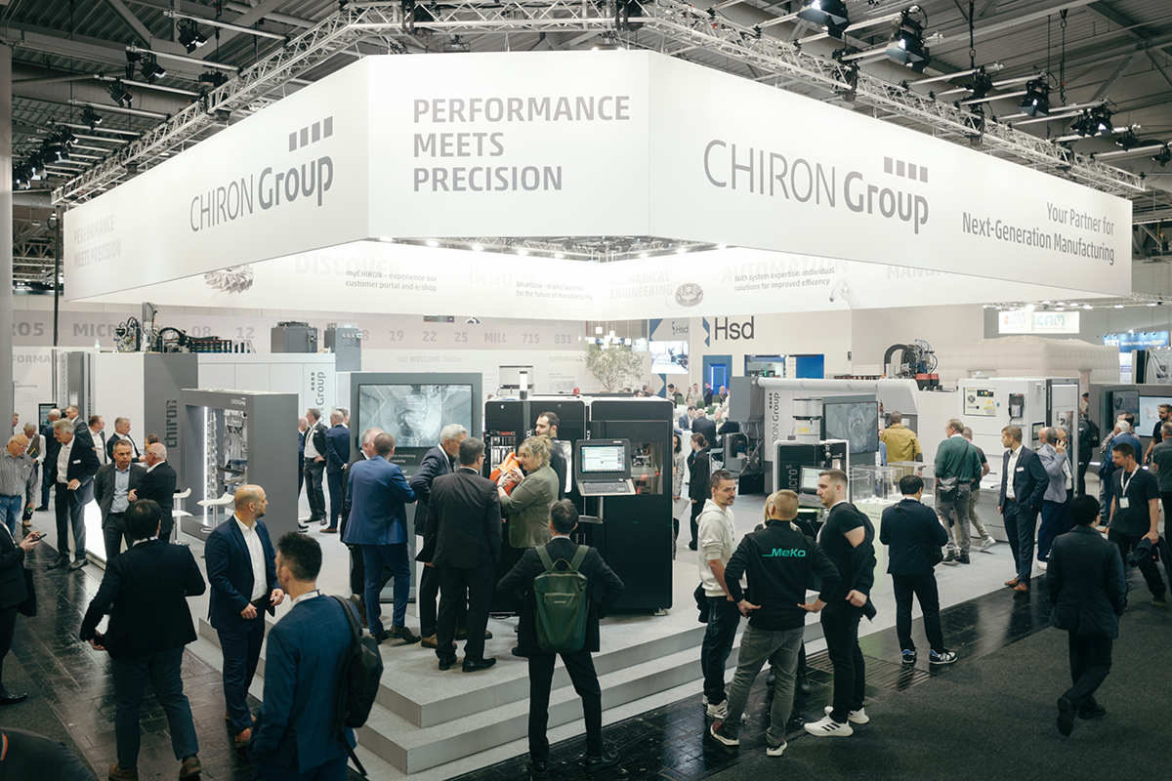

Image 1: The CHIRON Group convincingly lived up to its trade fair motto "Your Partner for Next-Generation Manufacturing" at EMO 2025, presenting the entire range of modern, efficient production for all target industries in live operation.

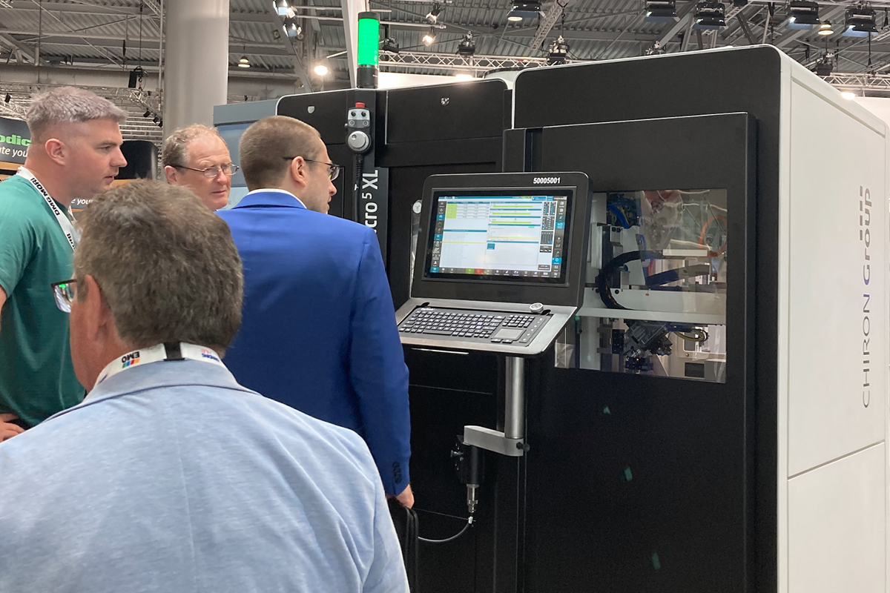

Image 2: Crowd-puller at EMO stand C 50 in hall 12: the integrated combination for extended possibilities in micromachining with the new Micro5 XL and the Variocell PICK&PLACE automation system.

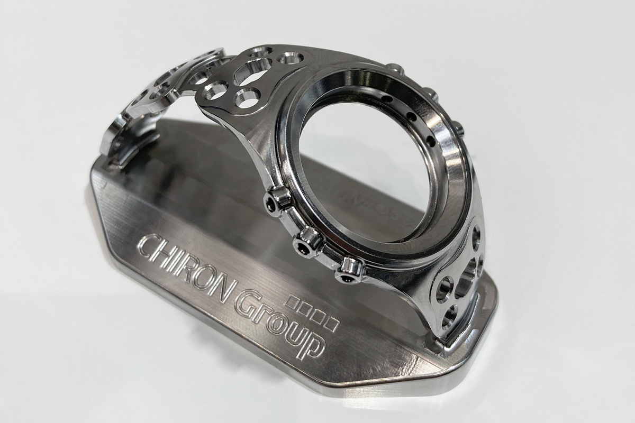

Image 3: Precision machining of a "bone watch", an example of the extended range of applications with the Micro5 XL in medical and precision technology.

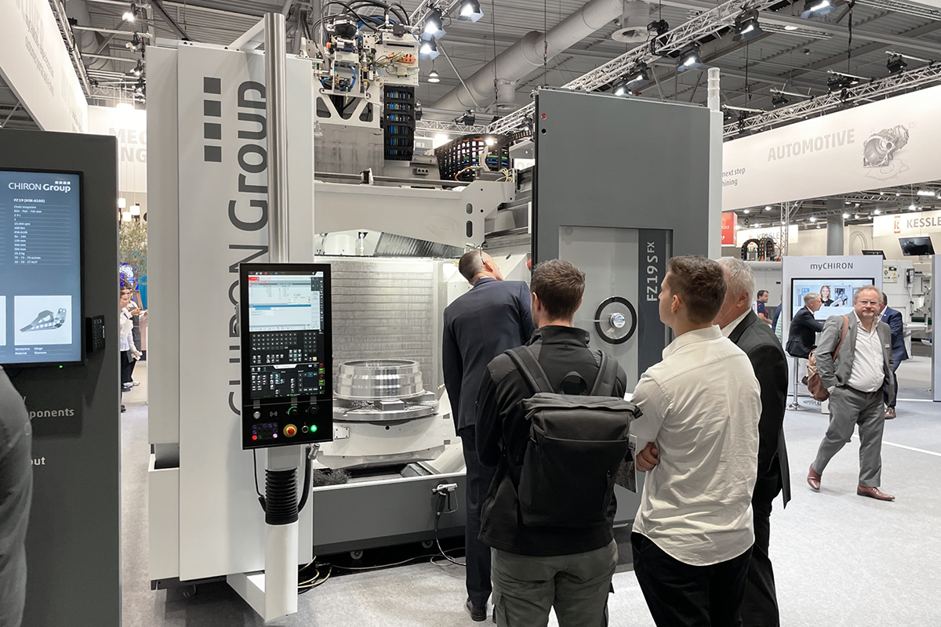

Image 4: Aha experience: The FZ 19 S five axis with open work area and view of the turbine housing completely machined in a continuous process.

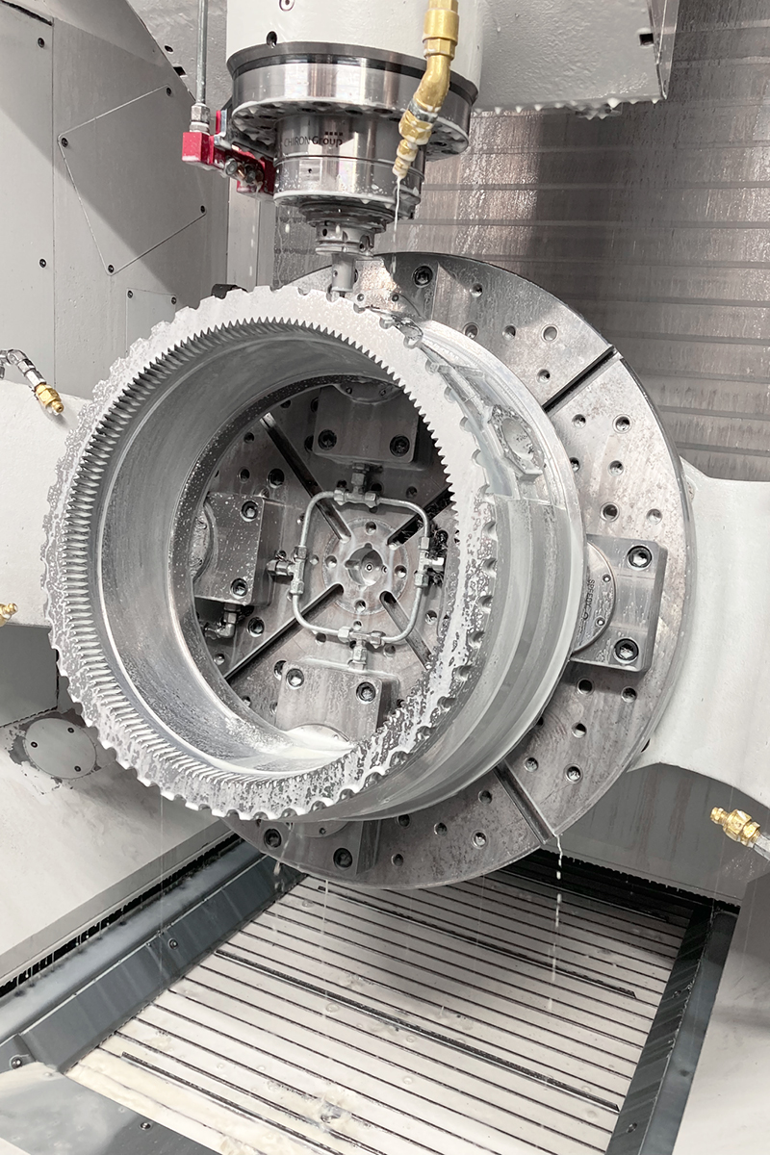

Picture 5: Those who stayed longer at the CHIRON Group stand were able to follow five processes live on the FZ 19 S five axis during the machining of a turbine housing: Rough machining, turning, skiving, drilling and simultaneous 5-axis milling.

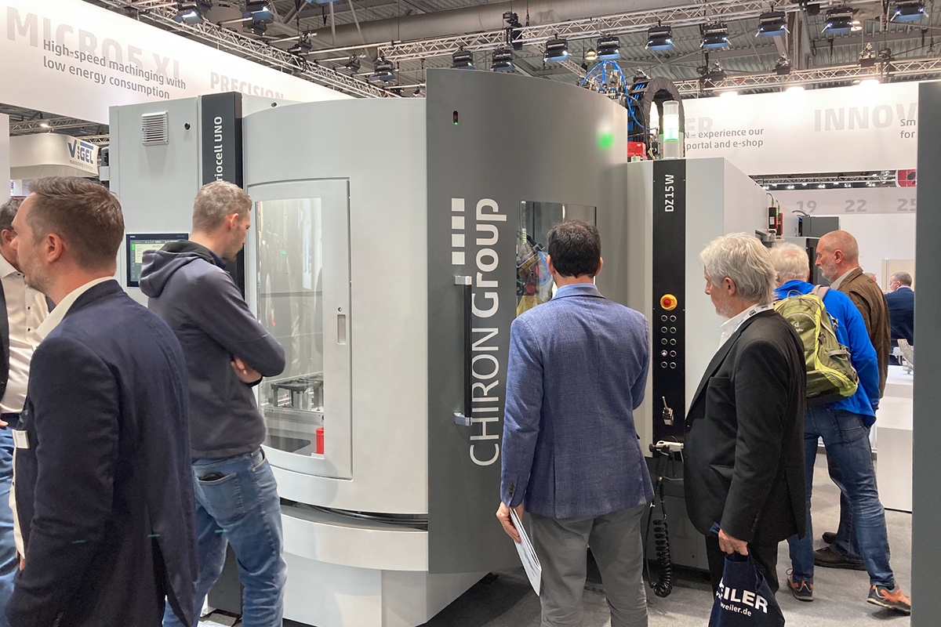

Image 6: Four hours of autonomous production of pump housings on one side of the table, two hours machining fan covers for mechanical engineering – with the highly productive combination of DZ 15 W and Variocell UNO.

