November 06, 2025

Micromachining with the CHIRON Group
Maximum precision and dynamics on a minimal footprint

Addressing markets with precision and meeting tomorrow’s requirements with innovative manufacturing solutions – that’s what the CHIRON Group stands for. One field of growing importance is highly dynamic micromachining of precision parts in short cycle times and with tolerances in the µm range. For these tasks, the company offers two purpose-built options: the proven Micro5 and – opening up a broader range of applications – the new Micro5 XL.

Both models set new standards in the machining of sophisticated components – for example in medical technology, precision engineering and other industries where dynamics and ultimate accuracy are essential. Key characteristic is their remarkable 5:1 ratio between the structural dimensions of the machine and the maximum workpiece size. For the Micro5, this means a milling center of 250 mm for a workpiece cubature of up to 50 mm, and with the Micro5 XL, 600 mm for the center of the machine with a maximum edge length of 120 mm. This ratio is unique, combining extreme compactness with outstanding performance.

Benchmark in micromachining: the Micro5
Whether medical or watch parts, fine jewelry, or delicate components for precision and micro-mechanics, the Micro5 is the perfect choice for machining small, high-value parts. What began as a small revolution has become the most successful micro machine on the market.

Weighing just 550 kg and equipped with a 230 V connection for true “plug and play”, the Micro5 can be flexibly integrated into almost any production environment, even directly at the workstation. Despite its ultra-compact footprint, it impresses with high static and mechanical rigidity and delivers the required precision for the most demanding geometries.

Micromachining in a new dimension: the Micro5 XL
In September, the CHIRON Group launched the Micro5 XL at EMO 2025, and it was a real crowd-puller. But what, beyond the proven strengths of the Micro5, distinguishes this new micro machine from other solutions? “Why ”a new dimension”? Because XL stands for more travel distance, higher cutting performance and maximum flexibility and thus for new opportunities in 5-axis simultaneous HSC machining – for example in the production of medical products such as knee inlays or bone plates, as well as larger watch cases or bracelets.

The Micro5 XL machines cubatures of up to 120 mm on a footprint of just 1.7 m² – with highly dynamic BC 5-axis kinematics, spindle speeds of 40,000 or 50,000 rpm, and jerk values up to 900 m/s³. This enables outstanding web and processing speeds with maximum precision.

Perfectly aligned: the automation solutions
To increase productivity and autonomy in series production, the Micro5 can be combined with the Variocell UNO handling system. It loads and unloads up to two Micro5 units and serves as a fully automated handler for workpieces and tools. It offers storage capacity for up to ten pallets, and tool changes are completed in less than five seconds.

For the Micro5 XL, the CHIRON Group offers three variants for a productive combination: pallet automation, and two types of workpiece automation – either with robots or, in the case of the new Variocell PICK&PLACE, with linear handling. The system feeds raw parts from the pallet storage into the clamping device and places finished components back into the storage unit. A key advantage is the identical operating logic, which ensures intuitive handling and quick setup. Operation is from the front, with a clear view of the machining process, and multiple production cells can be positioned in close succession – production can simply grow with demand.

Find out more about the Micro5 and Micro5 XL in the product finder.

About the CHIRON Group

The CHIRON Group, headquartered in Tuttlingen, Germany is a global company specializing in CNC vertical milling and mill-turning machining centers, as well as turnkey and automation solutions. Comprehensive services, digital solutions and products for additive manufacturing complete the portfolio. The Group has a global presence, with production and development sites, sales and service subsidiaries, and sales agencies worldwide. Around two thirds of machines and solutions that are sold are exported. Key customer sectors are the automotive, mechanical engineering, medicine and precision engineering, aerospace industries, as well as tool manufacturing.

Contact for the editorial team:

CHIRON Group SE
Melanie Buschle
Kreuzstrasse 75
78532 Tuttlingen

Phone: 07461 940-3255
E-mail: melanie.buschle@chiron-group.com
www.chiron-group.com

Captions

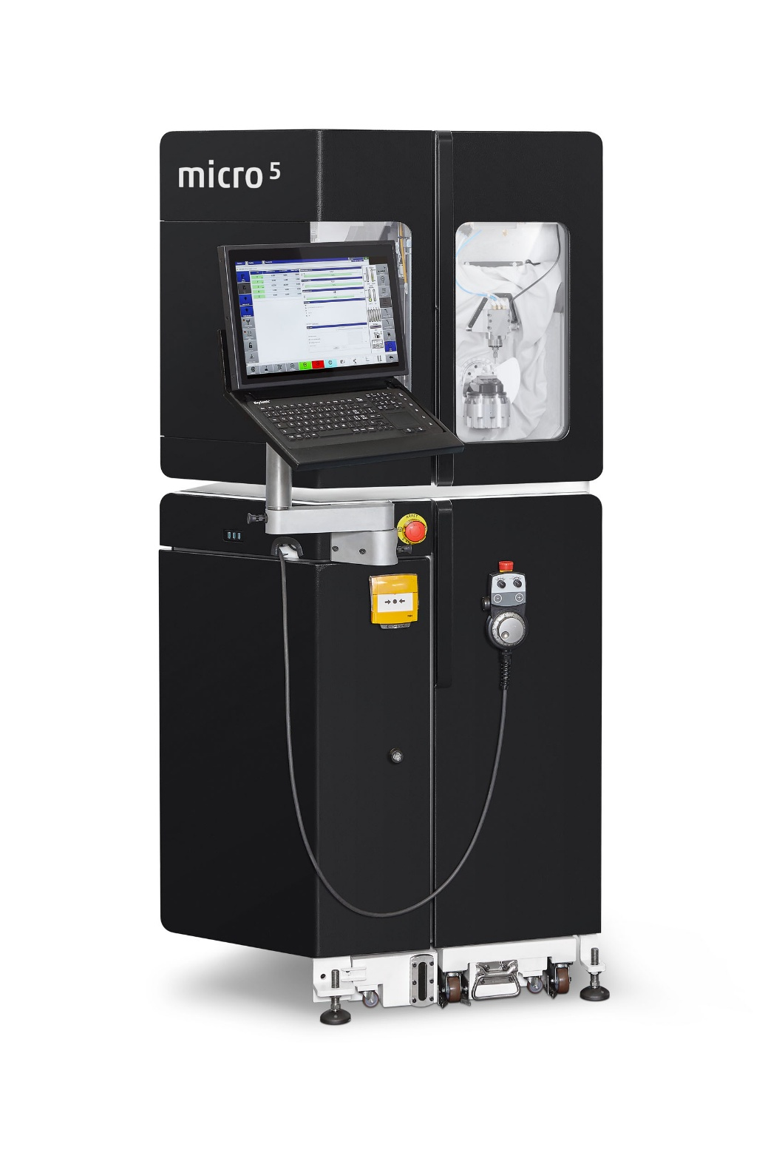

Image 1: High-precision 5-axis machining in the smallest possible space. With the original, the Micro5 of the CHIRON Group.

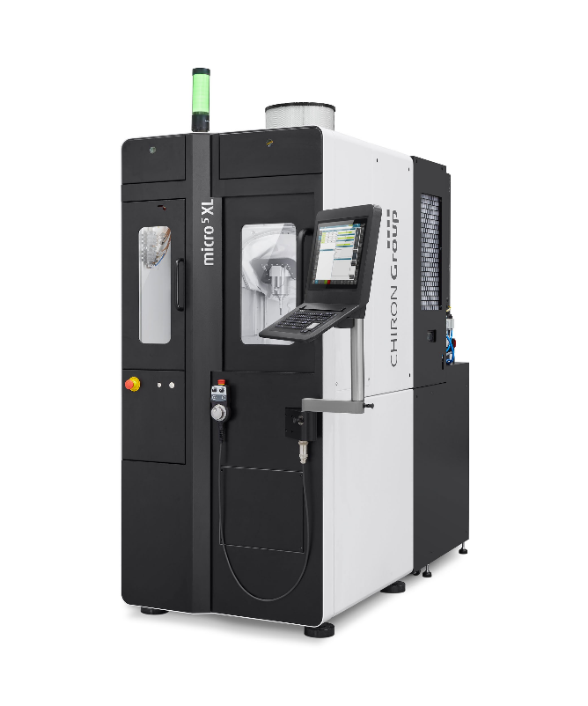
Image 2: For efficient production in demanding applications, the Micro5 XL combines maximum precision with maximum dynamics.

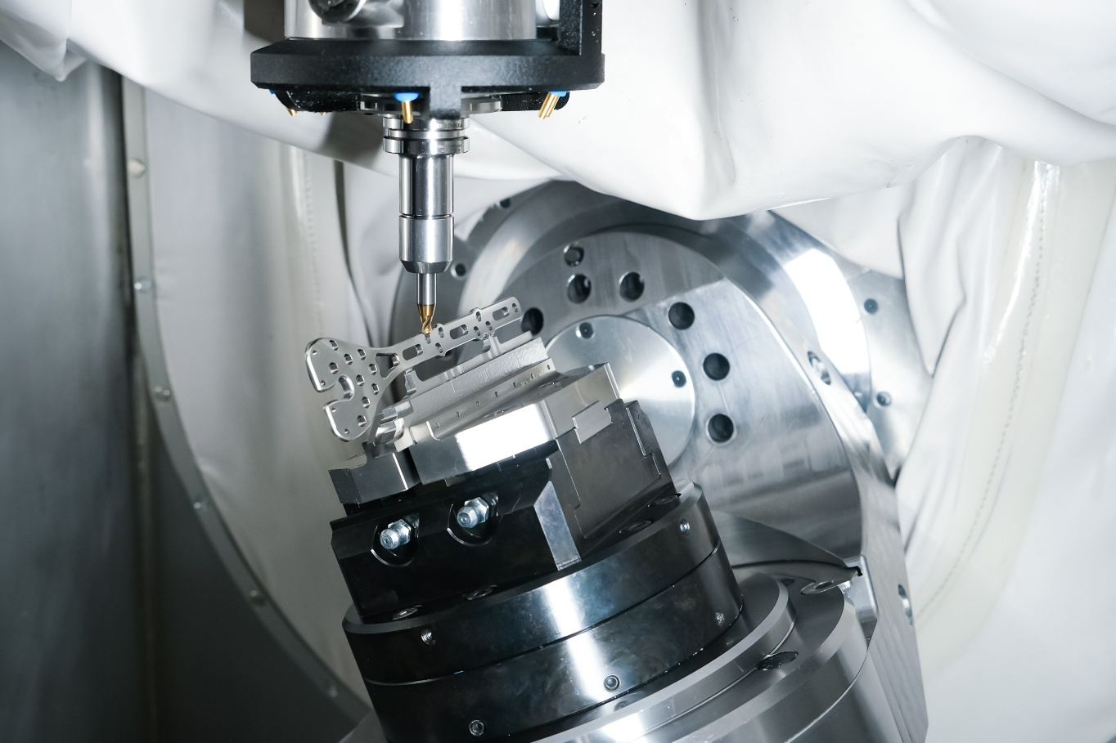
Image 3: Precision machining of a titanium bone plate – an example of the expanded range of applications with the Micro5 XL in medical technology.

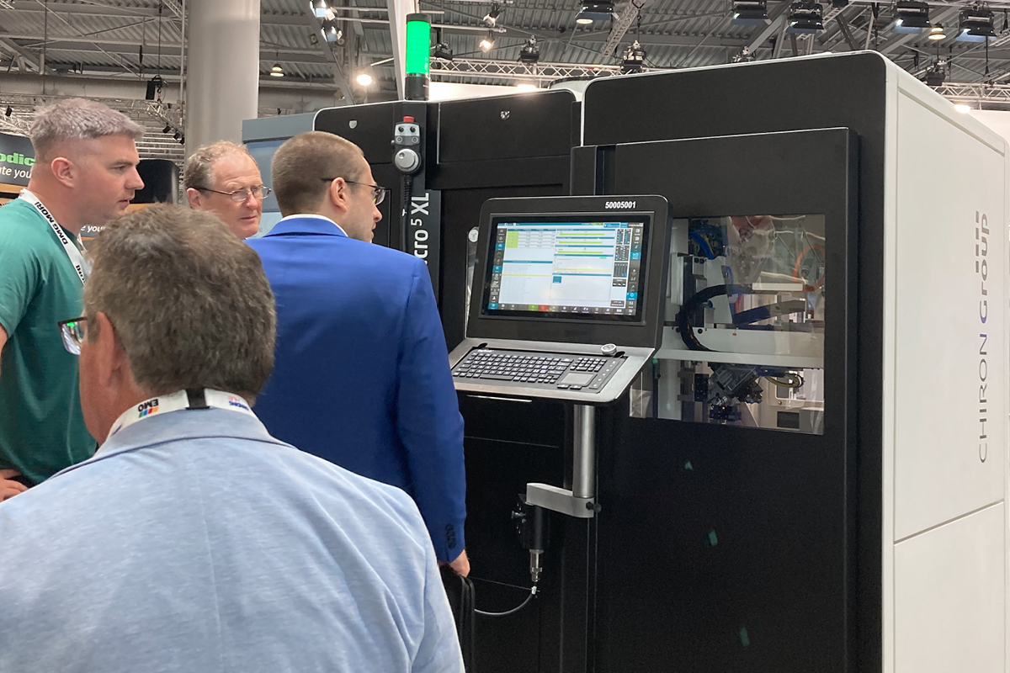

Image 4: Crowd-puller at the premiere at EMO 2025: the integrated combination for increased productivity with the Micro5 XL and the Variocell PICK&PLACE automation system.

