March 31, 2026

CHIRON Group appoints Roman Gaida as new CEO

The Board of Directors of CHIRON Group SE has appointed Roman Gaida as the new Chief Executive Officer of the international engineering group, effective July 1, 2026. With this appointment, the Board of Directors is sending a clear signal regarding the company’s international expansion, a stronger focus on customer needs, and a consistent commitment to profitable growth.

“With Roman Gaida, the CHIRON Group is gaining a CEO who combines strategic clarity, international leadership experience, and deep technical expertise,” explains Dr. Armin Schmiedeberg, Chairman of the Board of Directors. “His career path – from his roots in CNC machining through senior leadership roles to the global management of international organizations – makes him a valuable and forward-looking addition to our leadership team.”

Roman Gaida began his professional career in 1999 with an apprenticeship as a machinist and subsequently worked in that field for several years. At the same time, he completed further training to become a mechanical engineering technician. He then went on to study industrial engineering and earn an MBA at RWTH Aachen University. Later in his career, he held various leadership roles in engineering, sales, business development, and general management at internationally active technology companies. His professional career includes roles at the Wieland Group, OC Oerlikon Balzers, and Mitsubishi Electric, where he headed the CNC business in the EMEA region. Most recently, he served as Chief Sales Officer at Bürkert Fluid Control Systems, where he was responsible for global sales, marketing, and service operations.

“I am very much looking forward to working with Roman Gaida on the Group Executive Committee. His extensive international sales experience, his in-depth market knowledge, and his structured understanding of global customer needs will provide valuable impetus to our organization. We expect this to be a significant asset to the further development of our business, particularly in the interplay between sales, technology, and operational implementation”, says Markus Unterstein, CFO and Spokesperson of the Group Executive Committee a.i.

Upon taking office, Mr. Gaida will assume overall responsibility for the CHIRON Group SE and will also lead global sales in the future. During his first few months, as part of his onboarding process, he will gain a comprehensive understanding of processes, markets, and customer expectations at CHIRON Groups international locations.

With this appointment, the Board of Directors aims to further develop the CHIRON Group into a mechanical engineering solutions partner for its customers, expand its digital and automation business, broaden its international market presence, and clearly align the Group’s strategy with profitable business areas for the future.
About the CHIRON Group

Headquartered in Tuttlingen, the CHIRON Group specializes in CNC-controlled vertical milling and mill-turn machining centers, as well as turnkey and automation solutions. Comprehensive services and digital solutions round out the portfolio. The Group has a global presence with production and development sites, sales and service branches, and commercial agencies. Approximately two-thirds of the machines and solutions sold are exported. Key user industries include the automotive industry, mechanical engineering, medical and precision engineering, aerospace, and tool manufacturing.

Media Contact:

CHIRON Group SE
Matthias Rapp
Kreuzstraße 75
78532 Tuttlingen

Phone: 07461 940-3181
Email: matthias.rapp@chiron-group.com
www.chiron-group.com

Captions

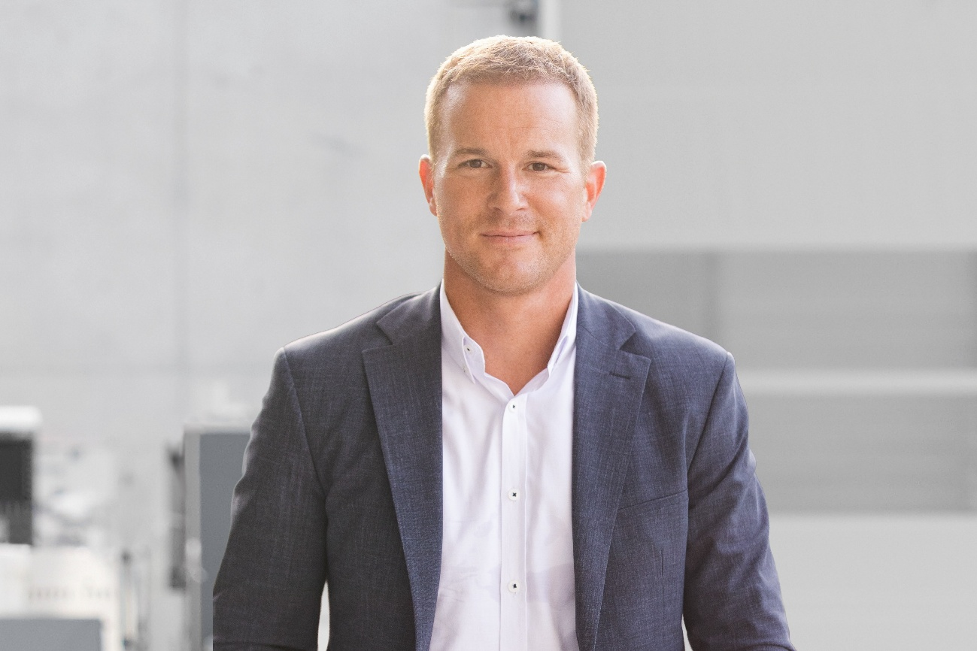

Image 1: Roman Gaida, new CEO of the CHIRON Group effective July 1, 2026.

