1st August 2022

The CHIRON Group acquires spindle and fixture specialist in Croatia

¯ HSTEC is a system partner for innovative spindle drive technology for
CNC machining centers, for fixtures as well as spindle services and
repair

¯ Acquisition as part of the global growth strategy expands the capacity of the CHIRON Group, completing its skill set thanks to insourcing of the motor spindle key component

¯ New company CHIRON Croatia, based in Zadar, is headed by
managing director Mladen Šarlija

The CHIRON Group, headquartered in Tuttlingen, Germany, is continuing to follow its global growth strategy in 2022 too, and today announced its takeover of 90 percent of the Croatian company HSTEC.

The name HSTEC stands for »high speed technique«, for system expertise in development, design and manufacture of high-speed motor spindles for challenging machining. Clamping devices for machining centers and automation solutions complete the portfolio. Furthermore, HSTEC is leading the way in spindle services and repair for in-house products and spindles from other manufacturers.

With the acquisition, the CHIRON Group is expanding its capacities and strengthening three areas of expertise: Complete development, manufacturing and assembly of the key components, motor spindles and turning spindles, for the Group's machining centers. With HSTEC fixtures for workpiece clamping, turnkey projects can be designed even better in line with customer-specific specifications. Furthermore, the CHIRON Group is expanding its services globally to include part repair, refurbishing and optimizing of all motor spindles in existing machines.

With the new name CHIRON Croatia, the CHIRON Group has a presence in eastern Europe with another of its own companies; it can support customers better in the region and will continue to develop at the Zadar site. Over 100 employees, 25 of whom alone work in engineering, increase the number of employees in the Group globally to around 1,900.
The current CEO Mladen Šarlija has been appointed Managing Director of CHIRON Croatia. The representative offices of HSTEC in Germany, the USA and China will remain, as well representation of Balluff, Bosch Rexroth, Hofmann and Mitutoyo for the Croatian market.
HSTEC will continue as a brand, joining the ranks of the CHIRON Group brands: CHIRON, STAMA, FACTORY5, CMS, GREIDENWEIS, HSTEC.

About the CHIRON Group

The CHIRON Group, headquartered in Tuttlingen, Germany is a global company specializing in CNC vertical milling and mill-turn machining centers, as well as turnkey and automation solutions. Comprehensive services, digital solutions and products for additive manufacturing complete the portfolio. The Group has a global presence, with production and development sites, sales and service subsidiaries, and sales agencies worldwide. Around two thirds of machines and solutions that are sold are exported. Key customer sectors are the automotive, mechanical engineering, medicine and precision engineering, aerospace industries, as well as tool manufacturing.

The CHIRON Group is proprietor of the CHIRON, STAMA and FACTORY5 brands for new machines, as well as the automation brand GREIDENWEIS, CMS for refurbishment and HSTEC for motor spindles and fixtures. CHIRON machining centers are renowned for their highly dynamic design and their precision. The focus of STAMA is on stability and complete machining, while FACTORY5 expert area is high-speed machining of micro-technical components. GREIDENWEIS is a system partner for custom, end-to-end automation solutions, and CMS provides completely refurbished machines from the Group. HSTEC specializes in the development, manufacture and repair of high-speed motor spindles and fixtures. The final core area of expertise in the CHIRON Group is in additive manufacturing products and solutions.

Contact person for editors:

CHIRON Group SE
Matthias Rapp
Kreuzstraße 75, 78532 Tuttlingen, Germany
Phone: +49 (0)7461 940-3181

Mail: matthias.rapp@chiron-group.com
www.chiron-group.com

Image captions

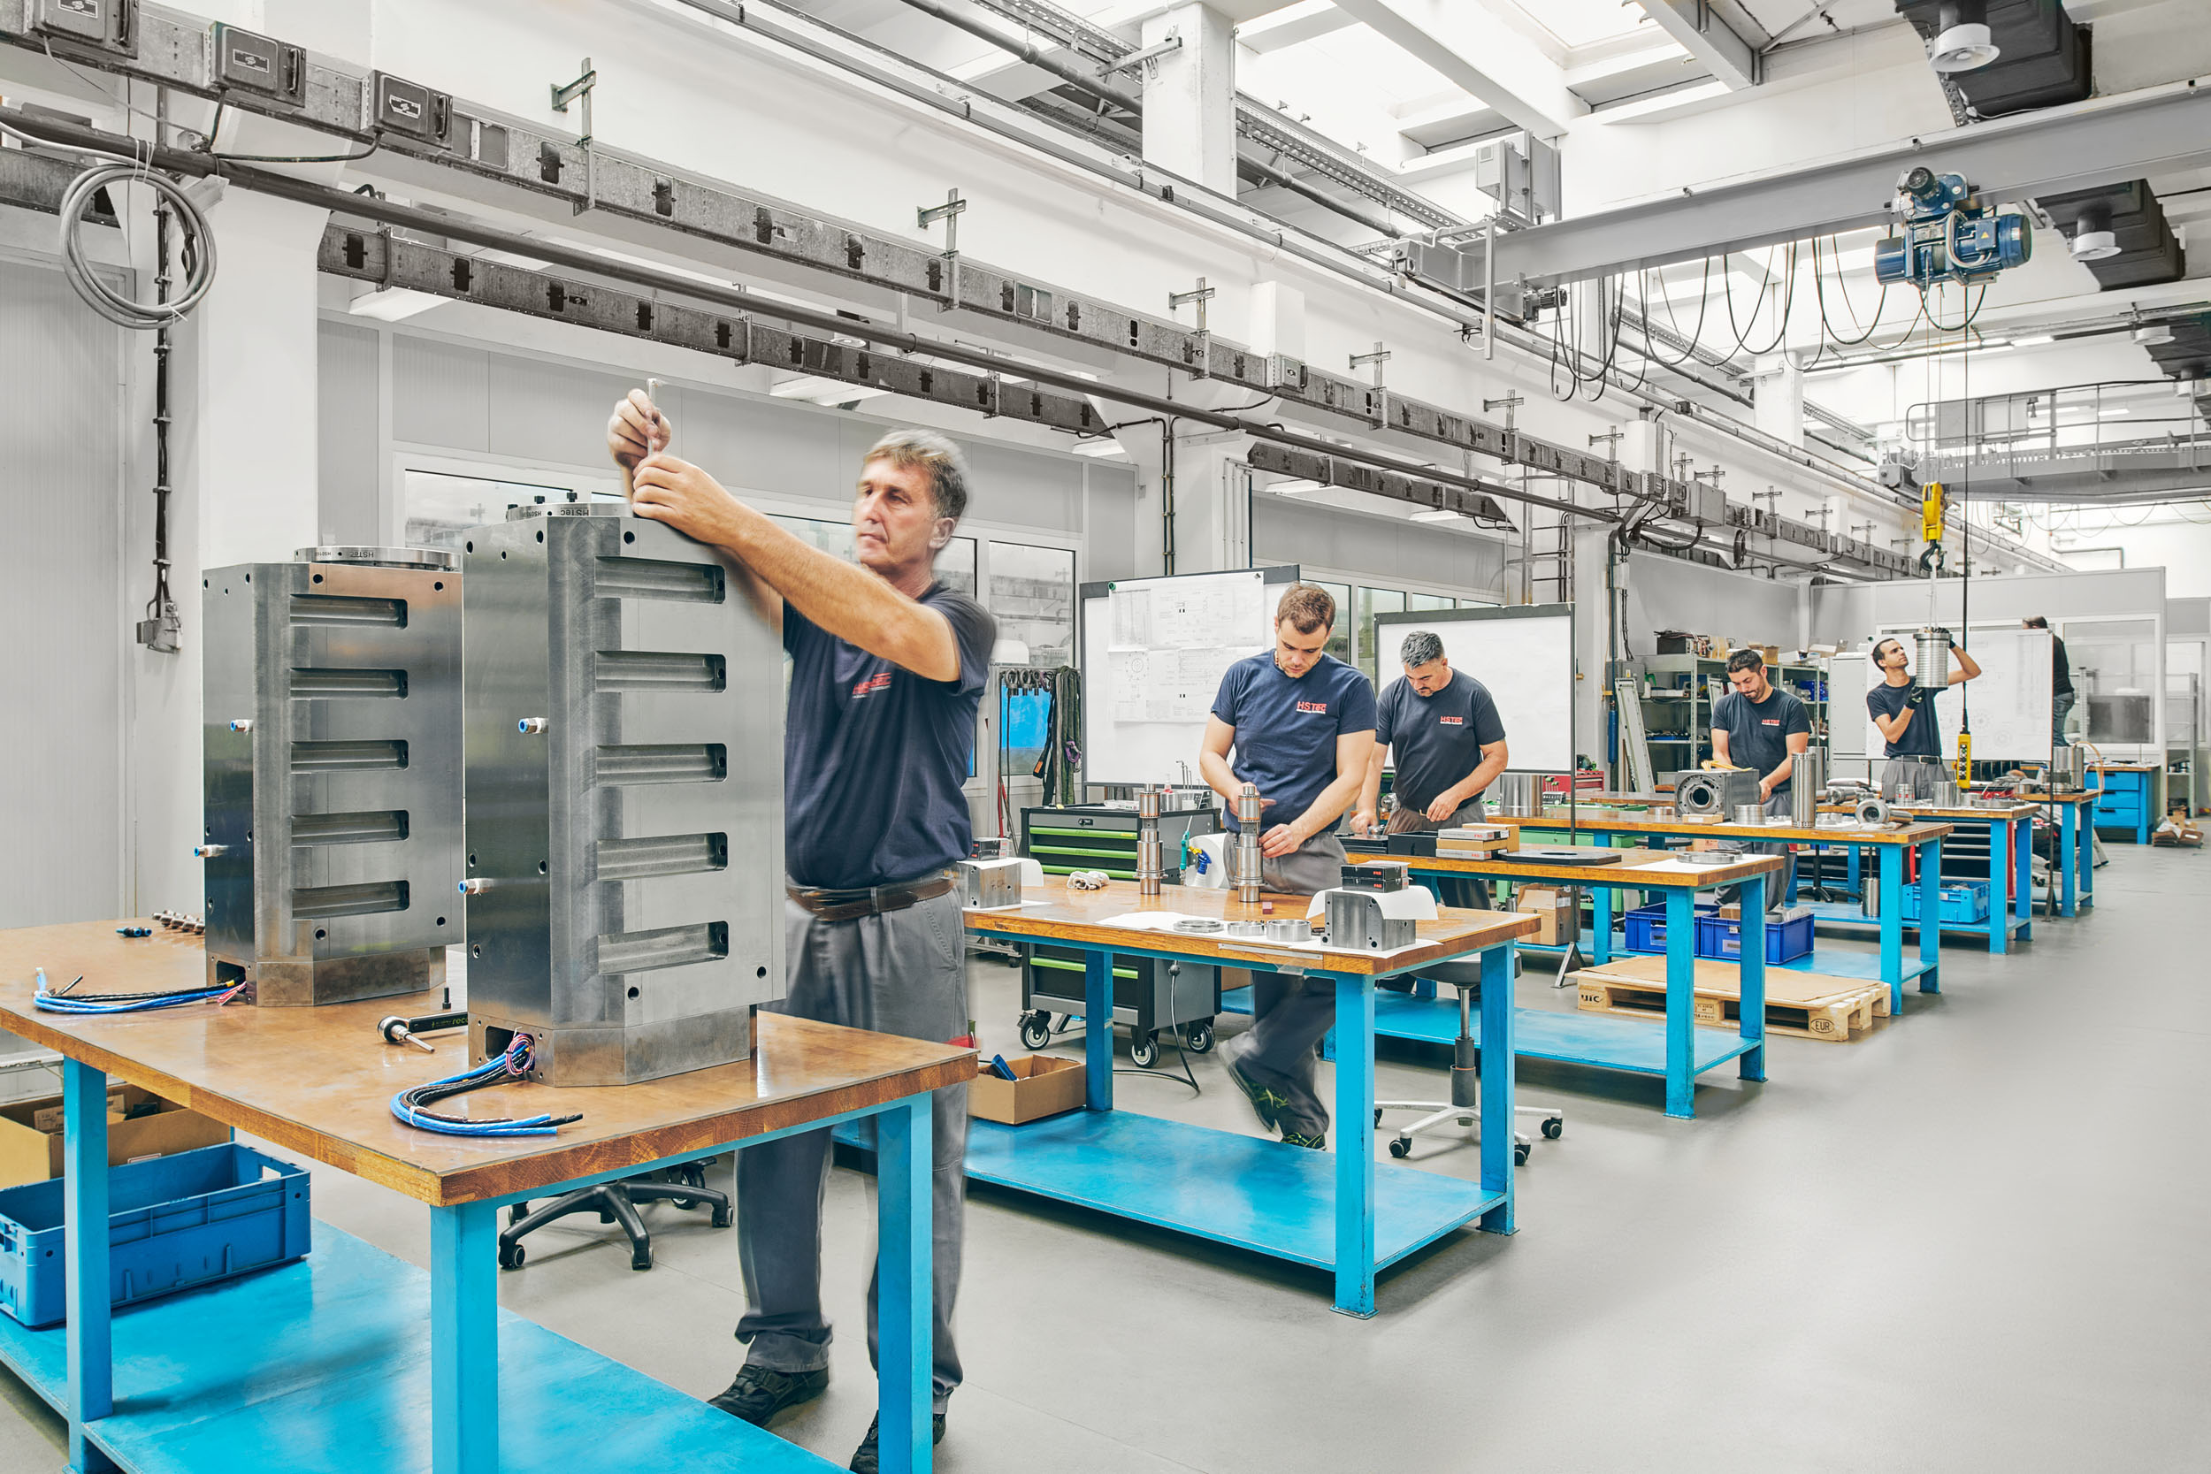
Picture 1: HSTEC is now a brand of the CHIRON Group and benefits from the company's global presence and expertise in mechanical engineering.

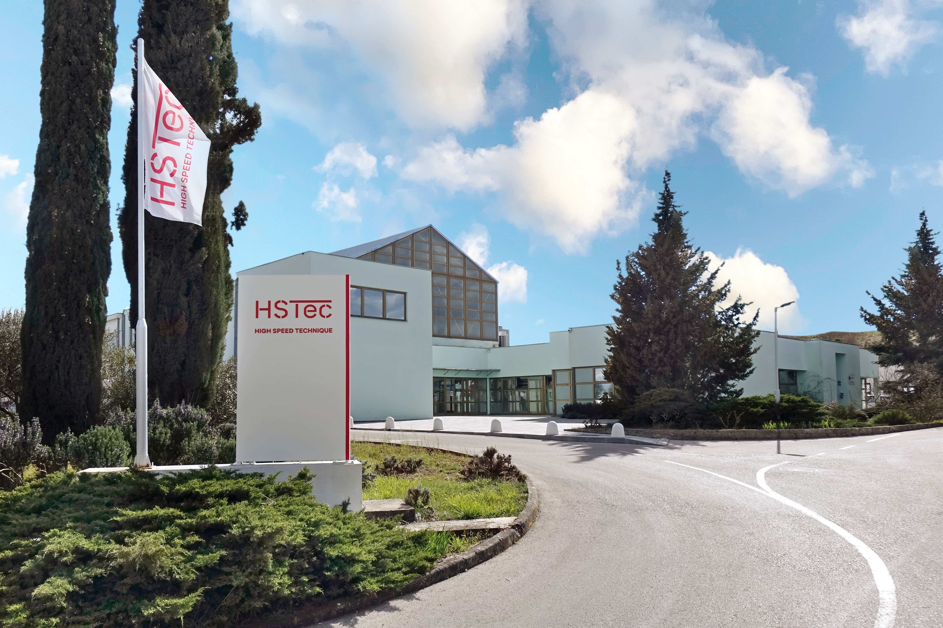
Picture 2: The employees at the Zadar site in Croatia bring their expertise in development, manufacturing and repair of high-speed motor spindles and clamping devices.

