21st September 2022

The chips are flying again: The CHIRON Group at the AMB 2022
Exhibitors and visitors at the 20th edition of the AMB would have been gladly saying „Finally!“ at the end of that statement, whether out loud or to themselves, last week. The CHIRON Group's exhibition team was also delighted with the atmosphere in the Stuttgart exhibition halls and presented the Group's comprehensive range for future-proof, highly productive manufacturing processes under the slogan „PERFORMANCE MEETS PRECISION“ – including, of course, machining centers live in action.

The exhibition magazine AMB SPECIAL wrote that „key factors for decision-makers at the AMB 2022 are productivity increases and the technical availability of their systems“. What is the best way to achieve these aims? With a globally established partner like the CHIRON Group. One who covers all relevant areas of expertise and is therefore able to offer customized complete solutions rather than just machines. Milling and mill-turning, additive manufacturing, automation, turnkey, digital solutions, services, machine refurbishment: At the AMB 2022, the CHIRON Group showcased the expertise that it has continued to acquire in all fields.

Machine innovations live in action
In recent years, the CHIRON Group continued to pursue its product campaign with great vigor and demonstrated three machining centers live in action in Stuttgart: The DZ 22 W five axis with HSK-A 100 interface and spindle distance of 600 mm is specially designed for dynamic, precise and highly productive machining in the automotive and aerospace industries. The double spindle machine can be used to manufacture complex workpieces – such as the shown e-motor housing – in fast machining cycles at reduced unit costs. The experts also demonstrated the benefits of ProtectLine on this machine. The digital system from the SmartLine portfolio protects a machining center preventively and reliably against collisions in any operating mode based on a digital twin. The presentation on the DZ 22 W five axis also included two „better together, better digital“ projects. One relating to automated tool handling and tool changing in cooperation with ZOLLER, the other about intelligent coolant management with MOTOREX.

The CHIRON Group also showcased the new MT 715 two⁺ for five-axis complete machining and mill-turn operations on six sides. Integrated workpiece handling provides increased productivity and reduced costs in all versions of the 715
Series – MT for Mill Turn, MP for Multi Profile – with additional unmanned shifts.
More autonomy is also coming into focus in micro machining. This requirement is met by the new Feed5 handling system for the smallest machine in the CHIRON Group's portfolio, the Micro5. The six-axis robot feeds in workpieces at up to two machines fully automatically.

The specialists from CMS showcased two alternatives for people who approach new manufacturing tasks with state-of-the-art technology but are not currently investing in a new machine and who would like to protect the environment as well as conserve their financial resources: Individual refurbishment of a customer's machine or a CHIRON or STAMA machining center, refurbished with manufacturer expertise, from the machine pool of the CHIRON Group.

The CHIRON Group Service mainly focused on LifetimeSolutions. These are services and digital SmartServices, available from any location, which enable greater productivity, ultimate machine availability and optimized overall equipment effectiveness throughout every phase of the machine lifecycle.

New additions for additive manufacturing too
The additive manufacturing department gave a preview of AM Coating, its latest innovation for coating brake disks. The video demonstrated the main benefits of the system, which is designed for 24/7 operation. The layers of buffer and hard material are applied without interruption using high-speed laser deposition welding, doing away with the need to preheat the brake disks. This not only results in a shorter process, it also consistently achieves the best application quality without the formation of cracks.

Preliminary conclusion: Positive from all angles
Bernd Hilgarth, CSO of CHIRON Group, drew a positive preliminary conclusion at the get-together on the evening of the second day of the AMB: „After four long years, there is once again a lot going on at our exhibition booth, our machine innovations are live in action, and we are enjoying in-depth consultations and lively dialog in all languages: I've missed the special feeling of in-person events! You can feel how attending an event like the AMB in person has a completely different dynamic and atmosphere than one that is held online. Here, we can demonstrate our expertise to great effect, we have the right contacts for all areas of expertise and user industries, and we can provide general information and targeted advice. And we can show that „PERFORMANCE MEETS PRECISION“ is a promise to our customers that we take very seriously and one that we are growing ever more successful at keeping with new, future-proof solutions.“

About the CHIRON Group

The CHIRON Group, headquartered in Tuttlingen, Germany is a global company specializing in CNC vertical milling and mill-turn machining centers, as well as turnkey and automation solutions. Comprehensive services, digital solutions and products for additive manufacturing complete the portfolio. The Group has a global presence, with production and development sites, sales and service subsidiaries, and sales agencies worldwide. Around two thirds of machines and solutions that are sold are exported. Key customer sectors are the automotive, mechanical engineering, medicine and precision engineering, aerospace industries, as well as tool manufacturing.

The CHIRON Group is proprietor of the CHIRON, STAMA and FACTORY5 brands for new machines, as well as the automation brand GREIDENWEIS, CMS for refurbishment and HSTEC for motor spindles and fixtures. CHIRON machining centers are renowned for their highly dynamic design and their precision. The focus of STAMA is on stability and complete machining, while FACTORY5 expert area is high-speed machining of micro-technical components. GREIDENWEIS is a system partner for custom, end-to-end automation solutions, and CMS provides completely refurbished machines from the Group. HSTEC specializes in the development, manufacture and repair of high-speed motor spindles and fixtures. The final core area of expertise in the CHIRON Group is in additive manufacturing products and solutions.

Contact person for editors:

CHIRON Group SE
Christina Messmer
Kreuzstraße 75, 78532 Tuttlingen, Germany
Phone: +49 (0)7461 940-3712

Mail: christina.messmer@chiron-group.com
www.chiron-group.com

Image captions

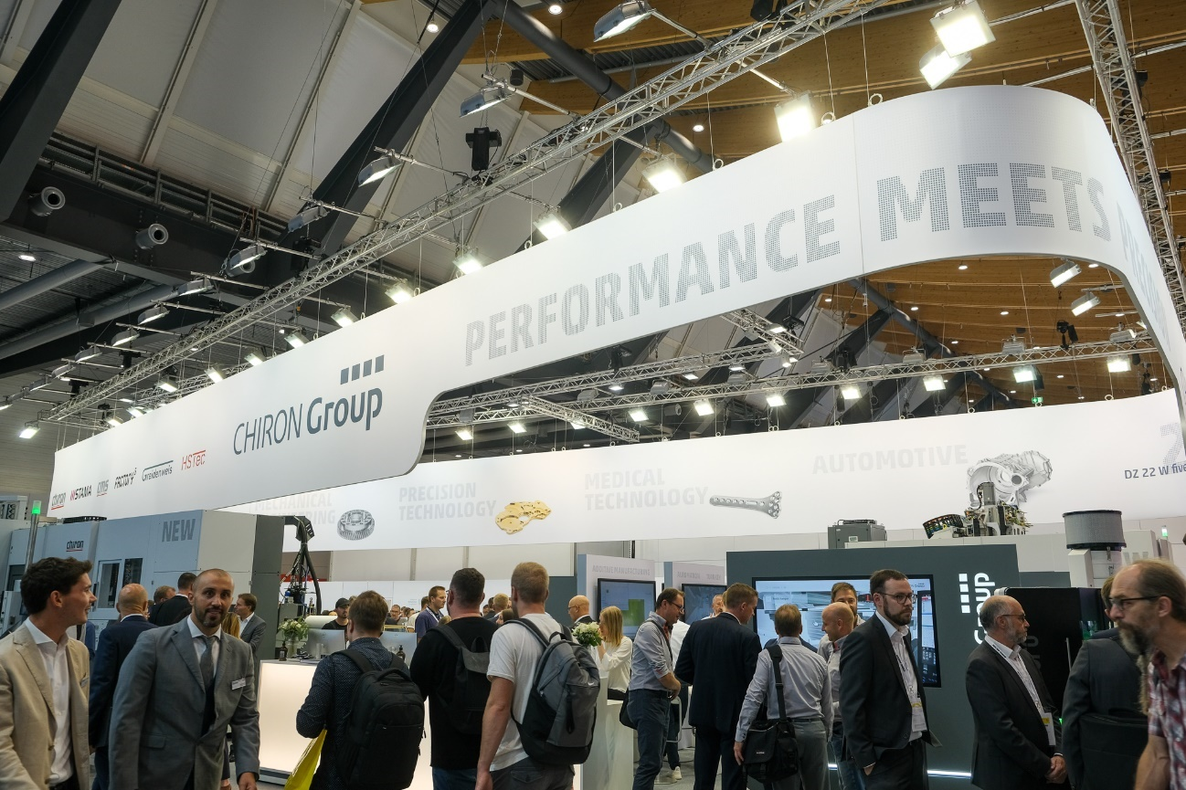
Image 1: There was a lot going on at the CHIRON Group's exhibition booth. Visitors and the exhibition team enjoyed animated discussions at the AMB 2022 and were happy to finally get together in person again.
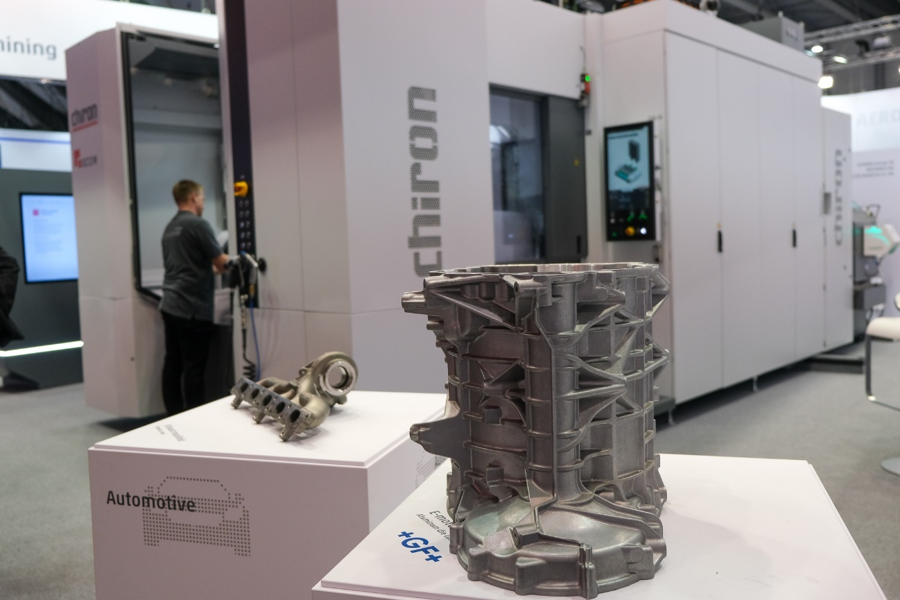
Image 2: The DZ 22 W five axis for double-spindle machining of large components in short cycle times and workpiece changer for loading and unloading during regular machine operation.

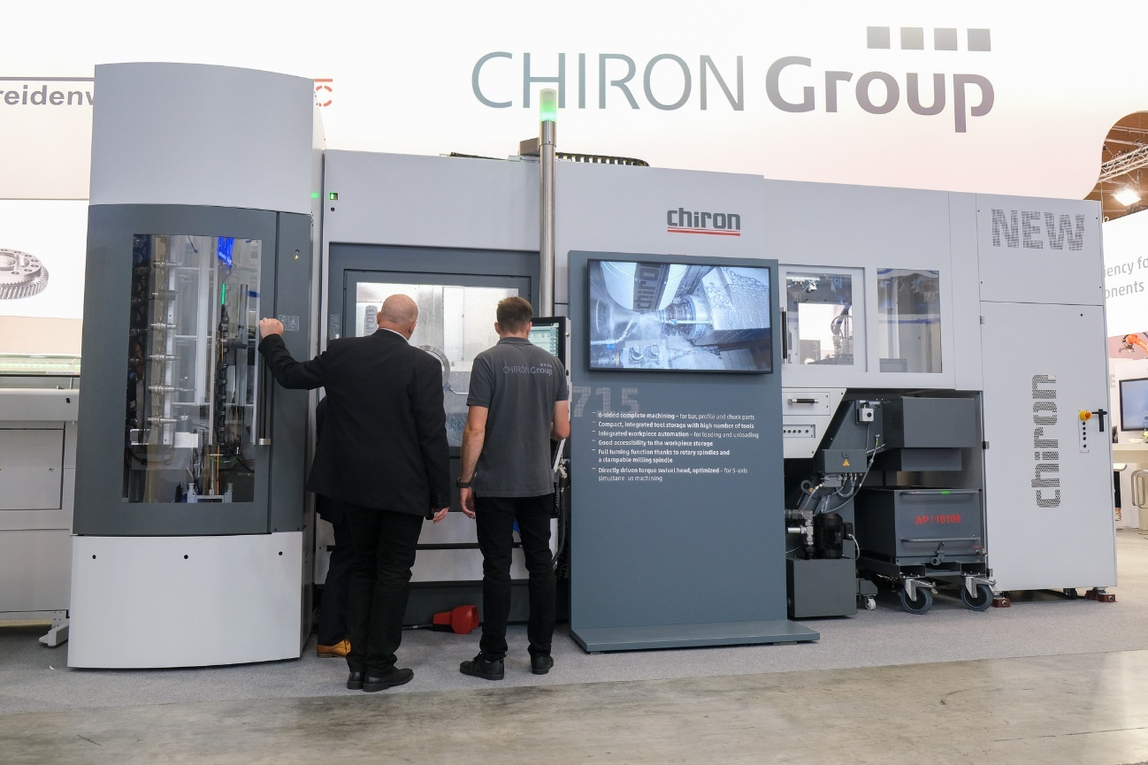
Image 3: The 715 Series with integrated automation for dynamic and precise complete machining of workpieces up to a diameter of 300 mm and length of 1,000 mm.

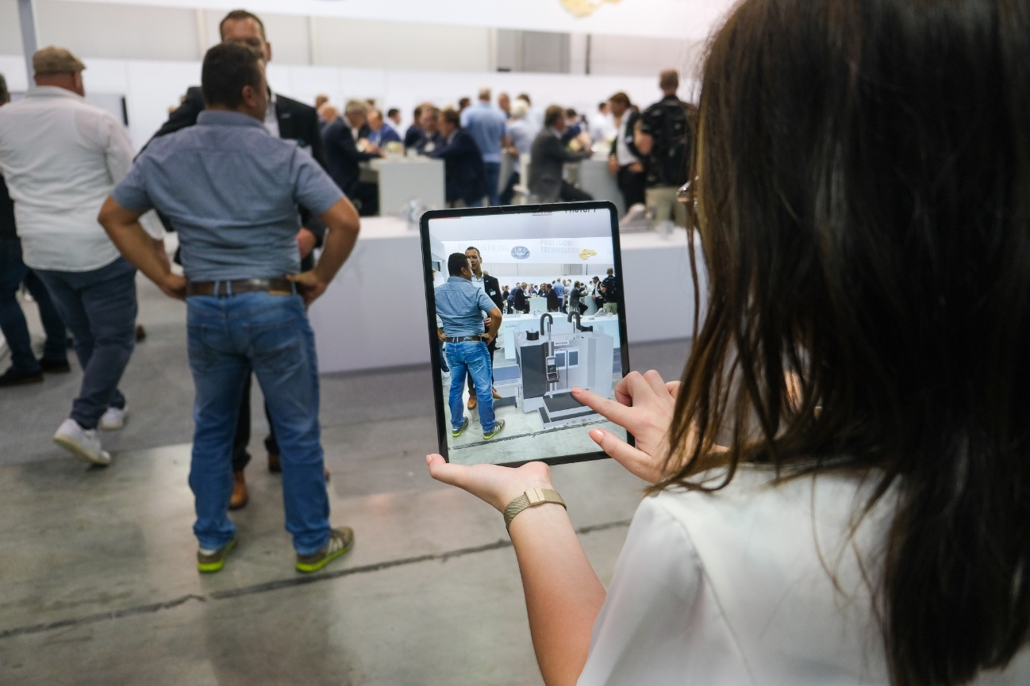 Image 4: Whether in the interactive showroom or as an AR application, if the machining centers were not available to view in person, visitors had the opportunity to discover them digitally.

