March 23, 2022

A next-level experience: the CHIRON Group OPEN HOUSE 2022

From May 11 to 13, 2022, the CHIRON Group warmly invites to the renowned, highly popular event for the whole industry – the »OPEN HOUSE« in Tuttlingen, Germany. Visitors can finally see numerous machining innovations live in action and get valuable information on products and solutions for automated, future-proof and sustainable production.

A real, in-person handshake to welcome you, personal conversations and individual advice: at the CHIRON Group OPEN HOUSE 2022, everything is possible again. And, just as long missed: the opportunity to see machining innovations live in action. For example, the two efficiency boosters DZ 25 P five axis and DZ 28 P five axis for automotive and aerospace, or the Micro5 for micromachining the smart way. Further highlights of this year’s event include intelligent solutions with additive manufacturing, and the new CHIRON 715 Series for multi-functional complete machining, presented via augmented reality. Other future-focused topics for discussion between the visitors and experts include automation, services, refurbishment and future-focused cooperation with process partners.
Competent, smart, innovative, sustainable: These are four pillars that the CHIRON Group would love for you to experience and explore at the OPEN HOUSE, with the five strong brands CHIRON, STAMA, CMS, FACTORY5 and GREIDENWEIS, each highlighting their specific expertise for optimized productivity with a lower CO₂ footprint. New impulses for the manufacturing practice are also provided by 29 competence partners for process expertise with their products and services and the lecture program with the three theme days competent & smart, innovative and sustainable.

All in all, the event, which runs May 11 to 13, 2022, is an excellent platform for innovative manufacturing solutions and the exciting, expert exchange, for example at the »Get Together« at the end of the second day, complete with live music.

Register and make an appointment via: https://chiron-group.com/openhouse

About the CHIRON Group

The CHIRON Group, headquartered in Tuttlingen, is a global company specializing in CNC vertical milling and mill-turn machining centers, as well as turnkey manufacturing solutions. The Group has a global presence, with production and development sites, sales and service subsidiaries, and sales agencies worldwide. Around two thirds of machines and solutions that are sold are exported. Key customer sectors are the automotive, mechanical engineering, medicine and precision engineering, aerospace industries and tool production.

Contact person for editors:

CHIRON Group SE
Christina Messmer
Kreuzstraße 75, 78532 Tuttlingen, Germany
Phone: +49 (0)7461 940-3712

Mail: christina.messmer@chiron-group.com
www.chiron-group.com

Captions

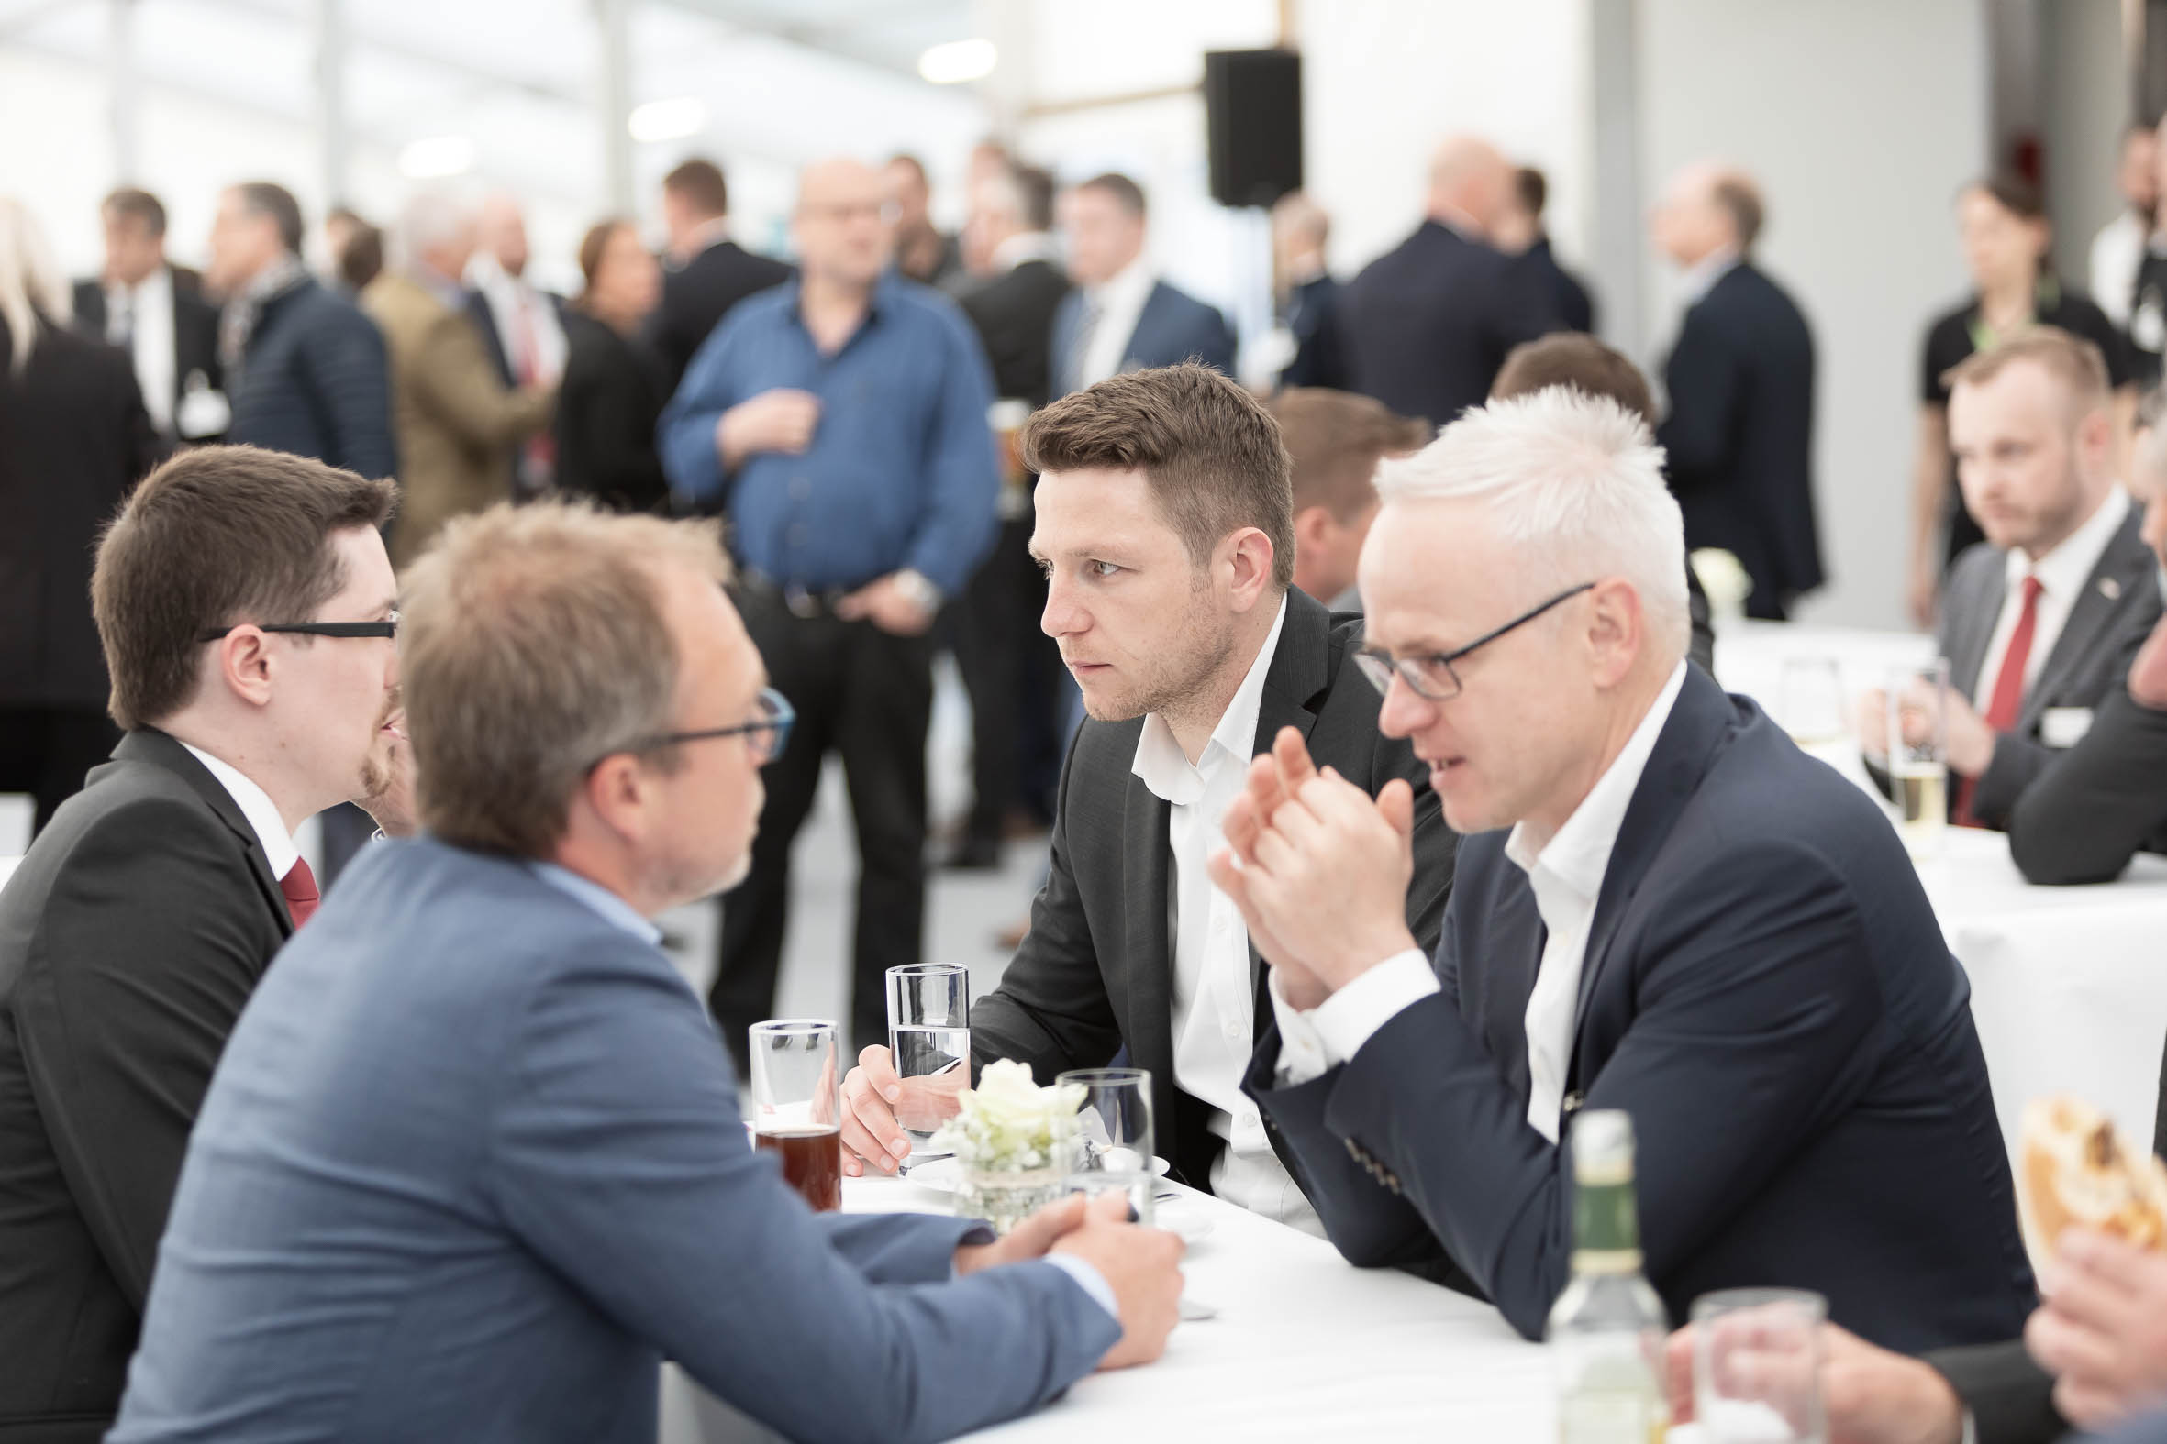

Picture 1: Look back on the OPEN HOUSE 2019: The well-established industry event is finally able to come to life again, with a live event at the CHIRON Group premises in Tuttlingen, Germany.

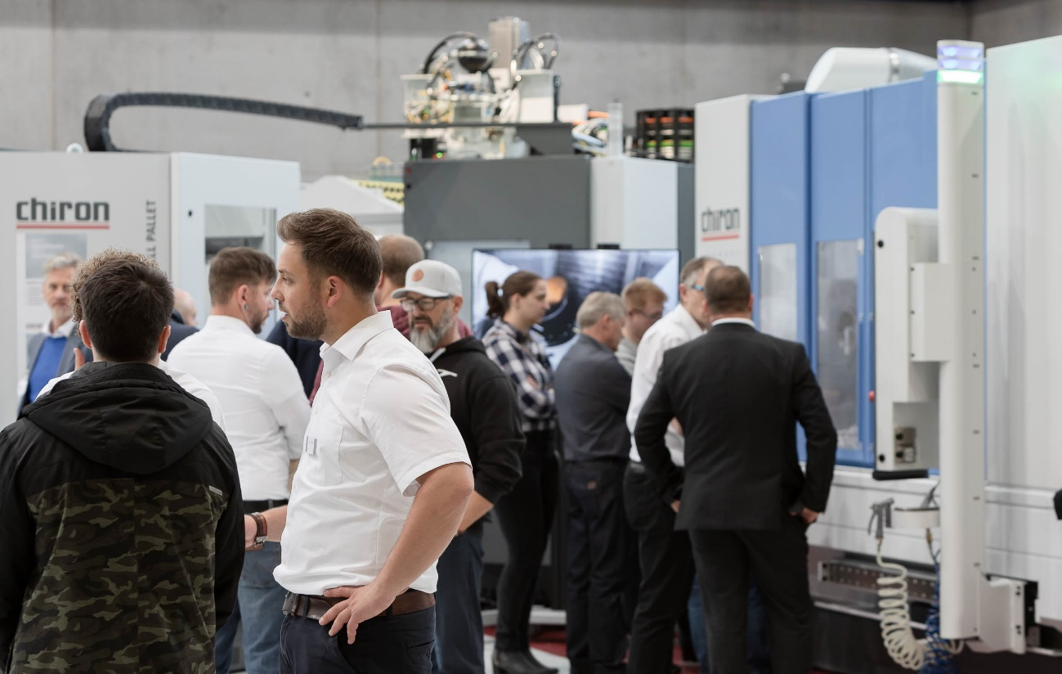

Picture 2: Visitors can finally see numerous machining innovations in action and get valuable information on products and solutions for automated, future-proof and sustainable production.

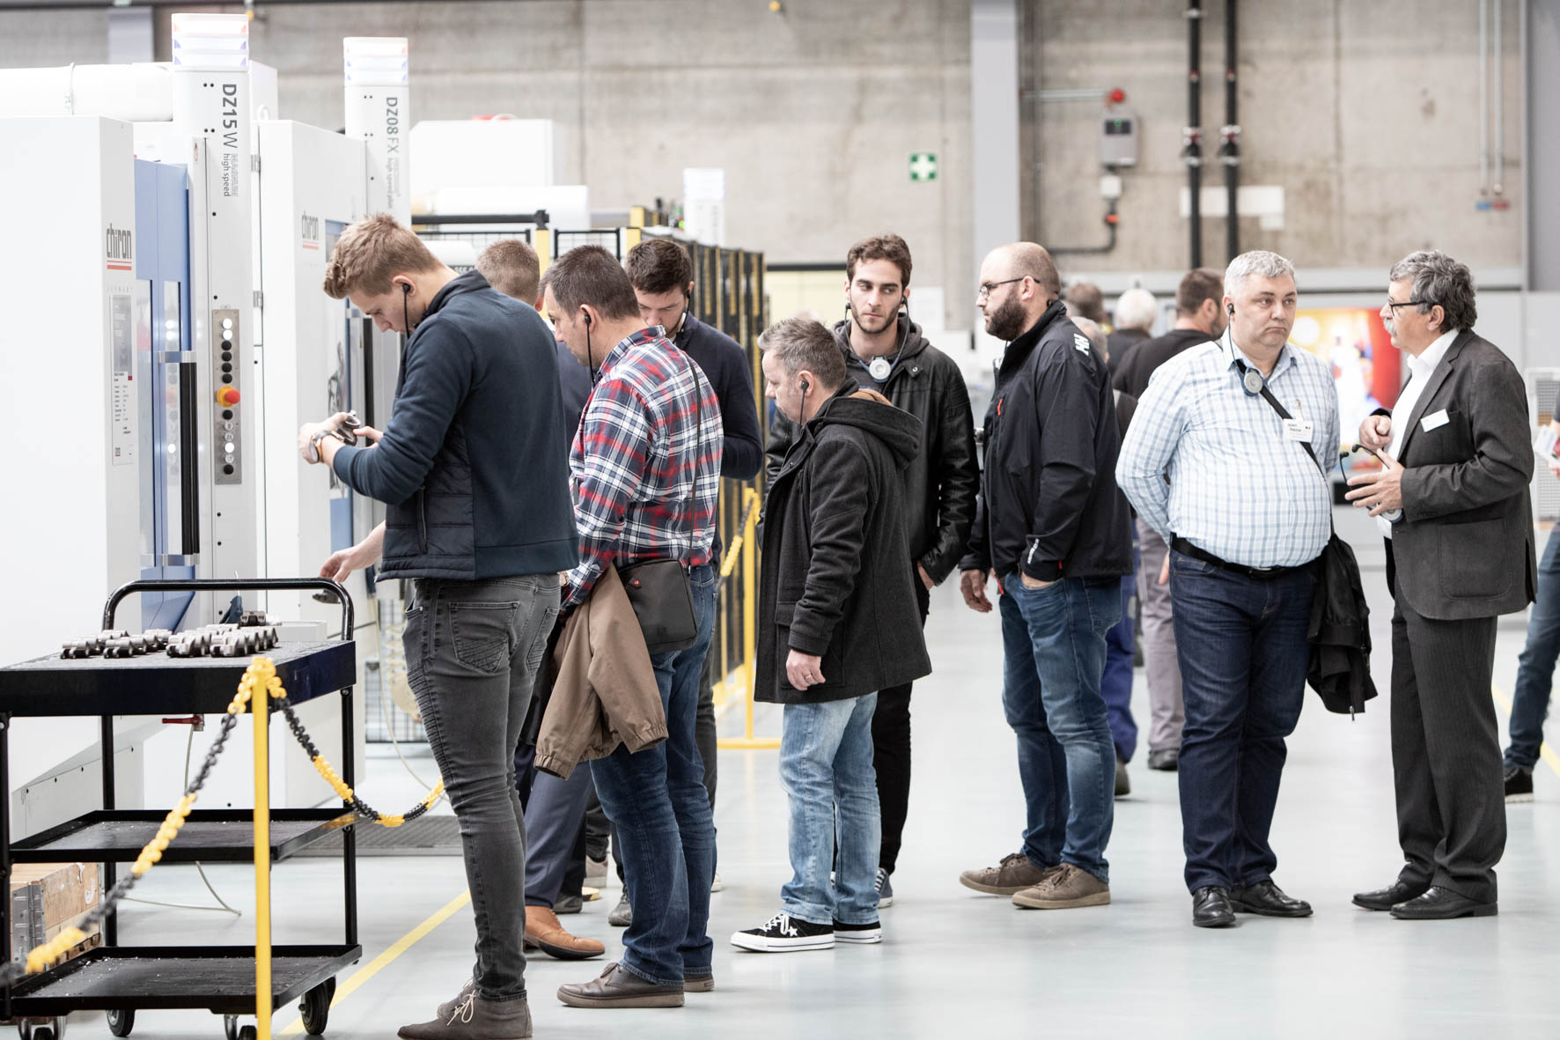

Picture 3: 29 competence partners and a wide program of lectures offer visitors fresh inspiration for their manufacturing practice.

