11th May 2022

Competences combined, complete machining expanded
The CHIRON Group has enhanced and expanded its system automation solutions with GREIDENWEIS expertise and is introducing an innovative complete machining solution with integrated automation with the new Mill-Turn Series 715.

The CHIRON Group acquired GREIDENWEIS in January 2022, gaining access to its many years of experience and comprehensive expertise in integrating technical solutions into automated assembly and production lines. The first phase of integration has been a success: The intensive exchange of experience has allowed our teams to develop new approaches and applications. Specific customer projects in the field of automated assembly are already underway, and further development projects are in the early stages.

The goal is to develop even more efficient machining, assembly and production processes via innovative automation solutions. This applies to applications ranging from high-volume parts production in a single machining center to complex production lines – incorporating processes from blanking to machining through to end-of-line testing. By combining expertise from the fields of machining and automation, the CHIRON Group has succeeded in expanding its expertise on both a strategic and operative level, in order to provide customers with even more attractive solutions to new challenges in the area of full-process automation.

Complete machining of complex workpieces – 715 Series with integrated automation
Complete machining is a core competence of the CHIRON Group, based on the experience and expertise gained from the CHIRON and STAMA brands. With this new series, the CHIRON Group is addressing the requirements of all manufacturers that rely on six-sided complete machining with milling and turning as a key technology. The goal of this series is to provide the required level of quality and cost-effectiveness, right from the very first part produced. This provides greater sustainability, in both an environmental and economic sense, for complex, technically demanding parts with high added value – particularly the production of small series and batch size one.

The new 715 Series has been available for one year so far for these industry-specific and workpiece-specific complete machining solutions. This mill-turn center with integrated automation is positioned between the FZ 08 S mill turn precision+ and the MT 733. Alongside the well-known benefits of the MT technology, the MT 715 also offers the flexibility to quickly and easily switch between bar stock and chuck machining. As an MP variant, the series is capable of machining profiles with aperture sizes of 150 x 150 mm. In practical use by pilot customers working in contract production, the 715 Series has already been successfully incorporated into production processes and has achieved the required production quality. Additional turnkey solutions based on the new 715 Series will be ready for delivery in the near future.

About the CHIRON Group

The CHIRON Group, headquartered in Tuttlingen, Germany is a global company specializing in CNC vertical milling and mill-turn machining centers, as well as turnkey and automation solutions. Comprehensive services, digital solutions and products for additive manufacturing complete the portfolio. The Group has a global presence, with production and development sites, sales and service subsidiaries, and sales agencies worldwide. Around two thirds of machines and solutions that are sold are exported. Key customer sectors are the automotive, mechanical engineering, medicine and precision engineering, aerospace industries, as well as tool manufacturing.

The CHIRON Group is proprietor of the CHIRON, STAMA and FACTORY5 brands for new machines, as well as the automation brand GREIDENWEIS and the retrofit brand CMS. CHIRON's machining centers are renowned for their highly dynamic design and their precision. STAMA's focus is on stability and complete machining, while FACTORY5's expert area is high-speed machining of micro-technical components. GREIDENWEIS is a system partner for custom, end-to-end automation solutions, and CMS provides completely overhauled machines from the Group. The final core area of expertise in the CHIRON Group is in additive manufacturing products and solutions.

Contact person for editors:

CHIRON Group SE
Matthias Rapp
Kreuzstraße 75, 78532 Tuttlingen, Germany
Phone: +49 (0)7461 940-3181

Mail: matthias.rapp@chiron-group.com
www.chiron-group.com

Image captions

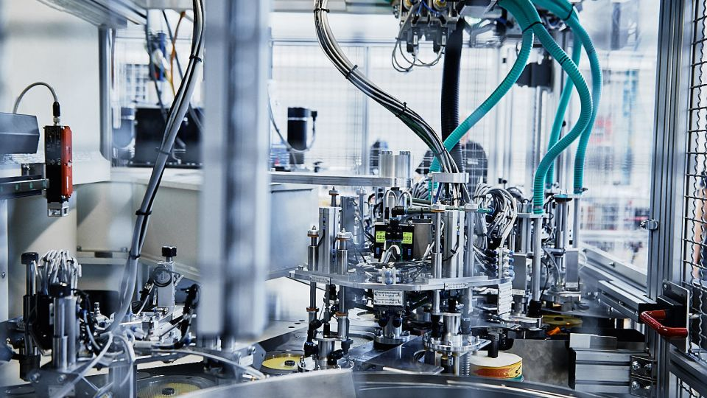

Picture 1: With the combined expertise of the CHIRON Group and GREIDENWEIS, process and system automation for a range of manufacturing technologies is now available from a single source.
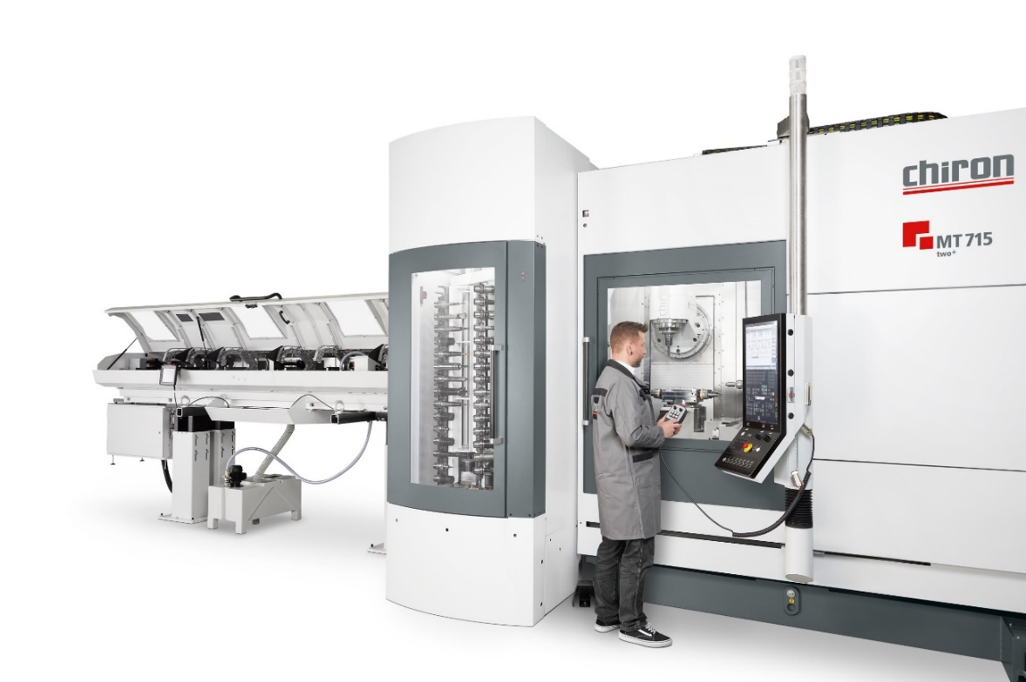

Picture 2: 715 Series – dynamic and precise complete machining with clear workpiece flow and high flexibility.

