11th May 2022

Smart cooperation for networked manufacturing

The requirements of increased efficiency, availability and productivity are impressively fulfilled by a CHIRON Group machining center combined with the SmartLine digital systems. This is achieved even more effectively if, in addition to the machining process, the processes around the machine are also incorporated in networked production.

An important part of productive manufacturing is quick and automatic changeover of tools. But what about the path of the tools in and out of the machine? How can we ensure that the right tool is equipped? How can tools be changed with the maximum level of security and efficiency? And what about the supply, monitoring and maintenance of cooling lubricant – a key criterion for optimal machining results? How can the emulsion always be kept just right and how can machines be supplied without interruption?

These are many questions to which ZOLLER, MOTOREX and the CHIRON Group have provided compelling answers under the slogan »Better together – Better digital« as part of collaboration projects.

ZOLLER and the CHIRON Group: Automated tool handling with preventive collision protection
The core competency of ZOLLER is setting and measuring prepared complete tools. The first step in developing the smart solution for automated tool handling and tool changes is connecting the »venturion 450« setup and measuring device to the machining center. This enables tool data to be transferred directly – clearly, automatically and free from errors. Part two is integrating the full tool modeling data in the machine's digital twin for comprehensive, preventative collision protection with the SmartLine module »ProtectLine«.
The third and highest configuration level comprises automated and highly efficient tool handling with the collaborative robotic assistant »cora«. The system from ZOLLER communicates directly with the machining center and ensures significantly increased productivity, both around the machine and in the machining process.

MOTOREX and the CHIRON Group: Intelligent coolant management with condition monitoring
To achieve optimum machining results, the conditions need to be perfect – and the cooling lubricant is an important way of achieving this. To keep the emulsion just right and supply it continuously to machines, the CHIRON Group is collaborating with MOTOREX. The system created by the Swiss lubricant specialist ensures continuous monitoring, dispensing, and maintenance and is scalable for every requirement. Incorporated into automatic condition monitoring with ConditionLine, all of the relevant values – such as the concentration, pH value, conductivity, temperature, and fill level – can be viewed directly and used for direct support.

In addition to providing the best conditions for different various materials, automatic fluid management also offers improved sustainability and health and safety. This means that the fluid can be used for longer and consumption is reduced by up to 25 percent. It is no longer necessary to use chemical additives in the tank that are harmful to health in the tank and the specified pH value is reliably adhered to.

»To achieve optimum machining results, the conditions need to be perfect. Besides the machine itself, the cooling lubricant is an important way of achieving this.«
Adrian Schoch, Head of Application at MOTOREX

»We look at tools with a systematic approach that includes identification, setting, measurements, inspection, automation, storage systems, software, data transfer and digital twin solutions. All this is perfectly implemented in the collaboration project with the CHIRON Group.«
Christoph Zoller, CEO at ZOLLER
About the CHIRON Group

The CHIRON Group, headquartered in Tuttlingen, Germany is a global company specializing in CNC vertical milling and mill-turn machining centers, as well as turnkey and automation solutions. Comprehensive services, digital solutions and products for additive manufacturing complete the portfolio. The Group has a global presence, with production and development sites, sales and service subsidiaries, and sales agencies worldwide. Around two thirds of machines and solutions that are sold are exported. Key customer sectors are the automotive, mechanical engineering, medicine and precision engineering, aerospace industries, as well as tool manufacturing.

The CHIRON Group is proprietor of the CHIRON, STAMA and FACTORY5 brands for new machines, as well as the automation brand GREIDENWEIS and the retrofit brand CMS. CHIRON's machining centers are renowned for their highly dynamic design and their precision. STAMA's focus is on stability and complete machining, while FACTORY5's expert area is high-speed machining of micro-technical components. GREIDENWEIS is a system partner for custom, end-to-end automation solutions, and CMS provides completely overhauled machines from the Group. The final core area of expertise in the CHIRON Group is in additive manufacturing products and solutions.

Contact person for editors:

CHIRON Group SE
Matthias Rapp
Kreuzstraße 75, 78532 Tuttlingen, Germany
Phone: +49 (0)7461 940-3181

Mail: matthias.rapp@chiron-group.com
www.chiron-group.com

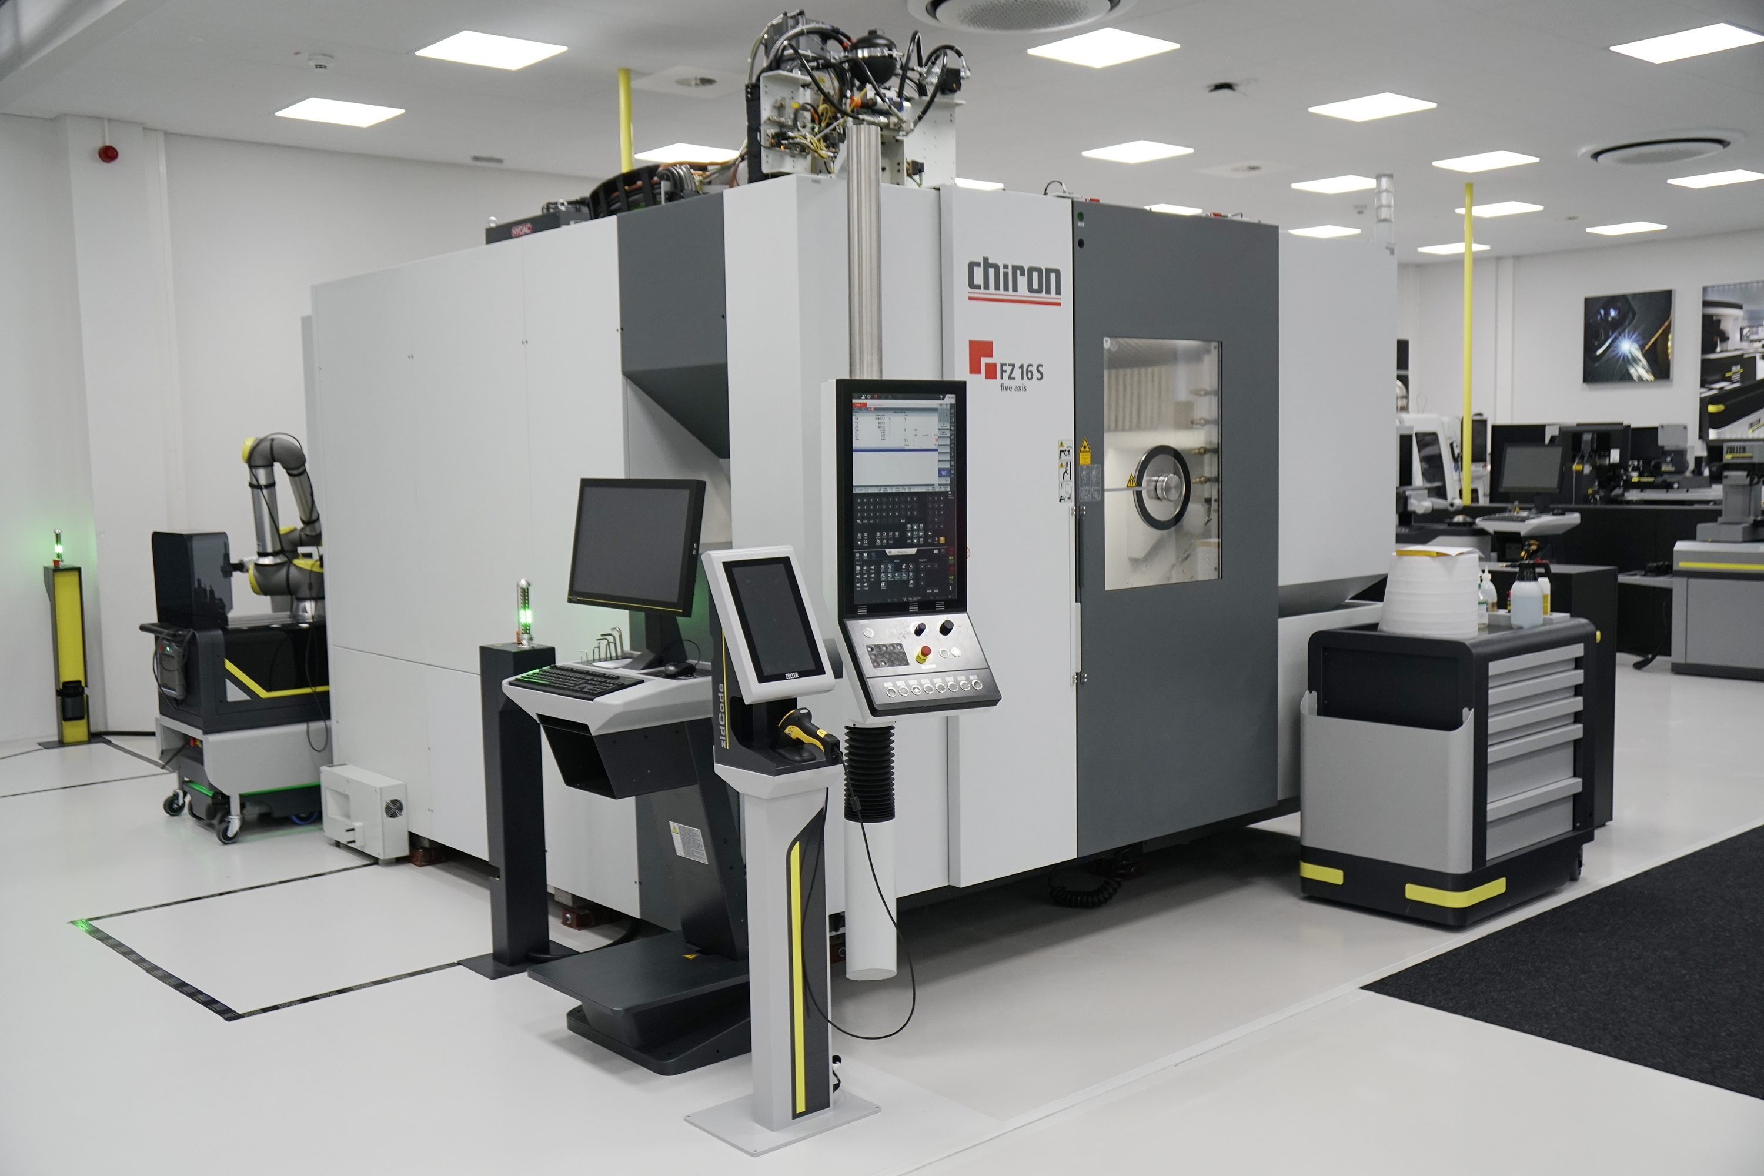

The ZOLLER smart factory in Pleidelsheim, Germany: Automated tool handling is tested and further developed using the CHIRON FZ 16 S five axis.

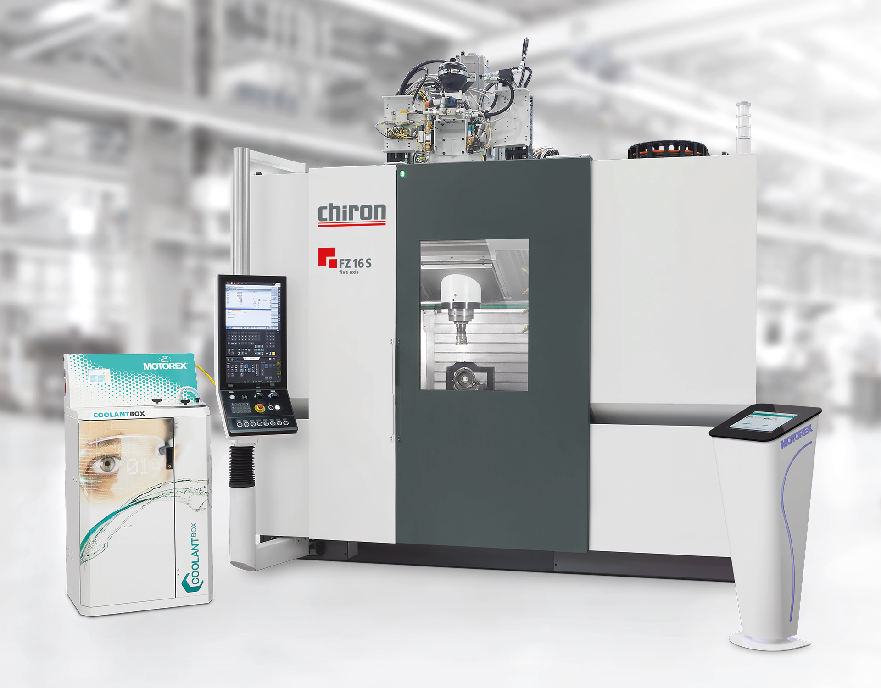

The intelligent coolant management supplied by MOTOREX ensures ideal machining results and can be integrated into the automatic condition monitoring tool »ConditionLine« offered by the CHIRON Group.

