31st May 2022

Thanks and appreciation
Vanessa Hellwing has informed the Board of Directors that she resigns as CFO of CHIRON Group SE

After nearly four years with CHIRON Group, Chief Commercial Officer (CFO) Vanessa Hellwing has decided to pursue a new career opportunity.

When Vanessa Hellwing took over as CFO in 2018, her stated goal was to contribute to the profitable growth of CHIRON Group with well-integrated financial processes while making the company's cost structure more breathable.

According to CEO Carsten Liske, "She has more than succeeded in this. She has steered the company safely through very challenging times and joined the German companies into the current CHIRON Group SE, a strong, agile unit. For this, she deserves thanks and high recognition, also on behalf of the Board of Directors."

Under Vanessa Hellwing's commercial management, the CHIRON Group integrated FACTORY5 and GREIDENWEIS in recent years to enable it to also offer innovative micromachining centers and more advanced automation solutions. "We are on a sustainable growth path," says Vanessa Hellwing, "and the employees are very motivated to set new standards for the industry from this position of strength. I wish everyone, including my colleagues on the management team, every success in this endeavor."

Details of the succession plan will be announced by CHIRON Group in due course. Vanessa Hellwing will retain full responsibility for the commercial management until then.

About the CHIRON Group

The CHIRON Group, headquartered in Tuttlingen, is a global company specializing in CNC vertical milling and mill-turn machining centers, as well as turnkey manufacturing solutions. The Group has a global presence, with production and development sites, sales and service subsidiaries, and sales agencies worldwide. Around two thirds of machines and solutions that are sold are exported. Key customer sectors are the automotive, mechanical engineering, medicine and precision engineering, aerospace industries and tool production.

Contact person for editors:

CHIRON Group SE
Matthias Rapp
Kreuzstraße 75, 78532 Tuttlingen, Germany
Phone: +49 (0)7461 940-3181

Mail: matthias.rapp@chiron-group.com
www.chiron-group.com

Image captions

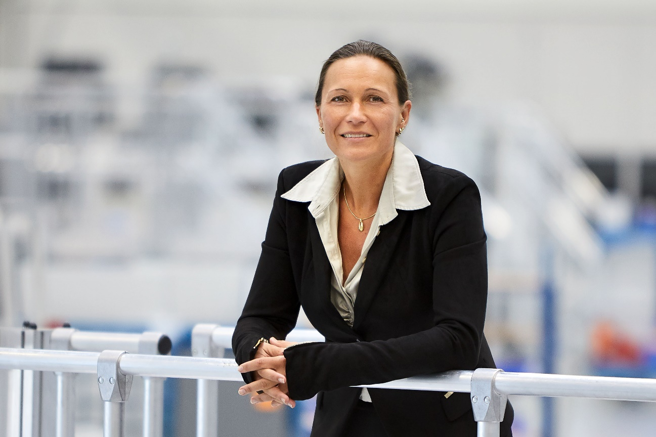

Picture 1: Vanessa Hellwing, CFO of the CHIRON Group SE.

