19th September 2022

CHIRON Group machining centers now available with new Siemens SINUMERIK ONE control system

¯ CHIRON Group counts on Siemens SINUMERIK ONE

¯ The combination of Siemens and the CHIRON Group at the forefront of technology

As part of the launch strategy for the Siemens SINUMERIK ONE control system, the CHIRON Group has already developed and extensively tested machining centers using the Siemens SINUMERIK ONE. Among other products, the AM Cube 3D metal printer in the field of additive manufacturing was developed using a SINUMERIK ONE control system. At the AMB 2022 exhibition in Stuttgart, the CHIRON Group paved the way for further expansion with the Siemens SINUMERIK ONE. From the beginning of the exhibition, all machining centers from the 16, 22, 25, 28, 715 and 733 Series are available with the new Siemens control system upon request.

As a result, state-of-the-art machine technology is combined with cutting-edge control technology and is available to CHIRON Group customers. Thanks to the new control system, the machining center achieves even higher path velocities and even greater productivity. The new digitalization interface also offers new possibilities. For example, the use of SPS data in the „virtual machine” means that cycle times can be simulated with even greater precision. In addition, integration into the MindSphere or other higher-level systems is now even easier.

As with the previous version, the Siemens SINUMERIK ONE control system can be seamlessly integrated into the CHIRON Group's TouchLine control panel. Moreover, there is the option of having machining centers equipped with a Siemens control panel.

Siemens AG and CHIRON Group SE have a long-standing partnership that goes back to the 1980s.

Quote from Dr. Eppler, CTO of the CHIRON Group:
„The new Siemens SINUMERIK ONE control system now offers all of the functions for automating our CHIRON Group machining centers, from the five-axis milling machine to the multi-channel mill-turn machining centers. The significantly improved performance of the NC and PLC offers considerable benefits in production times and downtime and, in turn, further improves the machining center's productivity.”

About the CHIRON Group

The CHIRON Group, headquartered in Tuttlingen, Germany is a global company specializing in CNC vertical milling and mill-turn machining centers, as well as turnkey and automation solutions. Comprehensive services, digital solutions and products for additive manufacture complete the portfolio. The Group has a global presence, with production and development sites, sales and service subsidiaries, and sales agencies worldwide. Around two thirds of machines and solutions that are sold are exported. Key customer sectors are the automotive, mechanical engineering, medicine and precision engineering, aerospace industries, as well as tool manufacturing.

The CHIRON Group is proprietor of the CHIRON, STAMA and FACTORY5 brands for new machines, as well as the automation brand GREIDENWEIS, CMS for refurbishment and HSTEC for motor spindles and mechanisms. CHIRON machining centers are renowned for their highly dynamic design and their precision. STAMA's focus is on stability and complete machining, while FACTORY5 expert area is high-speed machining of micro-technical components. GREIDENWEIS is a system partner for custom, end-to-end automation solutions, and CMS provides completely overhauled machines from the Group. HSTEC specializes in the development, manufacture and repair of high-speed motor spindles and mechanisms. The final core area of expertise in the CHIRON Group is in additive manufacturing products and solutions.

Editorial contact:

CHIRON Group SE
Matthias Rapp
Head of Marketing Global
Kreuzstraße 75
78532 Tuttlingen, Germany

Telephone: +49 (0) 7461 940 3181
Email: Matthias.Rapp@chiron-group.com
www.chiron-group.com

Image captions

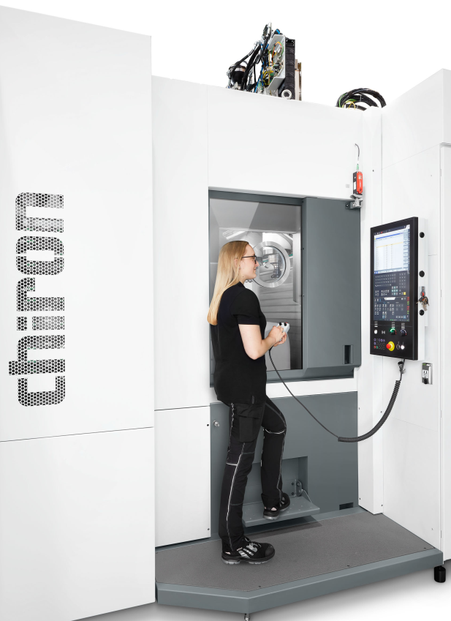
Image 1: An employee operates the Siemens SINUMERIK ONE using the CHIRON Group's TouchLine control panel.

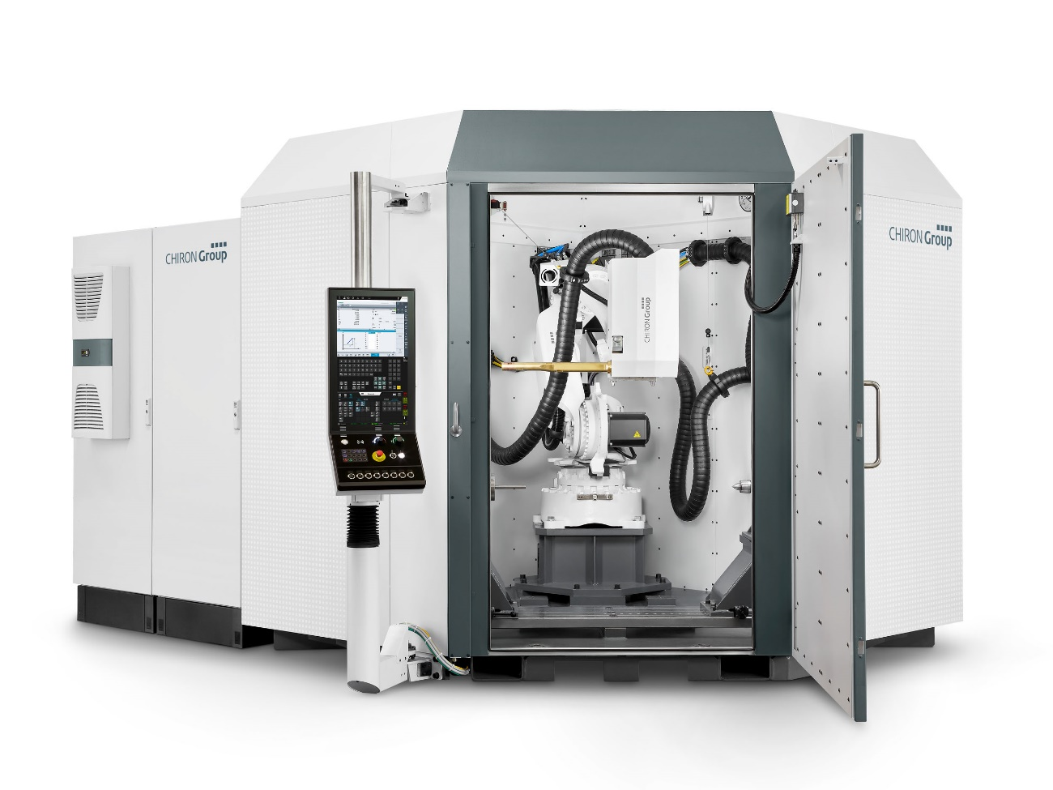
Image 2: The AM Cube 3D metal printer is ready for operation with the Siemens SINUMERIK ONE control system.

