28th October 2022

AM Coating: Innovative coatings for brake disks
A high-speed process to protect against corrosion and wear

This year's edition of Formnext on November 15 - 18, 2022 is all about the next generation of intelligent industrial production. In keeping with the exhibition's main focus, the CHIRON Group's Additive Manufacturing department will be showcasing its latest innovation – AM Coating. This is an industrial system designed for 24/7 operation for applying particularly hard coatings on brake disks.

How can the protective layer be applied to the brake disk more quickly and more effectively? And how can it be made to stay on for longer? „The solution is intelligent coatings, as can be applied to brake disks using our AM coating system,” says Dr. Géza Koscsák. The new Head of Additive Manufacturing at the CHIRON Group, who has been in his position since October, played a prominent role in developing the new system and reaching the decision to opt for the high-speed deposition welding process in his previous job as Head of Advanced Development.

Innovative and productive process
Compared with the conventional LMD process, powder particles travel a longer distance before they are applied during high-speed laser material deposition. This means that they absorb more energy and already melt in the laser beam, which enables a significantly faster coating speed. This process also has a clear advantage in comparison to thermal coating using high-velocity oxygen fuel spraying – pre-treatment of the brake disks is dispensed with, which shortens the process significantly.

AM coating's quicker speed and shorter process are two advantages with respect to the future Euro 7 standard, believes Dr. Koscsák. „When the standard comes – and it certainly will come – a production volume of 10 million brake disks annually will need to be managed, for the European vehicle brands alone. With a cycle time for conventional brake disks of around 30 seconds per disk, it's clear that the coating process needs to keep up,” he adds.

In line with market requirements: AM Coating available in two versions
AM Coating TWIN is specifically designed for series production. The system works with two lasers for front and rear coating and the brake disks are transferred fully automatically. AM Coating SINGLE is the ideal choice if you would like to test materials and material combinations in parallel with or before series production, to develop the application process or to manufacture small series. Upon request, the team of experts at the CHIRON Group can provide support during process development, either at the customer premises or in Tuttlingen. „We could install a base machine here,” says Dr. Koscsák, outlining a potential scenario, „where the customer's specialists can learn the process, run tests and set up the parameters with us ready for series production. Or, for a continuous and even more productive process, we can integrate a grinding machine and perfectly coordinate both systems.”

Top-quality, firmly bonded application
Of course, productivity is not enough on its own – the quality of the coatings needs to be right too. What about crack formation and durability? Project Manager Ernest Frombach, says „we use high-speed laser material deposition to achieve improved adhesion through the firmly bonded connection. The layers are also thinner, down to tenths of a millimeter. This uses much less material and our powder management enables us to achieve a high degree of powder utilization. The powder and hard material layers are applied directly one after the other. By applying the first layer, the brake disk is tempered as it were, and we consistently achieve the best application quality for every brake disk without pores or cracks forming.”

In addition to AM Coating, visitors will also be able to discover the AM Cube in the digital showroom at Formnext. Our experts will be on hand not only to discuss how the 3D metal printer works and its benefits, but also to dive into expert discussions with the AM community and to talk about new applications and possible uses for the all-rounder.

In addition, the team will be presenting two digital systems that can be used to analyze and optimize the application process for the AM Cube and AM Coating in a targeted manner. DataLine AM continually displays, records and documents relevant process data in real time, meaning that the product and process quality can be reliably assessed. Meanwhile, VisioLine AM visualizes and saves video files recorded by multiple camera systems, thereby enabling systematic process monitoring.

About the CHIRON Group

The CHIRON Group, headquartered in Tuttlingen, Germany is a global company specializing in CNC vertical milling and mill-turn machining centers, as well as turnkey and automation solutions. Comprehensive services, digital solutions and products for additive manufacturing complete the portfolio. The Group has a global presence, with production and development sites, sales and service subsidiaries, and sales agencies worldwide. Around two thirds of machines and solutions that are sold are exported. Key customer sectors are the automotive, mechanical engineering, medicine and precision engineering, aerospace industries, as well as tool manufacturing.

The CHIRON Group is proprietor of the CHIRON, STAMA and FACTORY5 brands for new machines, as well as the automation brand GREIDENWEIS, CMS for refurbishment and HSTEC for motor spindles and mechanisms. CHIRON machining centers are renowned for their highly dynamic design and their precision. STAMA focuses on stability and complete machining, while the expert area of FACTORY5 is high-speed machining of micro-technical components. GREIDENWEIS is a system partner for custom, end-to-end automation solutions, and CMS provides completely overhauled machines from the Group. HSTEC specializes in the manufacture and repair of high-speed motor spindles and mechanisms. The final core area of expertise in the CHIRON Group is in additive manufacturing products and solutions.

Editorial contact:

CHIRON Group SE
Melanie Buschle
Kreuzstraße 75
78532 Tuttlingen, Germany

Telephone: +49 (0) 7461 940 3255
E-mail: melanie.buschle@chiron-group.com
www.chiron-group.com

Image captions

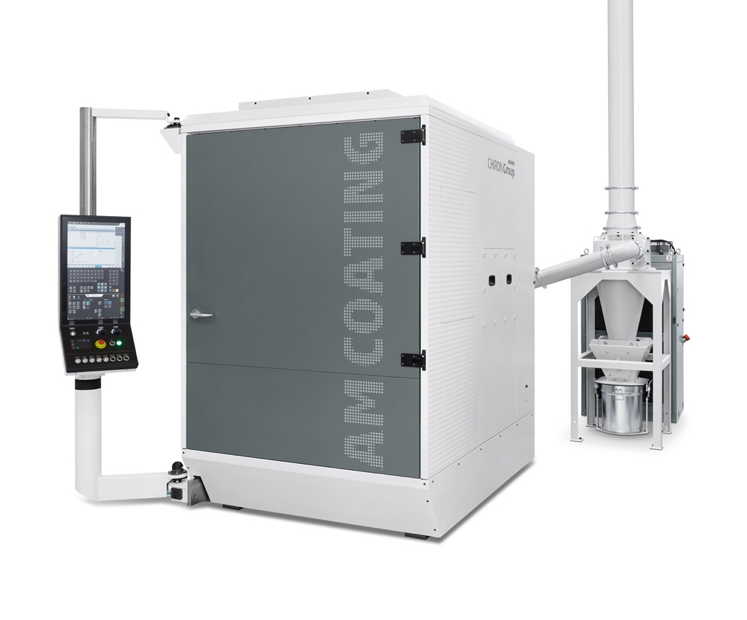
Image 1: AM Coating's powerful extraction device protects the laser against contamination and operating personnel against exposure.

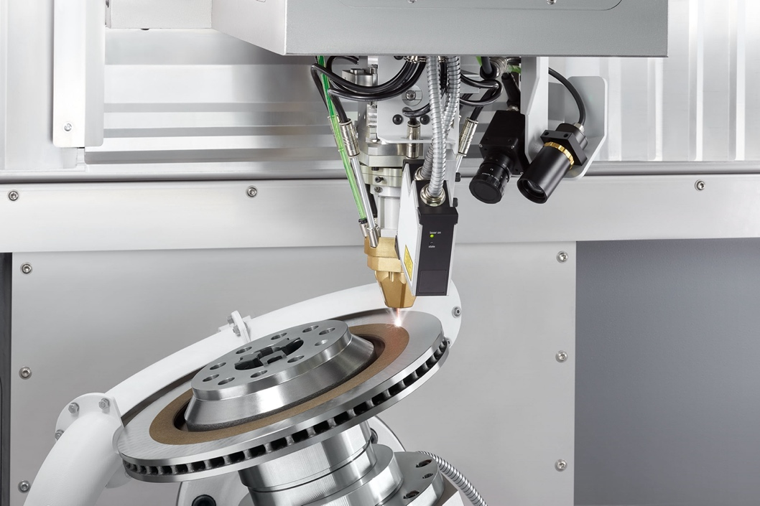
Image 2: Advantage of the process for a high coating speed – the powder particles already melt in the laser beam.

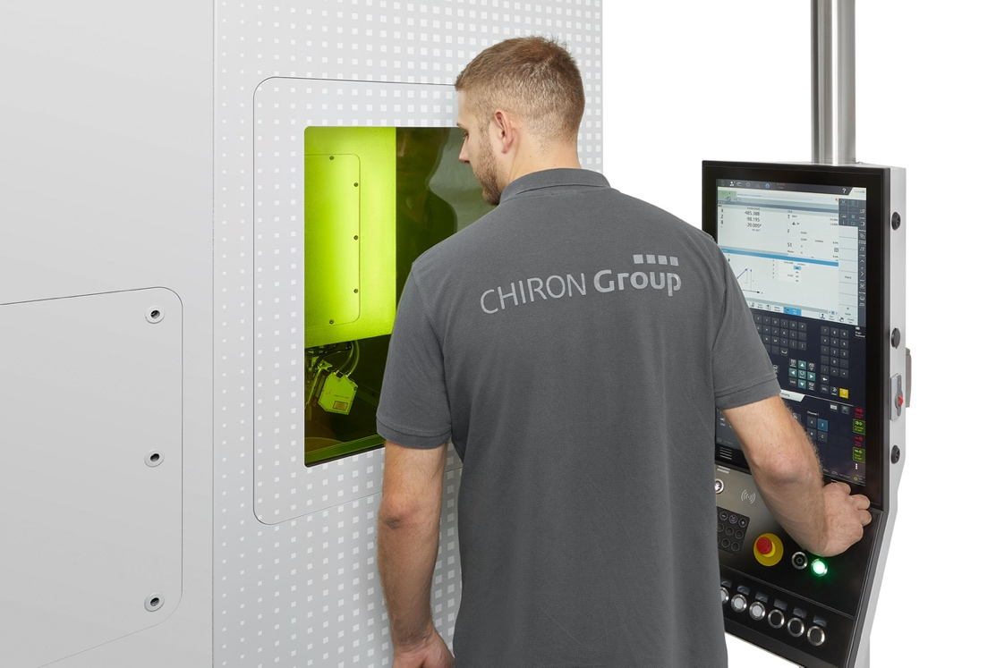
Image 3: Intuitive operation via TouchLine and the laser protection screen provides an unobstructed view of the process.

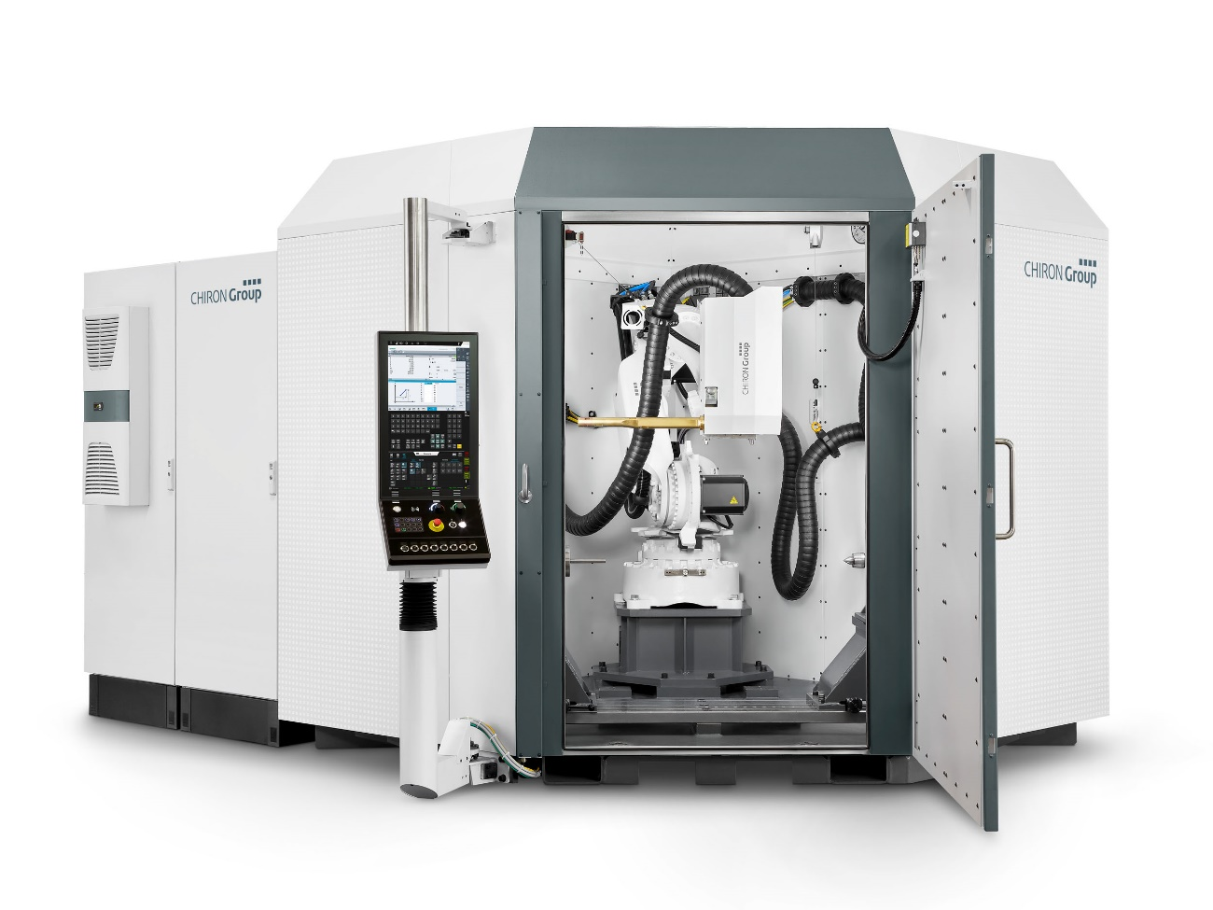
Image 4: The AM Cube 3D metal printer: The automatic changing of the deposition heads is a key advantage of the AM Cube, and a true USP. With its three deposition heads, the AM Cube can apply both wire and metal powder in various phases of production.

