April 11, 2023

CHIRON Group management team complete

Markus Unterstein will take over the position as Chief Financial Officer (CFO) of the CHIRON Group on May 1, 2023. Thus completing the management team of the globally positioned group of companies headquartered in Tuttlingen, Germany.

"I am pleased that we have been able to attract Markus Unterstein, an outstanding financial expert, who brings extensive management experience from his many years of working in family-owned tech companies," Dr. Armin Schmiedeberg, Chairman of the Board of Directors.

Markus Unterstein holds a degree as Management Business Economist (VWA), from the Academy of Administration and Business in Munich, Germany. He completes the management team of the CHIRON Group, which in the future will consist of Carsten Liske CEO, Markus Unterstein CFO, Bernd Hilgarth CSO and Dr. Claus Eppler CTO.

Markus Unterstein, future CFO: "I am very delighted to be part of the CHIRON family in the future. Above all, the technically sophisticated products and the global orientation of the company were key factors in my decision to join the CHIRON Group."

With almost 20 years of professional experience as a CFO, Markus Unterstein brings along the necessary qualifications for his future task in the CHIRON Group. In 2006, he started his career as Chief Financial Officer at KRAIBURG TPE. In 2012, he moved to HAWE Hydraulik SE and successfully led this company as Chief Financial Officer for almost 11 years until he took up his new position at CHIRON Group SE in May 2023.

Carsten Liske, CEO: "Markus Unterstein brings many years of relevant experience to actively support the CHIRON Group in achieving our strategic goals."

Upon joining CHIRON Group SE, Markus Unterstein is in charge of the commercial resorts with the areas finance, human resources, information technology and controlling. In addition, he is responsible for the business unit CMS and the branch office in Schlierbach, Germany.

About the CHIRON Group

The CHIRON Group, headquartered in Tuttlingen, Germany is a global company specializing in CNC vertical milling and mill-turn machining centers, as well as turnkey and automation solutions. Comprehensive services, digital solutions and products for additive manufacturing complete the portfolio. The Group has a global presence, with production and development sites, sales and service subsidiaries, and sales agencies worldwide. Around two thirds of machines and solutions that are sold are exported. Key customer sectors are the automotive, mechanical engineering, medicine and precision engineering, aerospace industries, as well as tool manufacturing.

The CHIRON Group is proprietor of the CHIRON, STAMA and FACTORY5 brands for new machines, as well as the automation brand GREIDENWEIS, CMS for refurbishment and HSTEC for motor spindles and fixtures. CHIRON machining centers are renowned for their highly dynamic design and their precision. The focus of STAMA is on stability and complete machining, while FACTORY5 expert area is high-speed machining of micro-technical components. GREIDENWEIS is a system partner for custom, end-to-end automation solutions, and CMS provides completely refurbished machines from the Group. HSTEC specializes in the development, manufacture and repair of high-speed motor spindles and fixtures. The final core area of expertise in the CHIRON Group is in additive manufacturing products and solutions.

Contact person for editors:

CHIRON Group SE
Christina Messmer
Kreuzstraße 75, 78532 Tuttlingen, Germany
Phone: +49 (0)7461 940-3712

Mail: christina.messmer@chiron-group.com
www.chiron-group.com

Captions

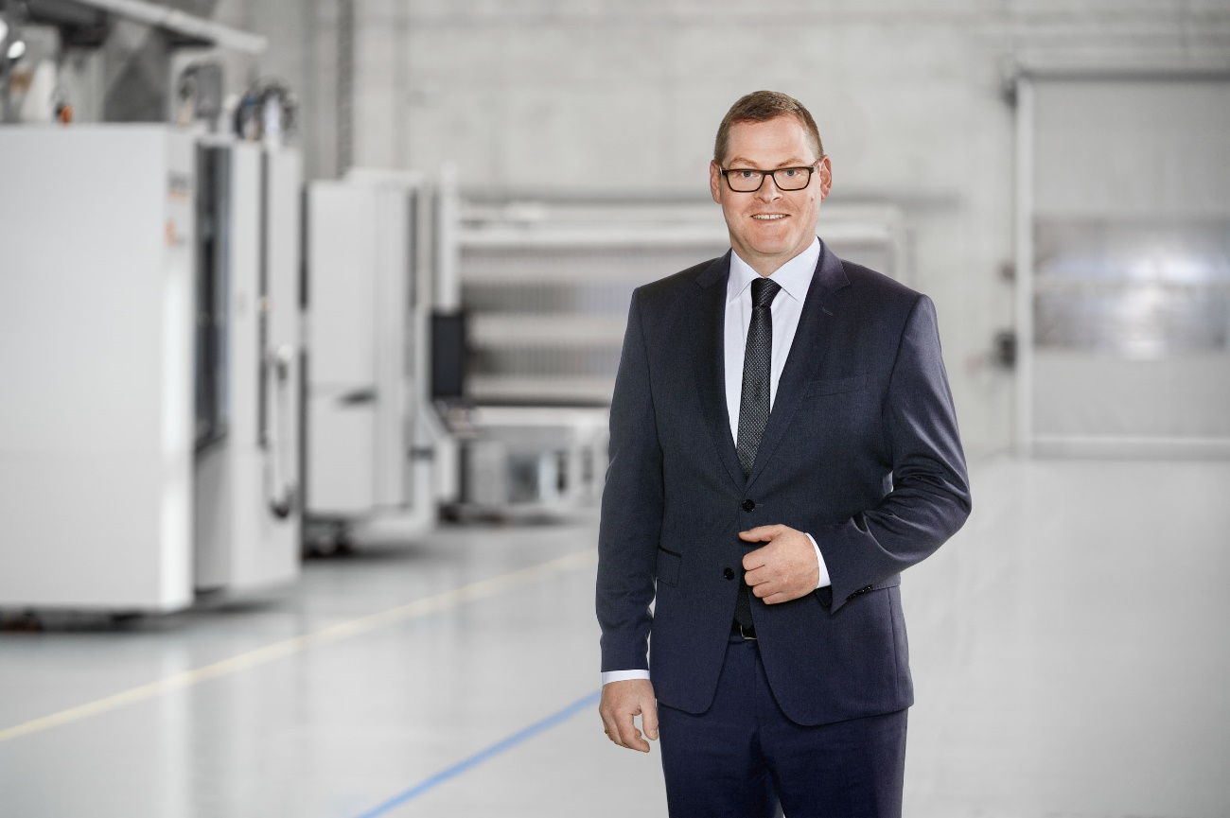

Picture 1: Markus Unterstein, new CFO at the CHIRON Group SE, will be in charge of the commercial resorts with the areas finance, human resources, information technology and controlling, as well as the business unit CMS and the branch office in Schlierbach, Germany.

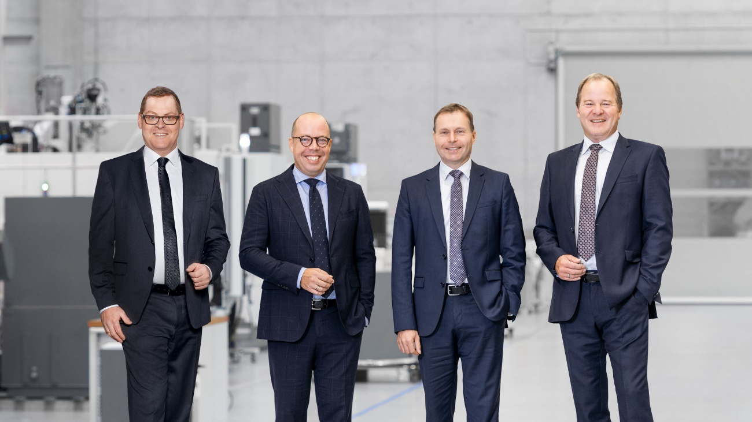

Picture 2: The management team of the CHIRON Group SE: Markus Unterstein CFO, Carsten Liske CEO, Dr. Claus Eppler CTO and Bernd Hilgarth CSO.

